Abstract Template

Title: Medical Photonics, Photo-biomodulation and the Future Disruptive Revolution by Lasers in Medicine

Presenter: Satava, RM^{1,}

¹Professor Emeritus, Department of Surgery, University of Washington Medical Center, Seattle WA, USA

Keywords: Directed energy, non-invasive surgery, cellular surgery, plasma medicine

I. Abstract Body (up to 250 words)
Non-healthcare industries have used a wide spectrum of energy-based systems for many different purposes, from microchip manufacturing to artist creations, but few have been exploited by surgeons. Although many technologies are large and sophisticated image-guided systems that provide precise targeting at the molecular and atomic level, new emerging technologies are small, hand-held portable systems. Thus, many time-honored surgical procedures will be performed as outpatient or office procedures, providing new opportunities for photonics in the clinical realm. A more disruptive change of the next revolution is directed energy for diagnosis and therapy (DEDAT), taking surgery to the final step – non-invasive surgery. Combining experience in lasers, photo-biomodulation, image guided surgery and robotic surgery, there are new energy-based technologies which provide the control and precision of photonic energy that enable operating (non-invasively) at the cellular and molecular level. The evidence that has been building from the multiple disciplinary fields of photonics, computer assisted surgery, genetic engineering and molecular biology communities (Radiology, Surgery, Plasma Medicine, Molecular Biology, the Human Genome) will be presented, including technologies beyond photonics such as high-intensity focused ultrasound (HIFU), terahertz imaging and therapeutics – to name a few. Though still in its infancy, DEDAT is but the tip of the iceberg that heralds the transition to non-invasive surgery. Such systems are based upon the premise that directed energy can bring precision, speed and reliability - especially as surgery ‘descends’ into operating at the cellular and molecular level. Nobel Laureate Richard Feynman was right – there is “plenty of room at the bottom” !

- Image:

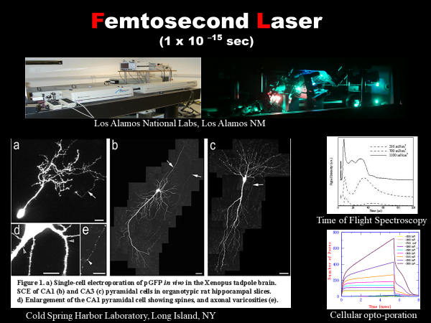

- Reference:
- Goodman AM, Neumann O, Nørregaard K, Henderson L, Choi MR, Clare SE, Halas NJ. Near-infrared remotely triggered drug-release strategies for cancer treatment. Proc Natl Acad Sci U S A. 2017 Nov 21;114(47):12419-12424. doi: 10.1073/pnas.1713137114. Epub 2017 Nov 6.
- Hamblin MR. Photobiomodulation for traumatic brain injury and stroke. J Neurosci Res. 2018 Apr;96(4):731-743. doi: 10.1002/jnr.24190. Epub 2017 Nov 13. Review. PMID: 29131369
- He Z, Liu K, Manaloto E, Casey A, Cribaro GP, Byrne HJ, Tian F, Barcia C, Conway GE, Cullen PJ, Curtin JF. Cold Atmospheric Plasma Induces ATP-Dependent Endocytosis of Nanoparticles and Synergistic U373MG Cancer Cell Death. Sci Rep. 2018 Mar 28;8(1):5298. doi: 10.1038/s41598-018-23262-0. PMID: 29593309
- Biography:
POSITIONS: Professor of Surgery Yale University, Professor of Surgery Walter Reed Army Medical Center, Program Manager Defense Advanced Research Projects Agency (DARPA) and Senior Science Advisor US Army Medical Research Command. TRAINING: Johns Hopkins University, Hahnemann University Medical School, Internship Cleveland Clinic, Surgical Residency Mayo Clinic with Master of Surgical Research. AWARDS: Smithsonian Laureate in Healthcare and Department of Defense Legion of Merit. DURING 23 YEARS OF MILITARY SURGERY: Flight Surgeon, Army astronaut candidate, MASH surgeon - Grenada Invasion, Hospital Commander - Desert Storm, all the while continuing clinical surgical practice. GOVERNMENT: White House Office of Science and Technology Policy (OSTP) Committee on Health, Food and Safety. MEDICAL: Numerous committees of American College of Surgeons (ACS), past-president of many surgical societies, on the editorial board of numerous surgical and scientific journals, and active in numerous engineering societies. EXPERTISE: Surgical education and surgical research (more than 250 publications and book chapters) - Surgery in Space, Video and 3-D imaging, Directed Energy Surgery, Robotic Surgery, Virtual Reality Surgical Simulation, Surgical Competence and Training.

- Presenting author details

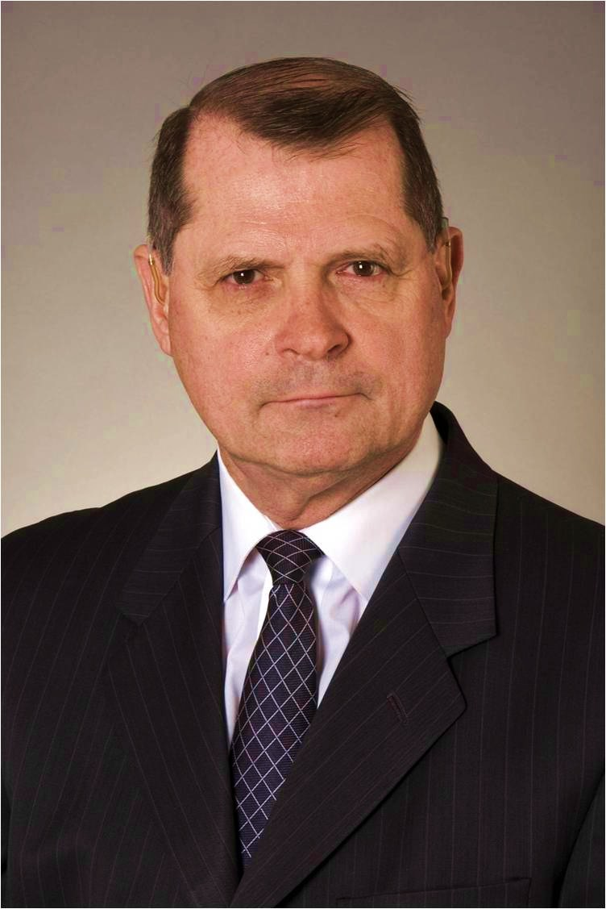
Full Name: Richard Satava, MD FACS
Contact number: rsatava@uw.edu +1 425 765-0730
Twitter account: N/A
Linked In account: N/A
Session name/ number: Future Drifts in Lasers, Optics and Photonics
Category: (Oral presentation)
Passport Number: 488192278

