Comprehensive properties enhancement of graphene oxide reinforced polymer nanocomposites.

Nidhin Divakaran, PhD, Fujian Institute of Research on Structure on Matter, Chinese Academy of Sciences, P.R. China
Lixin Wu, PhD, Professor, Fujian Institute of Research on Structure on Matter, Chinese Academy of Sciences, P.R. China

Abstract
The constant urge to boost the versatility of unsaturated polyester (UP) in the burgeoning area of automotive and aircraft industries has shifted the focus on developing high performance UP based nanocomposites with remarkable thermal, mechanical, and electrical properties. The current work traverses through the innovative method to contrive functionalized graphene oxide (f-GO)/UP nanocomposites. Similarly, Graphene oxide, synthesized from graphite using modified Hummers’ method, manifests into f-GO (GO-MAH, GO-NH_{2,} POSS-GO) via surface chemical functionalization. Different loadings of f-GO were assimilated within UP matrix through in-situ polymerization. The comprehensive properties of the nanocomposites enhance, despite addition of f-GO as low as 0.04 wt.%, which itself gives a scrupulous vindication of proper dispersion of fillers and formation of exfoliated and intercalated nanostructures, with SEM images furnishing the inference of meticulous dispersion. The fabricated nanocomposites exhibit tensile strength augmentation by 75.2% for ultralow content of 0.08 wt.% f-GO. Furthermore, the 0.10 wt.% addition of f-GO within UP displays 53.8% increase in storage modulus and thermal decomposition temperature at 10% mass loss boosts by 70.3 °C, while the electrical conductivity surges by 10⁹ S/m. The surface functionalized graphene oxide and their interaction with UP played a vital role in their property enhancement.

Image

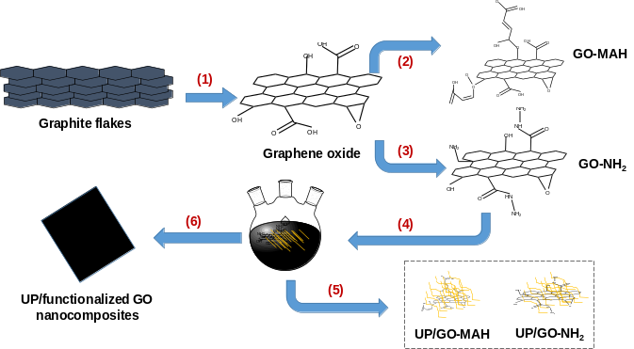
Figure 1. Schematic route to functionalize GO and synthesize UP/f-GO nanocomposites: (1) modified Hummers’ method, (2) maleic anhydride functionalization, (3) amine functionalization using APTES, (4) in-situ addition after sonicated with glycols, (5) preparation of UP/f-GO resin, and (6) curing.

Recent publications (minimum 5)
- Nidhin Divakaran.; Zhang, X.; Kale, M. B.; Senthil, T.; Mubarak, S.; Dhamodharan, D.; Wu, L.; Wang, J. Fabrication of Surface Modified Graphene Oxide/Unsaturated Polyester Nanocomposites via in-Situ Polymerization: Comprehensive Property Enhancement. Applied Surface Science. 2020, 502 (July 2019), 144164.
- Nidhin Divakaran, Kale, M. B.; Senthil, T.; Mubarak, S.; Dhamodharan, D.;Wu, L.; Wang, J. Novel unsaturated polyester nanocomposites via hybrid 3D POSS modified graphene oxide reinforcement: Electrotechnical application perspective, Nanomaterials, 2020
- Kale, M. B., Nidhin Divakaran.; Mubarak, S.;Dhamodharan, D; Senthil T.;Wu, L. Waterborne polyurethane nanocomposite reinforced with amine intercalated - zirconium phosphate – study of thermal and mechanical properties. Polymer (Guildf). 2019.
- Senthil, T.; Nidhin Divakaran; Wang, J.; Wang, R.; Wu, L. Evolution of Structural, Electrical, and Mechanical Response of 3D Robust Network and Conducting Mechanically Modified Glass Fabric-Polyester Composites with Devisable 1D VGCNF. Compos. Sci. Technol. 2018, 163 (November 2017), 171–179.
- Mubarak, S; Dhamodharan, D; Nidhin Divakaran; Kale, M. B.; Senthil T.; Wu, L; Wang, J. Enhanced Mechanical and Thermal Properties of Stereolithography 3D Printed Structures by the Effects of Incorporated Controllably Annealed Anatase TiO₂ nanoparticles, Nanomaterials, 202


Biography
Dr Nidhin Divakaran was a Junior Research Fellow under Dr Prachi Thareja in the Chemical Engineering department, Indian Institute of Technology, Gandhinagar from January 2015 in the field of Nanocolloids and Nanosensors. He currently finished his PhD in Materials Physics and Chemistry at Chinese Academy of Science Key Laboratory of Functional Nanostructure in Fujian Institute of Research on the Structure of Matter, Fuzhou under the guidance of Prof. Dr. Lixin Wu. He obtained his Masters in Technology (MTech) from Vellore Institute of Technology, Vellore, India in year 2014 with nanotechnology as his specialization. He did his Bachelor in Engineering (B.E.) in Instrumentation and Control from Government Engineering College, Gandhinagar, India in year 2012.
Dr. Nidhin’s research interests comprises of synthesis of polymer and their nanocomposites with inclusive property optimization, 2D and 3D nanofillers based composites, ultraviolet curable photosensitive resins and their 3D printing application. Dr. Nidhin has published research papers in international journals in the field of polymer nanocomposites. He has received the prestigious CAS-TWAS President Fellowship (2016-2020) to pursue his PhD in China. He is also the member European Nanotechnology and Nanoscience Association (ENNA).

Email: nidhin3222@gmail.com

