High Ultrafiltration Rate, Is It Bad?

A case report of a patient on Hemodialysis for 29 years with HIGH ULTRAFILTRATION RATE.
Dr. Aziz ul haq Syed, Dr. Majdah Barhamein, Dr. Issam Alghamdi, Dr.Elwaleed Nouri, Dr. Walaeldin Ahmed, Dr. Yasir Ahmed.

High ultrafiltration on Hemodialysis stresses cardiovascular and could have negative effect on survival.
This is the notion of many studies done in line with High ultrafiltration. However, are we missing the other side of coin, cumulated effect of fluid overload on cardiovascular system?
We present a case 60 year male develop protein urea lost follow up, presented with CKD 5, started on hemodialysis which he is on for 29 years now.
He was hypertensive to start with later became normotensive. His intradialytic weight gain is 4.5 to 5.5 liters, which he tolerates well without any episode of intradialytic hypotension.
Except Carper, tunnel Syndrome for which he had surgery, clinically stable, normal biochemical parameters and acceptable cardiovascular status with this entire very remarkable journey.

Introduction

Because of the advances in management of end stage renal disease and shortage of live and cadaveric donor kidneys the number of patients undergoing hemodialysis for longer period of time increasing.
The longest time having hemodialysis according to the available data is:
Mr. Jean Pierre Giavel a Canadian who had hemodialysis for 47 years and 363 days.
Mr. Kenneth Sharp has been on dialysis for more than 42 years.
Angela Taggaet has been on dialysis since she was 19 year and successfully completed 40 years.
One case report of successful kidney transplant after 38 years of hemodialysis from Japan by Masahiko Okaiudo.
We present a case on hemodialysis for the past 29 years.
He is one of the patient in Kingdom of Saudi Arabia who are on dialysis for such a long time. In our unit, there are five patients who are on hemodialysis for more than 20 years and all are well with reasonable good quality of life.

Our patient is male Saudi national born 1960. At age of 20 during his pre-employment medical check-up. Discovered having proteinuria. Neglected by physician (as per patient), he was not followed up as refer to Nephrologist.
Patient remain a symptomatic follow 10 years and presented with uremic symptoms and was diagnose having CKD 5.
Renal replacement therapy was initiated with right internal jugular catheter. His first session was on 12th Jan 1991.
Left forearm AV fistula was first time use after two months, function for 6 years. The second right forearm arteriovenous fistula works for another six years. Third arteriovenous fistula was created in 2003 working well and currently use for hemodialysis.
One month back he has Fistulogram showed stenosis distal part of cephalic vein.

Lab details:

Hemoglobin study stable for the last 4 years in the range of 10-12 gm/dl. Only occasion when his hemoglobin was below 10 when he was on antiviral medication for his HCV infection.

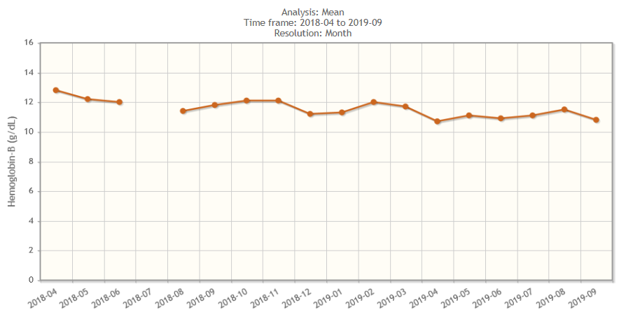

Bone Profile:
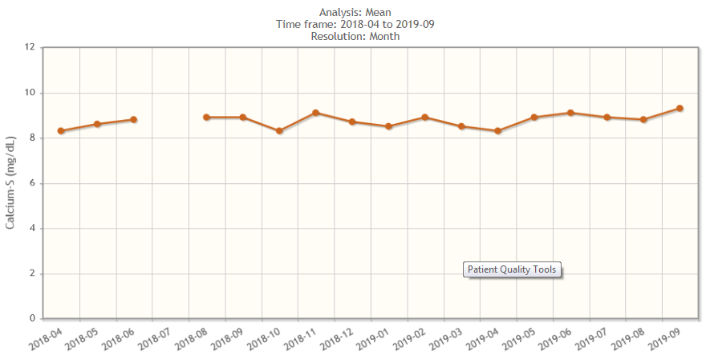
For the last 4 years, he has normal s. calcium, s. phosphorus and PTH.

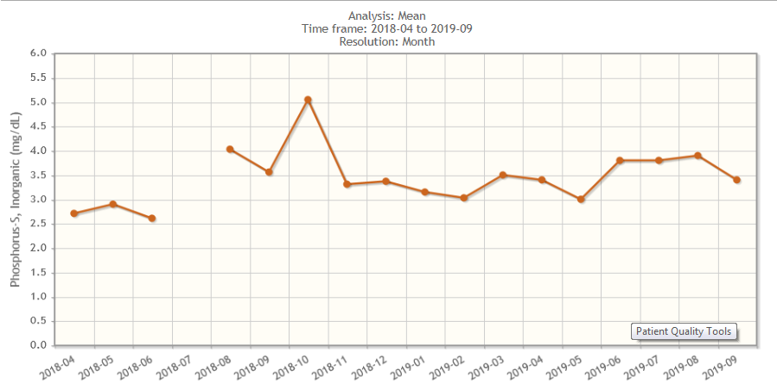

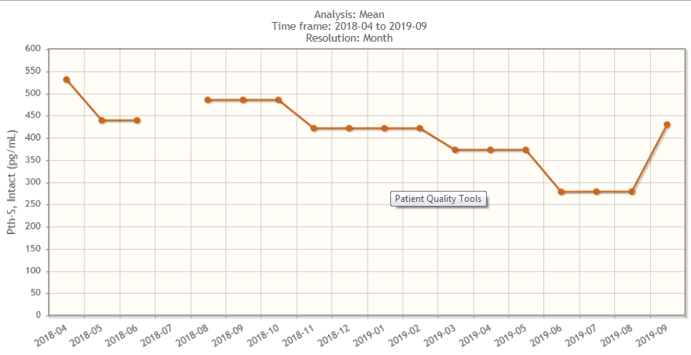

Electrolyte:
Interesting is to note his sodium (Na⁺) Pre and Post dialysis.
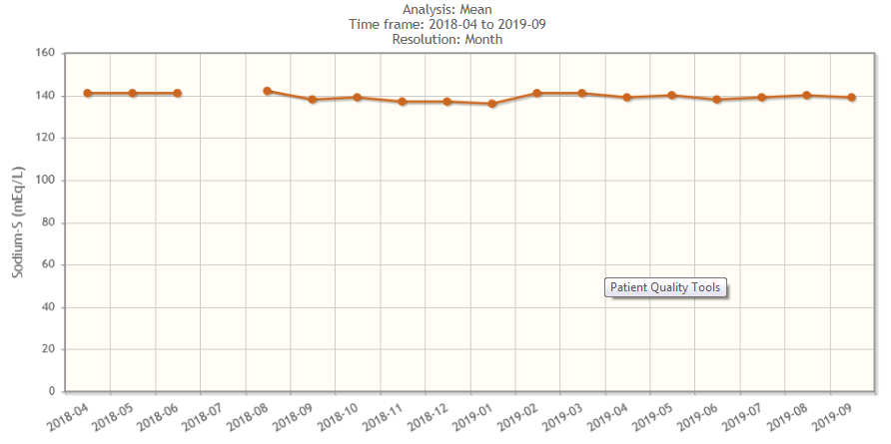
In dialysis prescription, his sodium (Na⁺) is 150 mmol/L
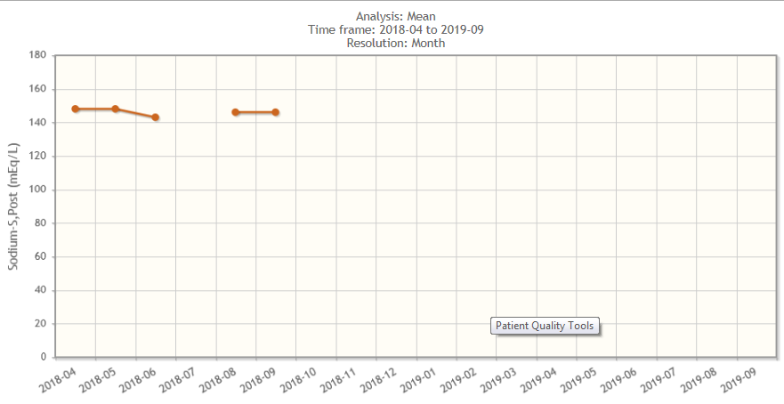

Hemodialysis
The start of maintenance hemodialysis was same routine prescription. He is usually had an average weight gain of 1-2 liter, having good residual renal function. In intradialytic weight, gain was acceptable. He was hypertensive to start with which was later improved by managing his dry weight.
After 18 months of maintenance hemodialysis and loosing residual renal function, he started to have very high intradialytic weight gain (IDWG) resulting in this intradialytic hypotension with poor quality of life (Mental composite summary and physical composite summary).
All efforts to bring his intradialytic weight gain of average 4 – 5 liters failed.
Gheuan- Ho Kim in his paper Dialysis un-physiology and sodium balance Quoted "Un-physiology Hypothesis". By Casl- Kjellstrand.
The dialysis complication are more common in patient who experience great swings in body weight , Urea (Osmolality) ,Potassium and range fluid load.
Dialysis prescription of patient was review and dialysate sodium (Na⁺) was gradually increase to 140 meq/L. The condition of patient during and post HD remain same. He was not able to complete 4 hours session. Dialysate Na⁺ was further increase to 150 meq/L. At this level, patient condition stabilize. There was no episode of intradialytic hypotension (IDH) . His quality of life improved both on mental composite summary and on physical composite summary.
Graph pre – Post BP

There was no noticeable change in his intradialytic weight gain (IDWG) which continue to be 4.5 – 5.5 kg.
so for the last 26 years his dialysis prescription is same.

This is his last echocardiography report:

When he joined, our dialysis unit 5 years back, his prescription was change fashion HD to HDF, but attempt to reduce dialysate sodium fail and we continue the same sodium concentration.
Six months back he was operated for carpel tunnel syndrome in the left hand and waiting for the second surgery on his right hand. This is the only complication he develop over these 29 years of HD.
The option of renal transplant was discuss many times but he seems to be happy things are going and will continue on hemodialysis.

Discussion
Long-term survival on HD has repeatedly claim clearly these belong to two categories:
- Longest total period on HD.
- Longest continues period on dialysis.
The question of long term survival in HD has received little scientific interest (Kuskasetal) .
Two factors noted in most reported cases of long-term dialysis are young age at start, no comorbidities (DM or HTN or CVD).
Our patient fits well in this criterion as dialysis was started at age of 22 years and he had no associated with comorbidities.
Many patients have survived > 30 years continuous improvement in dialysis treatment is expected to improve prognosis of patient on HD. ®
In our patient, we faced two problems very high intradialytic weight gain and intradialytic hypotension with poor quality of life post HD.
We succeeded to manage these by taking a challenge to increase dialysate sodium (Na⁺) to 150 meq/L, the highest in reported literature.
Castlo Basile in his paper aim at evaluating benefits and harm of difference dialysate Na⁺ prescription through a systemic review of available literature. Twenty-three studies (76635 subject) were reviewed.
Outcome of interest were mortality, Blood pressure, intradialytic weight gain (IDWG), Plasma Na⁺, hospitalization, use of antihypertensive agent and intradialytic complication.
The dialysate Na⁺ range low 133 to high 144 meq/L.
Conclusion was that there is no definite evidence providing the superiority of low or high uniform dialysate sodium on hard on surrogate and points in maintenance hemodialysis patient.
Our patient with dialysate Na⁺ of 150 meq/L remain normotensive during all these years, the intradialytic weight gain (IDWG)also did not noticeably changed.
As compared with the general population dialysis patient, continue to have significantly higher mortality risk.
According to US Renal Data System, in 2015 mortality rate for dialysis patient were 166/1000 patient –years.
With cardiovascular causes being responsible for 48% of death. ®
One major contributor to this high mortality risk is represented by abnormal fluid status.
Fluid overload is a common complication in dialysis patients. ®

Our patient also had Fluid overload problem started a few months of initiation of hemodialysis.
Fluid overload has been link with hypertension, arterial stiffness, left ventricular hypertrophy, endothelial dysfunction, congestive cardiac failure and increase CV morbidity and mortality.
Majority of the studies have assessed only the impact of baseline volume status.

In fact, cumulative fluid overload is a strong risk factor for death large multination Cohort of incident hemodialysis patient. ®
Despite of very high IDWG we successfully achieved post HD dry weight and maintained it for such a long period.
Reported in literature many solution for those patients with high intradialytic weight gain, like as Na⁺ profiling, ultrafiltration profiled hemodialysis to prevent intradialytic complication.
So in our opinion not only higher ultrafiltration rate has adverse effect on cardiovascular morbidity and mortality.
The effect of cumulated fluid overload is also have effect on cardiovascular morbidity and mortality.
We recommend individualizing dialysis prescription as mention in a paper by Rammah Abolityla. ®
Is possible by different complex calculation to individualize ultrafiltration rate using advance hemodialysis machine preventing adverse effect of high ultrafiltration target on cardiovascular system.

