Antimicrobial Resistance:
Is there light at the end of the tunnel?
Abstract:
Antimicrobial resistance or AMR is a serious global health emergency. The rapid spread of multi-drug resistant (MDR) and extremely drug resistant (XDR) bacteria across the globe has put the success of modern medicine in jeopardy. According to a report published by Jim O Neil in 2014, if no action is taken now then by the year 2050, 10 million people will die every year due to drug-resistant infections and this number would be greater than deaths caused by diabetes and cancer put together. Carbapenem resistant Enterobacteriacae (CRE). Carbapenem resistant Pseudomonas (CRPA) and Carbapenem resistant Acinetobacter (CRAB) have been identified by WHO as the priority pathogens for which new antibiotics are needed very soon. Focus on new rapid diagnostics, increasing coverage of vaccines, strengthening the national/regional epidemiological surveillance networks, developing novel alternates to antibiotics and suggesting ‘out of the box’ new drug development and commercialisation models are some of the measures proposed to counter AMR. The GAIN (Generating Antibiotic Incentives Now) Act - 2012, the PATH (Promise for Antibiotics and Therapeutics for Health) Act-2015 in US and ND4BB (new Drugs for Bad Bugs) 2013 by European Union are some of the well-known large initiatives taken to incentivise new antibiotic discovery. Pharmaceutical industry has also risen up to the challenge and the pipeline for breakthrough antibiotics targeted against critical gram negative pathogens is beginning to build up. Antimicrobial Stewardship (AMS) programs to optimise the clinical outcomes and minimise the unintended consequences of antibiotic use are being advocated at both hospital and community setting. All these measures plus increasing awareness and education on rational use of antibiotics raises hopes that there is light at the end of the tunnel, however if these efforts are not sustained and strictly enforced then this light at the end of the tunnel could be of an incoming train.
Images:
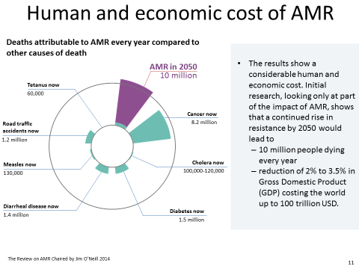

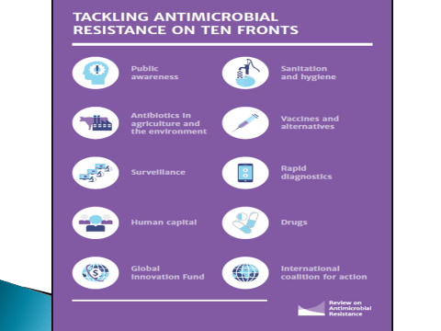
Recent Publications:
- The World State of Antibiotics 2015 by CDDEP (Centre for Disease Dynamics, Economics & Policy)
- The Review on Antimicrobial Resistance, Jan 2016 by Jim O’Neill
- WHO Report 2017 on Prioritisation of pathogens to guide discovery, research and development of new antibiotics for drug-resistant infections bacterial infections including Tuberculosis.
- Bassetti M etal. Antimicrobial resistance in the next 30 years, humankind, bugs and drugs: a visionary approach. Intensive Care Med (2017) 43:1464–1475
- Boucher WH etal. 10 × ’20 Progress—Development of New Drugs Active Against Gram-Negative Bacilli: An Update From the Infectious Diseases Society of
America. Clinical Infectious Diseases 2013;56(12):1685–94
Biography: 
Dr Ankur Gupta is Physician and Clinical Pharmacologist working with A.Menarini Asia Pacific in Singapore. He has 11+ years of experience on AMR and Antimicrobial Stewardship in Asia Pacific Region and Emerging markets (Russia, Latin America, S Africa). He developed the concept and helped in making implementation metrics of Antimicrobial Stewardship (AMS) in many tertiary care hospitals in India. Has helped more than 100 tertiary care hospitals in India in making evidence based antimicrobial treatment protocols based on the concepts of Antimicrobial Stewardship. Has trained medical personnel in about 25 countries (Asia pacific region, Middle east and Sub-Saharan Africa) on the concept of Antimicrobial Stewardship. Worked as Project lead for Antimicrobial Stewardship in Emerging Markets at MSD Pharmaceuticals from June 2013-May 2016 for implementation of AMS in tertiary care hospitals in Russia, India, Brazil, Vietnam, Philippines, Malaysia and S. Africa. Has made oral presentations on AMS at International conferences like ISAAR and ICID in 2012 and 2014. Has delivered more than 350 lectures on rational use of antimicrobials, Pk-Pd of antibiotics and management of multi-drug resistant bacteria

