TOXIC EPIDERMAL NECROLYSIS DUE TO CEPHALEXIN
IN A NON-SPECIALTY CARE UNIT SETTING
Ianne Jireh N. Ramos-Canizares, MD, MPM, Vicente Sotto Memorial Medical Center, Cebu, Philippines
Henry G. Canizares, MD, FPCP, FPSNM, Vicente Sotto Memorial Medical Center, Cebu, Philippines

Abstract
We report what we believe is only the 6th reported case of toxic epidermal necrolysis (TEN) due to Cephalexin and the first to survive outside of a specialty care unit. The patient was a 50-year old female who presented with generalized cutaneous bullous and desquamative lesions one week after taking Cephalexin which exacerbated upon subsequent use. She had no known comorbidities and did not have any prior history of allergies. A predicted mortality rate of 35.3% (SCORTEN 3) was calculated based on the extent on epidermal detachment (76%), age, and low serum bicarbonate level of the patient. The patient survived in spite of admission to a charity non-communicable disease ward instead of an intensive care or specialty burn care unit. The bullous lesions were aseptically punctured and drained, a technique which was not used in any other documented case of TEN. Histologic findings of focal and complete portions of epidermal detachment, and aggregates of lymphoplasmacytic inflammatory cells confirmed epidermal necrolysis, a rare, life-threatening non Ig-E mediated hypersensitivity reaction to drugs. The pathophysiology of TEN is incompletely understood and there is uncertainty around its accepted management since the rarity of the disease and its high mortality rate makes it difficult to conduct randomised control trials on emerging therapies. Conservative and multidisciplinary approaches to medical management are discussed according to current literature.

Image
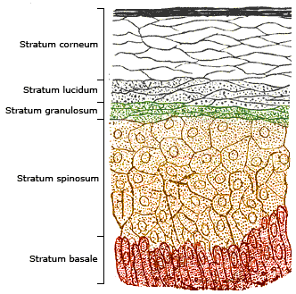
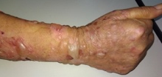
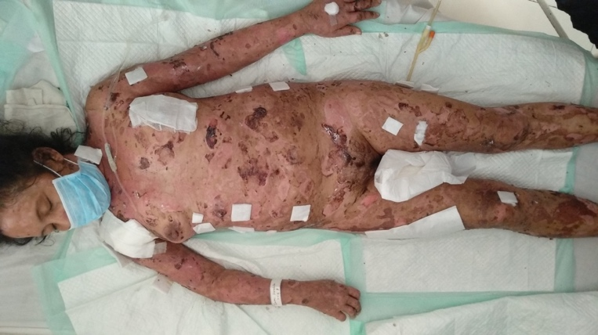
Figure 1. A 50-year old female with bullous erythematous skin lesions in 76% total body surface area, shown here after aseptic puncture and drainage of some of the bullous lesions. (Inset photo) Different lesions of TEN at different degrees of resolution.

Recent Publications
- Lyell A. Toxic epidermal necrolysis: an eruption resembling scalding of the skin. Br. J. Dermatol. 1956; 68: 355-361.
- Harris V, Jackson C, Cooper A. Review of toxic epidermal necrolysis. Int. J. Mol. Sci. 2016; 17: 2135.
- Schwartz R, McDonough P, Lee B. Toxic Epidermal Necrolysis. J Am Acad Dermatol. 2013; 69(2): 187.e1-16.
- Lam A, Randhawa I, Klaustermeyer W. Cephalosporin induced Toxic Epidermal Necrolysis and subsequent penicillin drug exanthema. Allergology Int. 2008; 57:281-284.
- Chung WH, Hung SI, Yang JY, Su SC, Huang SP, Wei CY, et al. Granulysin is a key mediator for disseminated keratinocyte death in Stevens-Johnson Syndrome and toxic epidermal necrolysis. Nat. Med. 2008; 14: 1343-1350.
- Hafermann M, Barber G, Dreskin S, Lindberg G. Fatal Case of cephalexin-induced toxic epidermal necrolysis. SAGE Open Medical Case Reports. 2014; 2: 2050313XI4532250.
- Fourchard N, Bertocchi M, Roujeau JC, Revuz J, Wolkenstein P, Bastuji-Garin S. SCORTEN: A severity-of-illness score for Toxic Epidermal Necrolysis. J Inv Dermatol. 2000; 115(2):149-153.
- Swanson J. (Photo Credits). Loyola University Dermatology Medical Education Website. 1996.
http://www.meddean.luc.edu/lumen/meded/medicine/dermatology/melton/skinlsn/sknlsn.htm
- Werth B. “Cephalosporins.” MSD Manual. 2018.
www.msdmanuals.com/professional/infectious-diseases/bacteria-and-antibacterial-drugs/cephalosporins
- Gosiengfiao V and Alberto N. Cutaneous drug reactions and their causative agents as seen at the Philippine General Hospital Section of Dermatology from January 2001 to March 2003. J Phil Dermatol Soc. 2005; 14: 49 – 52.
- Paliza A and L Rabe. Cutaneous drug hypersensitivity reaction among in-patients of the Santo Tomas University Hospital. Sto. Tomas J Med. 1993; 42 (3): 81-86.
- Lansang MA, Lucas-Aquino R, et al. Purchase of antibiotics without prescription in Manila, The Philippines. Inappropriate choices and doses. J Clin Epidemiol. 1990; 43 (1): 61-67.
- Lansang MA, Juban N, Machacor L, Kunin C. A drugstore survey of antibiotic use in a rural community in the Philippines. 1991; www.researchgate.net/publication/242180103.
- Creamer D, et al. U.K. guidelines for the management of Stevens-Johnson syndrome/toxic epidermal necrolysis in adults 2016. Br J Dermatol. 2016: 174: 1194-1227.
- Cabral L, Riobom F, Diogo C, Teles L, Cruzeiro C. Toxic Epidermal Necrolysis – Lyell’s Syndrome. Annals Burns Fire Disasters. 2004; 17: 90-102.
- Hogan DJ and Rooney ME. Toxic epidermal necrolysis due to cephalexin. J Am Acad Dermatol. 1987; 17: 852-853.
- Brand R and Rohr J. Toxic epidermal necrolysis in Western Australia. Australas J Dermatol. 2000; 41: 31-33.
- Dave J, Heathcock R, Fenelon L, et al. Cephalexin induced toxic epidermal necrolysis. J Antimicrob Chemother. 1991; 28: 477-478.
- Harnar TJ, Dobke M, Simoni J, et al. Toxic epidermal necrolysis complicated by severe wound sepsis: a case study. J Burn Care Rehabil. 1987; 8: 554-557.

Biography
Dr. Ianne Jireh Ramos-Canizares has experience in providing medical services at the grassroots and is passionate about removing barriers of health access and providing the utmost care for patients. She was a rural health physician under the Doctor to the Barrios (Villages) program and is currently on training as an Internal Medicine resident physician in Vicente Sotto Memorial Medical Center, Cebu City, Philippines. She works on systems-based approach in solving current medical problems and looking for better ways to do things. She is also interested in health information systems, like the e-Sakto program, using public-private partnerships.
Email:iann3jireh2012@gmail.com

Notes/Comments:

