Abstract

Title: Open drainages effecting for people in their day to day live and drainage wastage effecting the river in Theni district.

I. Abstract Body

The present study is considering the drainage coming into the rivers and affecting people’s lives in the Theni district, India. The Varaha (Varahanadhi) is a small river that flows through the town of Periyakulam in Theni district of the state of Tamil Nadu in India. It joins the Vaigai River near Marugalpatti. In today’s time the the Varaha river, once considered sacred, is fast becoming an open drain since the drainage water had been diverted to it. The Panchayat Union waste and Municipality waste has been directed to the river. People living along the banks complain of mosquitoes and presenting with sicknesses. They require closed drainages to prevent getting sick. Indian officials have said that to consider with an alternate drainage system to be created at the cost of about Rupees twenty-six crores. Survey and questions to the people living near this open drainage complained that the Indian officials had taken surveys, and nothing has been done so far, considering the money has been paid.

II. Image:

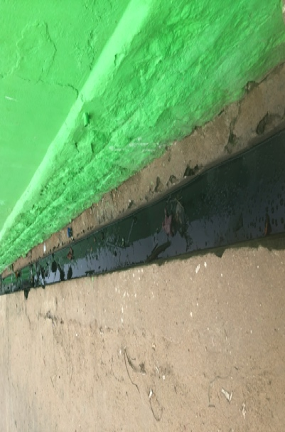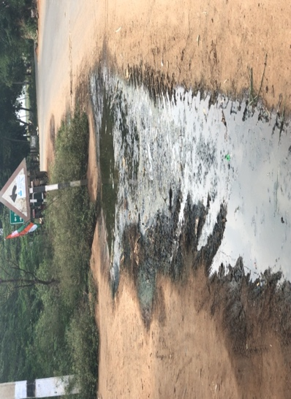
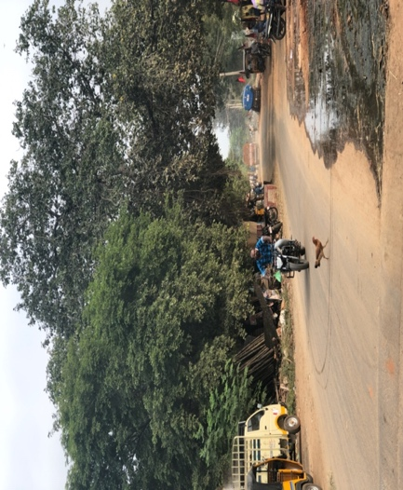

III.Biography:

Amudha Ondiveerappan completed MD at Windsor University School of Medicine at St Kitts & Nevis in 2007. Completing MPH in November 2020 at Walden University, located in Minneapolis, Minnesota. Born in New York City and living in Chicago, IL, since 2005.

IV. Presenting Author Details:

Full Name: Amudha Ondiveerappan

Contact Number: 312-869-0747

LinkedIn: https://www.linkedin.com/in/amudha-o-b66279174/

Category: (Oral presentation)

Passport Number: 522407715

