Abstract Template

Abstract
Malaria is one of the most dangerous disease for human which causing death of over than half million people annually which is 90% of them are children under five years of age in addition to pregnant women.
An important question needs a compelling logical answer; within the presence of both sensitive methods of laboratory diagnosis and an effective anti-malaria drugs; why still this large number of incidence and mortality in malaria cases.
To win the battle it is not enough standby equipment’s and own the strongest power but need management skills for both the time and the resources.
Therefore, establishing a logical and scientific algorithm for management of malaria cases is the best choice to decrease of the mortality numbers of deaths causes by malaria.
To establish and prepare an effective algorithm it must be taken in account a comprehensive knowledge and background about the life cycle for the malaria plasmodium parasite in the patient's body and what are the stages of the parasite appear in blood sample and what is the importance of each phase of these stages.
The issue of parasite counting and determination and estimated the parasitemia density and know what the border levels for the risk indicators as a quantity are or as a type.

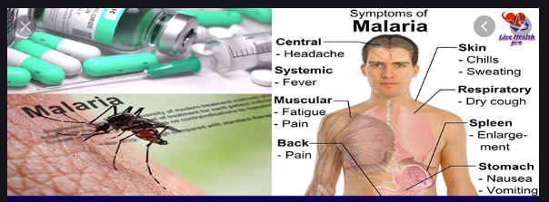

Reference:
- WHO Library Cataloguing-in-Publication Data
- Training module on malaria control: case management.
- ISBN 978 92 4 150397 6 (guide for participants) (NLM classification: WC 770)
- ISBN 978 92 4 150398 3 (guide for tutors)
- Algorithm for management of malaria – CDC.
Biography:
Mr. Atef Ali spent 40 years’ experience working in Malarial field. He has got the chance to work in both malaria laboratories departments, the entomological and the parasitological lab.
Mr. Atef is a member of the malarial technologist’s team who participated in the UAE national program for eradication malaria disease and assisted in the success of the program, which had been certified by WHO among announced the UAE is free of malaria transmission.
He is a trainer and a lecturer in malaria field and has got his own training programs, one for the medical laboratory technologists, providing a practical training for the microscopy diagnosis of Malaria parasites, while the other is opened for all technicians to learn the microscopy skills for identification the Anopheles species of larvae and adult mosquitoes, and both of the training courses are confirmed by the CME department at MOHAP.-UAE.
Mr. Atef Ali prepared two manual guide booklets for trainees in both aspects, the entomology and parasitology in malaria in addition for many articles and researches were published in some scientific international journals.
Mr Atef Ali also lecturer on other vector borne diseases and for many of infectious diseases for various society’s groups and medical staffs and he joined many medical conferences and participated as keynote speaker and conduct on Dubai-UAE on 6th November 2017 as the session chairman a scientific conference titled international healthcare and patient safety conference.
Presenting author details
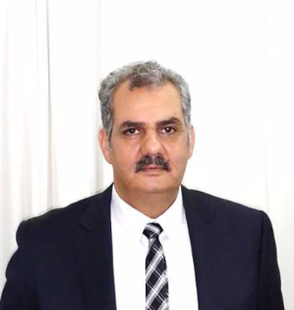
Full name: Atef Ali Kloub
Contact number:00971 56 4477982
Twitter account:NA
LinkedIn account: Atef Kloub
Category: (Oral presentation).

