Addressing Oral Systemic Inflammation via Bio-therapeutic Pharmabiome Intervention directed against Porphyromonas gingivalis
Peter Nara; Dan Sindelar and Marc Penn, Keystone Bio Inc., USA

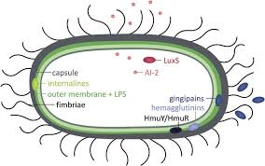
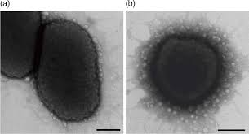
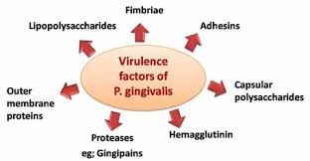
Abstract (300 word limit)
KEYSTONE BIO is a highly compact PharmaBiome company focused on the newly emerging oral-systemic healthcare market(s). More specificly the company is bringing a bio-therapeutic (“Prevevent_{tm}”-monoclonal antibody) through pre-clinical development and clinical trials. The biotherapeutic will address an unusaual disease paradigm of a single bacterial agent (Keystone pathogen) that following infection is capable of inducing a set of interelated multi-systems inflammatory disease processes throughout the body. A specific keystone bacterial pathogen (Porphyromonas gingivalis), of oral origin and community acquired over decades of life, plays a key role in the establishment of a chronic lifelong infection of the oral cavity-more specifically the subgingiva (gums). This infection leads to additional recruiting of other red complex anerobic bacteria that then form a poly-microbial dysbiotic biofilm that eventually after many years attack the gums and teeth locally. By this time the locally oral silent infection has progressed to visual gum disease it has been causing continuous major systemic vascular inflammation without fever and found assocaited with a multi-systems disease profile in humans (e.g. atherosclerosis, CVD/CAD, Alzheimer’s disease, stroke, NASH, TD-2 diabetes, esophageal, lung, colon and pancreatic cancers, glioblastoma and rheumatoid arthritis). The monoclonal has been shown in its first clinical study, a study designed to evaluate its role in periodontal disease, to be safe and highly effective in eliminating the bacteria with a few closely spaced oral topical treatments (INFECTION AND IMMUNITY, Vol. 64, No. 2 1996). The IgG1 monoclonal antibody is directed at the surface hemagglutinins of P. gingivalis and recognized by the antibody that include RgpA (Gingipain R1; also known as prpR1 or hemagglutinin HagE), Kgp (Lys-gingipain) and HagA (Hemagglutinin A). The phase 1 and 2 clinical trials will first address the well-defined area of its association of CAD/CVD.

Image

Recent Publications
- Ehrlich et. al. 2014 Journal of Applied Biomaterials and Fundamental Materials 12(1):e13-e20.
- Stein JM et. al. J Periodontol. 2009;80(10):1581-9.
- https://www.sciencedirect.com/science/article/pii/S2214762416300135
- J Oral Microbiol. 2015; 7:10.3402/jom.v7.27468
- V.Booth,1* F. P.Ashley,1and T. Lehner Infection and Immunity, Feb. 1996, p. 422–427 Vol. 64, No. 2.
- Front. Aging Neurosci., 24 October 2017 | https://doi.org/10.3389/fnagi.2017.00336

 Biography (150 word limit)
Dr. Nara is currently on of the co-founders, the Chief Scientific Officer and President Business Development for Keystone Bio Inc. in St. Louis, Mo., a Systemic-Oral Health Biomedical company that is targeting precision microbiome bio-therapeutics for the elimination of a specific oral bacterial associated with systemic inflammation. Former co-founder, President, Chairman and CEO (1997-2017)and now Chairman Emeritus at Biological Mimetics, Inc. and cofounder of Lantern Pharma Inc. and holds a M.Sc. in Immuno-pharmacology, a combined Doctor of Veterinary Medicine and Ph.D. (retro-virology/oncogenesis) from The Ohio State University, 4 year combined residency in Comparative Pathology and NIH post-doctoral Fellowship at the Armed Forces Institute of Pathology and a NIH respectively. Dr. Nara currently holds the Endowed Eugene Lloyd Chair, Professor in Vaccinology, founding Center Director for the Center for Advanced Host Defense, Immunobiotics, and Translational Comparative Medicine in the Department of Biomedical Sciences, in the College of Veterinary Medicine at Iowa State University, the Chief Executive Officer, President, Chairman & co-founder of Biological Mimetics, Inc.,. He is also an distinguished Alumni of The Ohio State University College of Veterinary Medicine 2014, and an elected Fellow of the American Association for the Advancement of Science in 2011.
Email:nara@keystonebio.com

Notes/Comments:

