Respiratory masks for infectious disease control and healthcare

Jinlian HU, Department of Biomedical Engineering,
City University of Hong Kong, Hong Kong
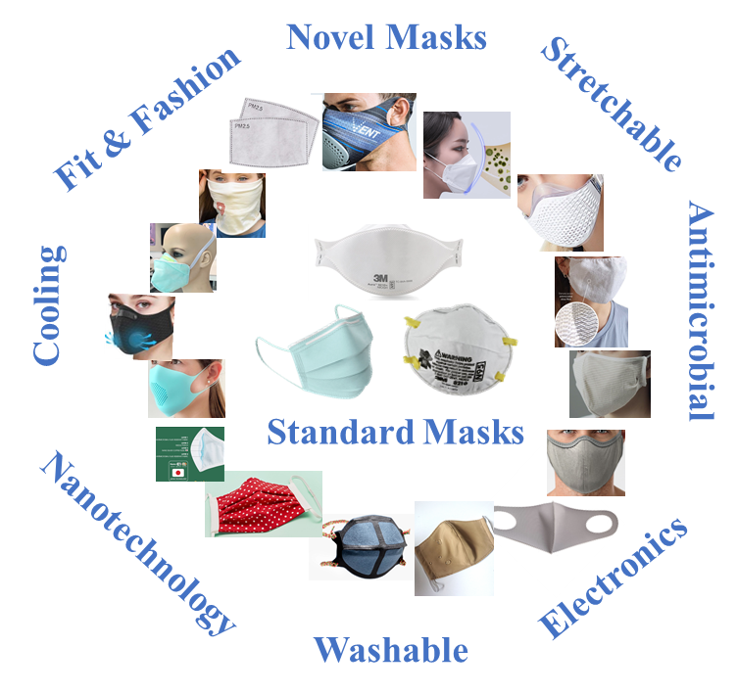

Abstract

Respiratory masks are the real frontline defence for medical workers and public during the time of this COVID-19 outbreak [1,2]. It plays a major role to prevent and lessen the chance of disease transmission from person to person in the form of aerosols or droplets [3]. Respiratory protective masks are usually used when uncontrollable airborne contaminants from gases, dusts, vapours, dusts, particulate and aerosols. These types of masks are usually used by professionals working in hospitals, industry, agriculture, mines, emergency responders, military, and household personnel. Respiratory masks help to protect the users based on physical or occasionally by chemical filtration mechanisms. The nature of barrier properties may interfere with human physiological performances which can even lead to severe life-threatening conditions. Current pandemic situation has spurred the demand of respiratory masks to new heights. As a result, a variety of unqualified or novel non-standard and claimed functional mask types appeared in market to meet the sudden demand. These masks can be commonly categorized as consumer masks as most of them fail to meet the professional standards for medical and occupational use. Most of these are not ameliorated to provide a perfect balance of protection and physiological comfort to the user (Fig. 1A). Most respiratory masks are simple in its appearance and designed to fit different type of users. However, being simple they can interfere with breathing, thermal balance, tactile sensations, eyesight, communication, psychological feelings, eating, sneezing and other equipment attached to body [4,5]. Existing literature only provides scattered/fragmented studies on facemasks performance of some old styles, but innovation needs knowledge and science in all sectors of the supply chain from materials, textile structure, performance and human physiology and ergonomics. On the other hand, even though current innovative masks offer wide range of novel properties, their ability to satisfy most essential requirements at acceptable levels remains unsolved. We are going to present the key issues for Respiratory masks for infectious disease control and healthcare and possible solutions

Image

Recent Publications
- Howard, J.; Huang, A.; Li, Z.; Tufekci, Z.; Zdimal, V.; van der Westhuizen, H.-M.; von Delft, A.; Price, A.; Fridman, L.; Tang, L.-H. Face masks against covid-19: An evidence review. 2020.
- 2. Prather, K.A.; Wang, C.C.; Schooley, R.T. Reducing transmission of sars-cov-2. Science 2020, 368, 1422-1424.
- 3. Chu, D.K.; Akl, E.A.; Duda, S.; Solo, K.; Yaacoub, S.; Schünemann, H.J.; El-harakeh, A.; Bognanni, A.; Lotfi, T.; Loeb, M. Physical distancing, face masks, and eye protection to prevent person-to-person transmission of sars-cov-2 and covid-19: A systematic review and meta-analysis. The Lancet 2020.
- 4. Johnson, A.T.; Grove, C.M.; Weiss, R.A. Mask performance rating table for specific military tasks. Military medicine 1993, 158, 665-670.
- 5. Johnson, A.T.; Weiss, R.A.; Grove, C. Respirator performance rating table for mask design. American Industrial Hygiene Association Journal 1992, 53, 193-202.



Biography:

Professor Jinlian Hu, from the City University of Hong Kong, received education in Textile Engineering and Materials with PhD from Manchester University, MEng, Donghua University and BEng, Wuhan Textile University. She is a pioneer, sustained and distinguished academic leader with world-wide impact in shape memory textiles (SMT) and has been very successful in securing research funding, averagely, around HK$6.5 million per year in the past 24 years. By applying shape memory materials, Prof. HU started biomaterials, medical and healthcare related activities more than 10 years ago. In addition to GRF projects, she obtained prestigious funding to support her initiatives on Novel Biomaterials for Bone, Nerve and Surgery applications from Central Chinese Government and succeeded as PI in Shenzhen Government first batch of largest Basic Research Fund for Intelligent Bone Repairing. The project has led to a spin-off company stationed in HK Science and Technology Parks.
Email: jinliahu@cityu.edu.hk

Notes/Comments

