1Abstract

The present study investigated Corona Virus(covid-19) in the United States on January 2020 the collected cases of a total on May 6,2020 is 1,193,813 new cases 22,303, total deaths 70,802 with new deaths of 2,523(CDC,2020). The Coronavirus Covid-19( SARS-CoV-2) is a positive sense, single-strand enveloped RNA virus that belongs to the family Coronaviridae. Seen under the microscope appears as a crown-like due to small bulbar projections formed by the viral spike (S) peplomers. Risk groups, Older age more than 65 years plus, males are more affected especially with critical illness COVID-19. Younger adults are also being hospitalized in the U.S from ages 20-44. New cases of Coronavirus in Children, syndrome can bear some resemblance to a rare childhood illness called Kawasaki disease, but as doctors learn more, they are emphasizing that the two conditions are not the same(Belluck,2020). In the US, Obesity appears to be emerging as a risk factor, BMI ≥ 30, in nearly half of hospitalized patients. Blacks appear to be hospitalized at a greater than expected frequency than expected on a population basis(Auwaerter,2020). If the SARS-Cov-2 will follow the traditional respiratory season with a decrease in the late spring and summer. Testing for the coronavirus, the first and most urgent focus is on increasing access to tests to diagnose people with current infections. But now other tests are appearing as well. Antibody tests, which can identify people with signs of past infection, are starting to be available. And a third type of test is on the way. The World Health Organization is closely monitoring the field of candidate Covid-19 vaccines, lists more than 100 projects, though many are being designed in academic laboratories without commercial production capacity. Of the total, eight are already being tested in people, four of them in China. Among the others is an RNA vaccine project being developed by Pfizer and partner BioNTech, which began testing four possible vaccines in a compressed Phase 1/2 trial in the U.S. on May 5,2020. The companies estimate they will be able to produce millions of doses this year, in facilities in the United States and Europe; by 2021, production could reach hundreds of millions of doses(Harris,2020). The focus of this Abstract and paper will be the vaccine for this virus and the new cases that are appearing in children.

II.Images

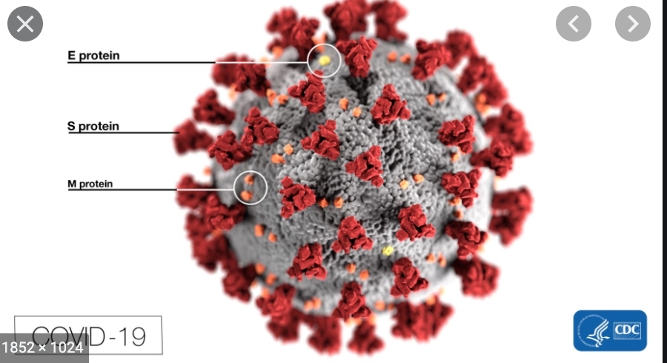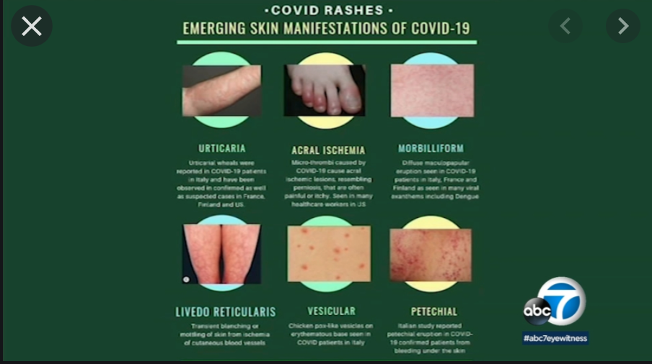

III.Biography
Amudha Ondiveerappan has completed her MD at Windsor University School of Medicine and will be completing her Master of Public Health (MPH) at Walden University, Minnesota in USA. She is enrolled in the National Society of Leadership and Success.

IV.Presenting author details

Full Name: Amudha Ondiveerappan
Contact number: 312-869-0747
Linkedin account: https://www.linkedin.com/in/amudha-o-b66279174/
Session Name: Corona Virus
Category: (Oral presentation)

References:
Auwaerter, P. G. (2020, May 6). Coronavirus COVID-19 (SARS-CoV-2): Johns Hopkins ABX Guide.Retrieved,May6,2020fromhttps://www.hopkinsguides.com/hopkins/view/Johns_Hopkins_ABX_Guide/540747/all/Coronavirus_COVID_19__SARS_CoV_2_

Belluck, P. (2020, May 6). A New Coronavirus Threat to Children. Retrieved May 6, 2020, from https://www.nytimes.com/2020/05/06/health/kawasaki-disease-covid-coronavirus-children.html

Centres for Disease Control and Prevention (CDC). (2020, April 29). Cases in the U.S. Retrieved May 5, 2020, from https://www.cdc.gov/coronavirus/2019-ncov/cases-updates/cases-in-us.html

Harris, R. (2020, May 1). How Reliable Are COVID-19 Tests? Depends Which One You Mean. RetrievedMay6,2020,fromhttps://www.npr.org/sections/healthshots/2020/05/01/847368012/how-reliable-are-covid-19-tests-depends-which-one-you-mean

