REVIEW ABOUT MULTIPLE SCLEROSIS

1Kalluri Vasavi and *,2Arumugam, P.
1Research Associate, Armats Biotek Training & Research Institute, India 2Director, Armats Bioteck Training & Research Insititute, Chennai, India

ABSTRACT

Key words:
Multiple Sclerosis, Demyleinating disease, Pathology, diagnosis, Drugs approved by FDA, Stem cell treatment, Monoclonal antibodies.

Multiple Sclerosis is an autoimmune and neurological disorder. The disease can be identified by some early signs and symptoms like numbness, confusion and many others. If neglected can lead to progressive development of disease where based on the stage the disease is classified into four stages. Pathology and pathogenesis of the disease is discussed. Certain drugs which are approved by FDA are used in treating MS. Other than these drugs few monoclonal antibodies are also used. Use of stem cells in treatment of MS is found to be successful in animal models. We mainly discuss about the treatment methods which are available in market and also of those under trials.

INTRODUCTION
- Secondary which includes severity of primary symptoms.

Multiple Sclerosis (MS) is a neurological disease of central nervous system which is a chronic auto immune disease and de-myleinating disease. Dr. Jean Martin Charcot was the first
- Tertiary is the stage psychological problems.
where people face social and

physician to describe, document and name this disorder in mid- 19th century. In a survey it was found that every year about one million people are diagnosed with Multiple Sclerosis but the distribution of the disease is not random. The disease is characterized initially with reversible neurological deficits followed by progressive neurological disorders which is known as clinically isolated syndrome (CIS). The specific cause for multiple sclerosis has not been identified. It appears to be caused due to genetic inheritance or can also be triggered
Neurologists have classified four major categories (Hauser SL,
Goodwin DS, 2008) based on the course or stage of the disease.

Relapsing Remitting Multiple Sclerosis (RRMS): This is the most common type of MS which affects about 85% people.

Secondary Progressive Multiple Sclerosis (SPMS): This is the continuation of RRMS and the time span between RRMS

by environmental factors. The disease is found to affect females than males in the age group between20 - 40. Early signs include lack of coordination, loss of balance, numbness and muscle weakness.

Symptoms are divided into 3 stagesas

  - Primary which is due to damage of myelin around the
and SPMS may be 18 - 19 years. Patients experience
neurocognitive decline.
Primary Progressive Multiple Sclerosis (PPMS): Found in 10 - 15% of people and is found to be resistant to the drugs used for treatment.

Progressive Relapsing Multiple Sclerosis (PRMS): It is very

nerves which leads to scarring where signalling
rare and affects less than 5% of population.

becomes a problem between brain and body. This leads to loss of balance, vision problems and numbness.

Pathology
Demyelinated plaques with inflammatory infiltrates consisting of macrophages and lymphocytes is the pathological hallmark of Multiple Sclerosis. Axonal loss and glial fiber production is

another important pathological feature
of MS. Recent
Type I accounts for 19% of lesions and demyleination is

discovery includes study regarding histopathology of MS. The study revealed that there was variability of lesions in different individuals with respect to neuro axonal injury and demyleination. About four different patterns were observed in the study (Lucchinetti et al., 2000).
mediated directly by macrophages or by macrophage toxins. It is T cell mediated.
Type II is mediated by antibodies and by T-cells and accounts for about 53%. Demyleination is due to specific antibodies and complement system.
Type III accounts for 26% and degenerative changes occur

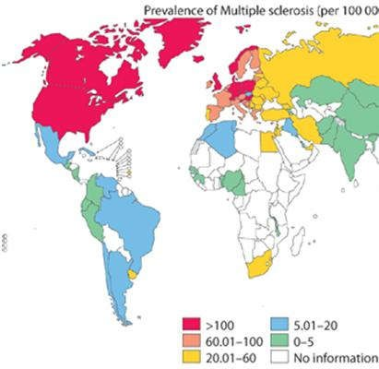which is followed by oligodendropathy.
apoptosis. This is related to

Type IV is for 2% of lesions and results from oligodendrocyte damage which is followed by secondary demyleination.
Another supporting evidence about MS lesions is neuroaxonal damage which has major impact on permanent neurologic deficits (Trapp BD, Ransohoff R, Rudick, 1999). The attack is triggered by myelin reactive T cells which leads to increase release of free radicals and nitric oxide by microglial cells leading to myelin breakdown. Increased concentration of the free radicals and nitric oxide mediate axonal injury by mitochondrial injury where energy depletion occurs and can be
prevented by sodium channel blockers. Another mechanism

Figure 1
found was increased level of glutamate in MS lesions which leads to cell mediated cytotoxicity.

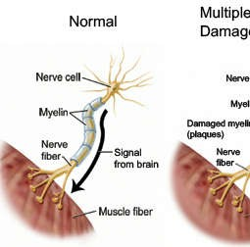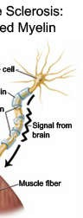Pathogenesis
Here, auto reactive peripherally activated CD4 T cells

recognize the antigens within CNS parenchyma of MHC-II
complex which are expressed by glial cells and dendritic cells

where TH1 phenotype is phenotype which is formed
formed (Hafler, 2005). The causes myelin disruption and

release of new CNS autoantigens. B-cells which amplify tissue
injury are found at the site due to interferons and tumor
necrosis factor (Link, 1998). This leads to the formation of
lesions. Even CD8 cells are also found to play a role in

Figure 2

Figure 3.
formation of lesions and leads to acute axonal injury leading to MS. T cells are activated in CNS by foreign microbes and microbial superantigens. These cells express integrins which bind to the surface of endothelium through adhesion molecules which then pass through extra cellular matrix which involves matrix metallo proteases. mmp plays an important role in proteolysing myelin components of MS. Other cells involved in the process are microglial cells, lymphocytes and macrophages which release excessive amount of glutamate, thus causing necrotic damage to oligo-dendrocytes and axons (Steinman, 2001).

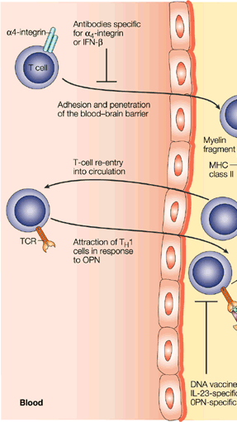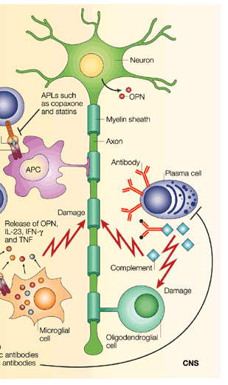
Pathogenesis mechanism
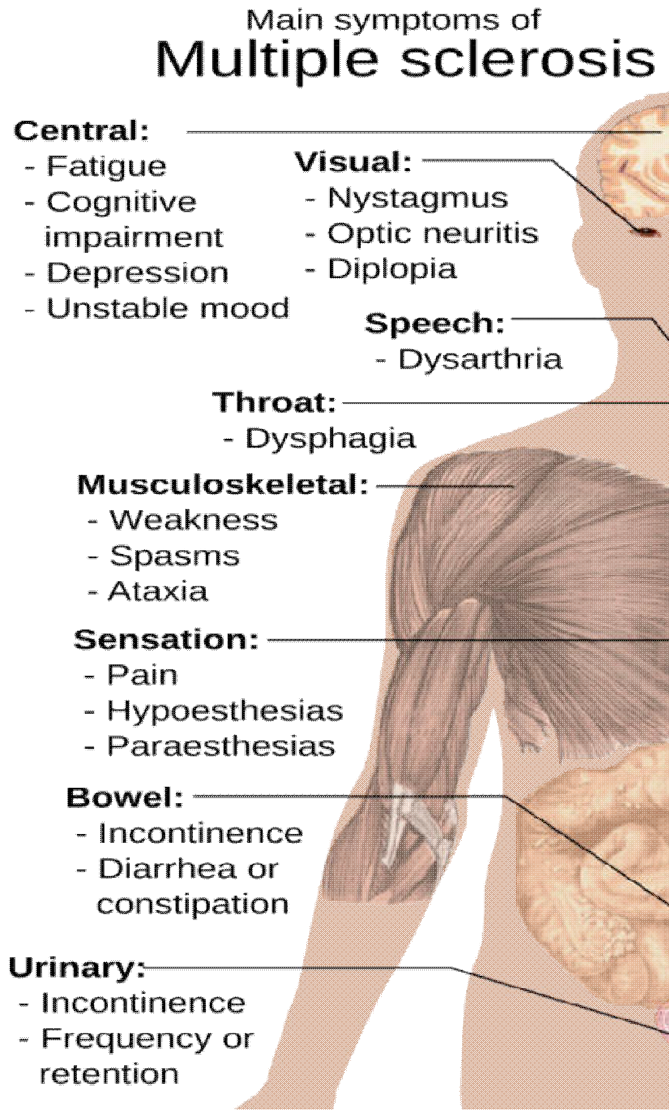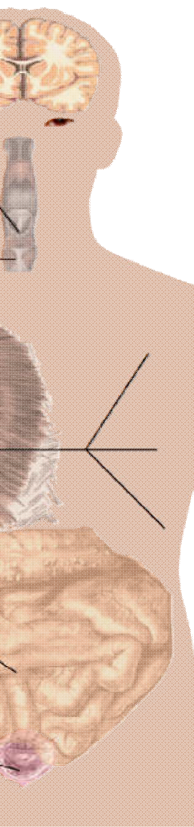Figure 4.
Symptoms of Multiple Sclerosis

Treatment

Acute relapses are treated using corticosteroids (Inglese, 2006) which reduce inflammation and enhances nerve conduction. Some drugs have been approved by FDA for treatment of RRMS and are

S.No Brand Drug

- Avonex Intramuscular β Interferon-1a
- Rebif Subcutaneous β Interferon-1a
- Betaseron Subcutaneous β Interferon-1b
- Copaxone Glatiramer acetate

Avonex is manufactured by Biogen Idec and Rebif manufactured by Pfizer have mode of action much similar to Betaseron whose mechanism is not completely known. Viral replication is inhibited through these drugs through antiviral and immunomodulating activities (Dhib-Jalbut S, Marks S, 2010).

Betaseron is given to patients with first level of symptoms. It is given to reduce the relapses in MS and was found to decrease the disease. The exact mechanism of action is not known. During trials which was double blinded it was observed that administration of Betaseron has reduced inflammatory lesions by 50% - 80%. Although betaseron was found to enhance life people were at risk for thyroid diseases, leucopenia and liver abnormalities. So they had to monitor liver enzymes like alanine amino transferase (ALT), aspartate amino transferase (AST) and white blood cell (WBC) count periodically during the initiation of treatment (Cree BAC, 2007).

Copaxone is glatiramer acetate produced by Teva which is a synthesized copolymer polypeptide mixture of L-glutamic acid, L-lysine. L-alanine and L-tyrosine. The drug mimics and competes with basic myelin protein and is delivered subcutaneously and was found that 20mg/day has reduced the occurrence of the RRMS. Precise mechanism is not known and in invitro studies and animal studies it was found upon administration of the drug T cells are activated. This is administered as a first line medication to people with RRMS and also given to patients who are intolerant to Beta interferons. In study it was observed that there was reduced inflammation on administration (Comi G, Filippi M, Wolinsky JS, 2001).
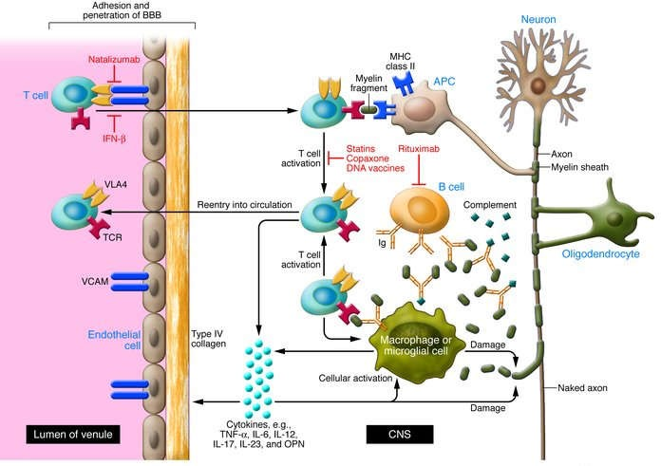
Figure 5.
Monoclonal Antibody based drugs are also available for the treatment and one such is Natalizumab. Natalizumab is recombinant immunoglobulin monoclonal antibody (IgG4) manufactured by Biogen Idec. The specific mechanism was not known. It binds to α-4 subunit of integrins which are expressed on the surface of leucocytes and inhibits the adhesion of leucocytes. FDA has approved this drug based on the results obtained during trials which included double blind trials with more than 2000 patients. And was found that the drug reduces the attack.

Dalfampridine is another formulation which has sustained release of 4-aminopyridine. The drug acts by blocking potassium channels on the surface of nerve fibers. This improves the conduction of nerve signals in fibers where myelin coat has been damaged due to disease. When overdosage is administered it can cause seizures and includes nausea, weakness, back pain, balance disorders and urinary tract infections. There are also some drugs which are in developmental phase in curing MS.

Laquinimod is produced by Teva /Active Biotech which is orally active, synthetic small molecule which affects immune system (Bruck W, Wegner C, 2011). There was an increase in synthesis of neuroprotective molecules (Tselis, 2010). In trials when people administered, it was detected that there was significant reduction statistically when compared to people who were given placebo. It was perceived that there was reduction in risk of disability progression by 36% and brain atrophy by 33%.

Teriflunomide developed by Aubagio, Sanofi is the active metabolite of leflunomide is an immunomodulating drug. Mechanism involves de novo synthesis of pyrimidine by blocking dihydroorotate dehydrogenase (DHODH) which is mitochondrial enzyme. Due to this blocking there is cytostatic effect on B and T cells (Gold and Wolinsky, 2011).

Ocrelizumab is human monoclonal antibody which targets CD-20 and is developed by Roche (Kappos et al., 2011). In results obtained during trials which were randomized and double blinded for about 218 adults after 24 months they observed that there was reduce in number of brain lesions.

Recent advancement in treating MS includes the use of mesenchymal stem cells (MSCs) and Induced pluripotent stem cells. They can modulate autoimmune response in CNS and promoted endogenous remyleination and repair process in animal models (Juan Xiao, 2015). MSCs are used mostly for their neurotrophic, immunosuppressive, immunomodulatory and repair mechanisms.

Immunosuppressive mechanism of MSCs is elucidated below. It was found experimentally that many factors like IFN-γ, TNF-α, IL-10, HGF, IL-6, PGE2 were secreted upon injection of MSCs. MSCs were found to enhance the function of neuronal axons, astrocytes and oligodendrocytes. The mechanism involves several cells involved in pathogenesis like macrophages, T cells and B cells.

Gaps in Research

The exact reason and mechanism for the cause of the disease has not been still clearly understood and research is in progress to find the exact mechanism of MS. Coming to treatment

researchers are trying to use stem cells to cure the disease and research is going on in animal models. There is a big gap in diagnosis of the disease. No perfect method has been found in diagnosing the disease. There is no single diagnostic test for MS (Hauser SL, 2008). Diagnosis is performed by the evidence of two different lesions in white matter of CNS or by chronic inflammation of CNS. In some cases autopsy has to be performed for confirmation of disease.
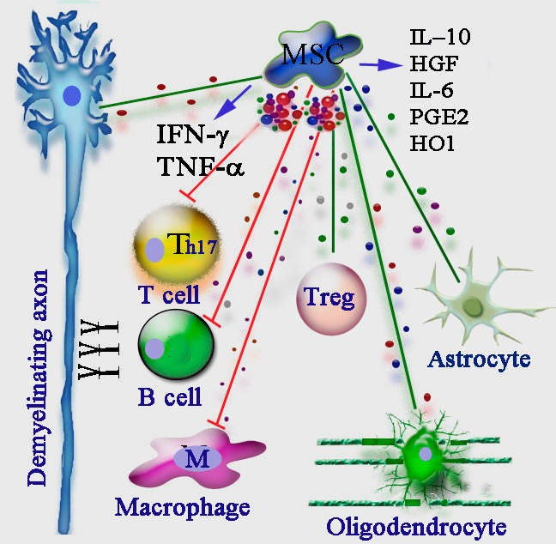

Figure 6.

Future directions

Future directions includes the use of much more monoclonal antibodies which are in developmental phase at a considerable cost to people through recombinant technology. There is also scope for the use of different stem cells like mesenchymal stem cells and induced pleuripotent stem cells which are derived from embryonic stem cells. Studies indicate that the use of stem cells was found to be successful in animal models. On conformation of disease i.e., during diagnosis if non invasive techniques are found it will be good add on in diagnosing the disease.

REFERENCES
Ampyra™ (dalfampridine), prescribing information. Hawthorne, N.Y.: Acorda Therapeutics, Inc.; January 2010. Brück W, Wegner C. Insight into the mechanism of
Laquinimod action. J Neurol Sci 2011; 306:173–179.
Comi, G., Filippi, M., Wolinsky, J.S. 2001. European/Canadian multicenter, double-blind, randomized, placebo-controlled study of the effects of glatiramer acetate on magnetic resonance imaging: Measured disease activity and burden in patients with relapsing multiple sclerosis. Ann Neurol., 49:290–297.
Cree, B.A.C. 2007. Multiple sclerosis. In: Brust JCM, ed. Current Diagnosis and Treatment in Neurology. New York: Lange Medical Books/McGraw-Hill Medical.
Dhib-Jalbut, S., Marks, S. 2010. Interferon-beta mechanisms of action in multiple sclerosis. Neurology., 74(Suppl 1):S17–S24.
Gold, R., Wolinsky, J.S. 2011. Pathophysiology of multiple sclerosis and the place of Teriflunomide. Acta Neurol Scand.,124:75–84.
Hafler, D.A., Slavik, J.M., Anderson, D.E., et al. 2005.
Multiple sclerosis.Immunol Rev., 204:208–231
Hauser, S.L., Goodwin, D.S. 2008. Multiple sclerosis and other demyleinating diseases. In: Fauci AS, Braunwald E, Kasper DL, Hauser SL, eds. Harrison’s Principles of Internal Medicine, vol. II, 17th ed. New York: McGraw- Hill Medical., 2611–2621.
Inglese M: 2006. Multiple Sclerosis: New Insights and Trends, AJNR 27 May, www.ajnr.org
Juan Xiao, Rongbing Yang ,Sangita Biswas, Xin Qin, Min Zhang and Wenbin Deng : Mesenchymal Stem Cells and Induced Pluripotent Stem Cells as Therapies for Multiple Sclerosis, Int. J. Mol. Sci. 2015, 16, 9283-9302.
Kappos, L., Li, D., Calabresi, P.A., et al. 2011. Ocrelizumab in relapsing remitting multiple sclerosis: A phase 2, 378:1179–1787.
Link, H. 1998. The cytokine storm in multiple sclerosis. Mult Scler., 4:12–15
Lucchinetti, C., Bruck, W., Parisi, J., et al. 2000. Heterogeneity of multiple sclerosis lesions: implications for the pathogenesis of demyelination.Ann Neurol., 47:707–17
Steinman, L. 2001. Multiple sclerosis: a two-stage disease. Nat Immunol., 2: 762–64
Trapp, B.D., Ransohoff, R., Rudick, R. 1999. Axonal pathology in multiple sclerosis: relationship to neurologic disability.Curr Opin Neurol., 12:295–302
Tselis, A. 2010. Laquinimod, a new oral autoimmune modulator for the treatment of relapsing–remitting multiple sclerosis. Curr Opin Investig Drugs., 11:577–585.
Tysabri® (Natalizumab), prescribing information. Cambridge, Mass.: Biogen Idec; September 2011. Available at: www. tysabri.com/ en_US/tysb/site/pdfs/TYSABRI-pi.pdf.

*******

