Immune landscape in patients with IBD
Hong Liu, PhD, Takeda Pharmaceuticals, Cambridge, MA USA

Abstract (300 word limit)

Myeloid cells, especially mononuclear phagocytes, which include monocytes, macrophages and dendritic cells (DC), play vital roles in innate immunity, and in the initiation and maintenance of adaptive immunity. While T cell-associated activation pathways and cytokines have been identified and evaluated in inflammatory bowel disease (IBD) patients, the role of mononuclear phagocytes are less understood.

We performed in silico analysis and evaluated the enrichment of immune cells, with a focus on mononuclear phagocytes in IBD patient colonic biopsies. Samples were from different gut locations, with different levels of disease severity, and with treatment response to current therapies. We observe enrichment of monocytes, M1 macrophages, activated DCs and plasmacytoid DCs in inflamed tissues from various gut locations. This enrichment correlates with disease severity. Additionally, the same mononuclear phagocytes subsets are among the top enriched cell types in both infliximab and vedolizumab treatment non-responder samples. We further investigated the enrichment of selected DC and monocyte subsets based on gene signatures derived from a DC- and monocyte-focused scRNA-seq study; and verified enrichment in both inflamed tissues and those with treatment resistance. Moreover, we validated an increased mononuclear phagocyte subset abundance in a Dextran Sulphate Sodium induced colitis model in C57Bl/6 mice representative of chronic inflammation.

We conducted an extensive analysis of immune cell populations in IBD patient colonic samples and identified enriched subsets of monocytes, macrophages and dendritic cells in inflamed tissues. Understanding how they interact with other immune cells and other cells in the colonic microenvironment such as epithelial and stromal cells will help us to delineate disease pathogenesis.
Image
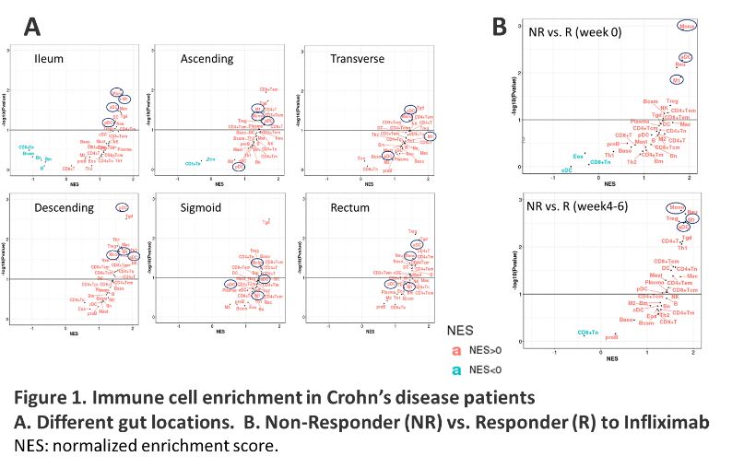
Recent Publications (minimum 5)
- Liu H, Dasgupta S, Fu Y, Bailey B, Roy C, Lightcap E, Faustin B (2019) Subsets of mononuclear phagocytes are enriched in the inflamed colons of patients with IBD. BMC Immunol. 20:42.
- Liu H, Liu J, Toups M, Soos T, Arendt C (2016) Gene signature-based mapping of immunological systems and diseases. BMC Bioinformatics 17:171.
- Aran D, Hu Z, Butte AJ (2017) xCell: digitally portraying the tissue cellular heterogeneity landscape. Genome Biol. 18:220.
- Villani AC, et al. (2017) Single-cell RNA-seq reveals new types of human blood dendritic cells, monocytes, and progenitors. Science 356:6335.
- Martin JC et al. (2019) Single-Cell Analysis of Crohn's Disease Lesions Identifies a Pathogenic Cellular Module Associated with Resistance to Anti-TNF Therapy. Cell 178: 1493.

Biography (150 word limit)
Dr. Hong Liu is an associate director of computational biology in Takeda. She has extensive industry experience in management of research projects and their translation to development, in the fields of target identification and validation, indication evaluation, as well as biomarker discovery for patient stratification and translational science strategies. Dr. Liu has developed gene signature-based analysis and built modular ‘biomap’ which reveals the linkages between different diseases and immune subtypes and provides evidence for the presence of specific immunocyte subsets in mixed disease tissues. One of her current publication is to deconvolute immune cell contexture in biopsies from IBD patients. Both in silico analyses and mouse model validation showed elevated immune cells, especially mononuclear phagocytes in inflamed colon mucosa biopsies. In addition, distinct cell type patterns were observed in patients with response vs. resistance to current biological therapies.
Email: hong.liu@takeda.com

Notes/Comments:

