A Case for the Future of The Hospital: Rethinking of Healthcare Roles from First Principle Thinking Perspective
Malak Halawy, MPH, AUB - Lebanon

Abstract (300 word limit)
Statement of the Problem: Hospitals, and the healthcare system, has evolved into a complex multifaceted structure that spans different stakeholders with various interests. This fact seems like the starting point of many presentations, conferences and academic papers to later span into promises of better electronic records adoption, better reimbursement mechanisms, and breakthrough disruptions in form of mobile apps and stylish wearables. In This presentation we will examine the obvious inefficiencies¹ that healthcare is suffering from. We will also pinpoint the theoretical models^{2,4} presented to solve these problems, then we will zoom out and see how these models contributed positively and how they failed to reform in the core of the healthcare conundrum³. Finally, we will introduce a future-looking model of healthcare that is based on first principle thinking adopted by pioneers on the new century, and which made them cause real disruptions in other disciplines. This will lead into a brave suggestion , a total reshape of the concept of healing which goes across medical education , the roles involved in delivering care⁵, the interactions of these roles to diagnose, treat and monitor patients’ health.

Image
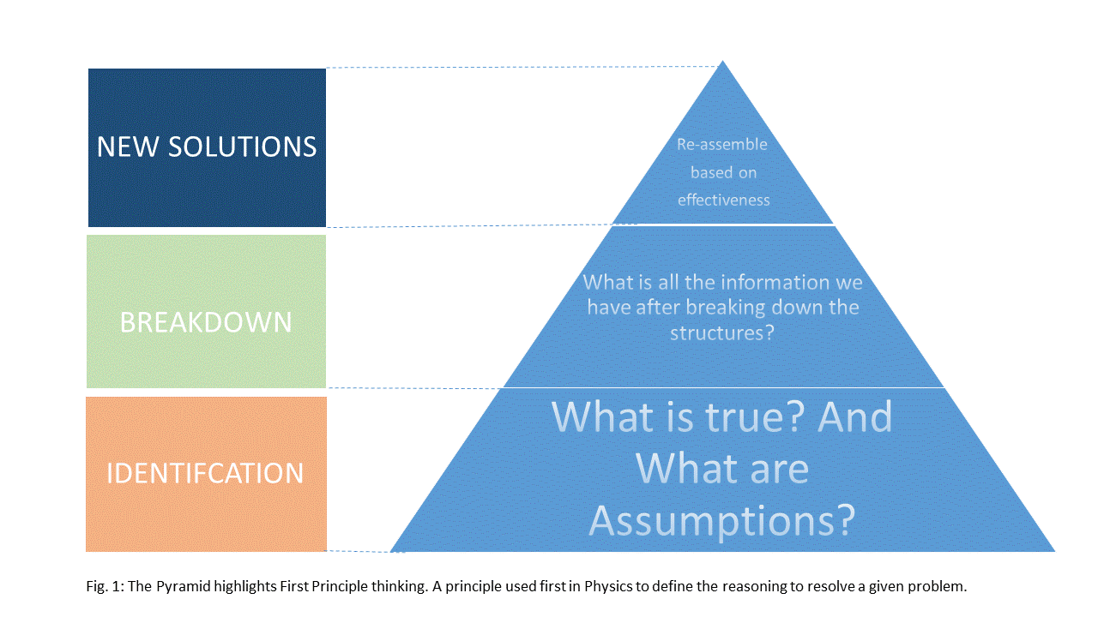
Recent Publications (minimum 5)
- Amitabh Chandra, Douglas O Staiger, Identifying Sources of Inefficiency in Healthcare, The Quarterly Journal of Economics, Volume 135, Issue 2, May 2020, Pages 785–843, https://doi.org/10.1093/qje/qjz040
- Mkanta, William N. PhD; Katta, Madhuri BDS; Basireddy, Karthika BDS; English, Gary PhD; Mejia de Grubb, Maria C. MD Theoretical and Methodological Issues in Research Related to Value-Based Approaches in Healthcare, Journal of Healthcare Management: November 2016 - Volume 61 - Issue 6 - p 402-418LiX
- Putera I. Redefining Health: Implication for Value-Based Healthcare Reform. Cureus. 2017;9(3):e1067. Published 2017 Mar 2. doi:10.7759/cureus.1067
- Miller HD. From volume to value: better ways to pay for health care. Health Aff (Millwood). 2009 Sep-Oct;28(5):1418-28. doi: 10.1377/hlthaff.28.5.1418. PMID: 19738259.
- Jin, Y., Wang, H., Wang, D. et al. Job satisfaction of the primary healthcare providers with expanded roles in the context of health service integration in rural China: a cross-sectional mixed methods study. Hum Resour Health 17, 70 (2019). https://doi.org/10.1186/s12960-019-0403-3

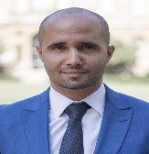Biography (150 word limit)
Malak Halawy has his expertise in Hospital operations and a passion in improving the health systems and healthcare conceptual framework. He is a Clinical Department Administrator in one of the oldest and most distinguished hospitals in the Middle East, the American University of Beirut Medical Center. He mentored academic students and was pivotal in merging different disciplines with healthcare management. His methods were aimed at improving and disrupting the current mold of healthcare inefficiency, citing innovations and new models of thinking as the way for future healthcare
Email: malakhalawy@gmail.com

