Remote consultation in eUPHC and its implications for Human Resources for Health and Universal Health Coverage: The experience of eUPHC model
Key Words: Universal Health Coverage, Electronic Medical Records, Electronic Urban Primary Health Center (eUPHC), Human Resources for Health, Universal Health Coverage, Out Patient (OP)
Human resources are one of the critical requirements for delivering quality services to patients. In India lack of specialist consultants is an impeding factor for providing curative services to a vast population where the density of physician per 1000 population is at low 0.758 as compared to its neighboring states 0.881 Sri Lanka, 0.978 Pakistan and 1.812 China.
The eUPHC project is a Government of Andhra Pradesh initiative operated by Apollo Tele Health services in 182 UPHC. Basic general examination, history and vitals are taken by the paramedics and data is entered electronically. Further, onsite OP consultation, remote inventory management, laboratory and pharmacy services is provided by the staff. To understand the implications of the model, this study is compared with the existing UPHC human resources and service provision. In eUPHC model provision of free tele-consultation with specialist consultants including General Medicine, Cardiologist, Endocrinology and Orthopedics to ensure timely and adequate treatment to the underprivileged community, if not remain untreated due to lack of services. Also, two Biochemist is ensuring tele-monitoring of 182 laboratory services. It is observed that, there is increase in patient consultations and improved treatment outcome like control of diabetes, hypertension and Upper Respiratory Tract Infection. eUPHC model has a great potential to address increasingly strained human resources for health by ensuring specialist consultants for underprivileged urban community with standard treatment. In the backdrop of Universal Health Coverage, telemedicine is a groundbreaking solution to provide comprehensive health care without exposing one to financial hardship.
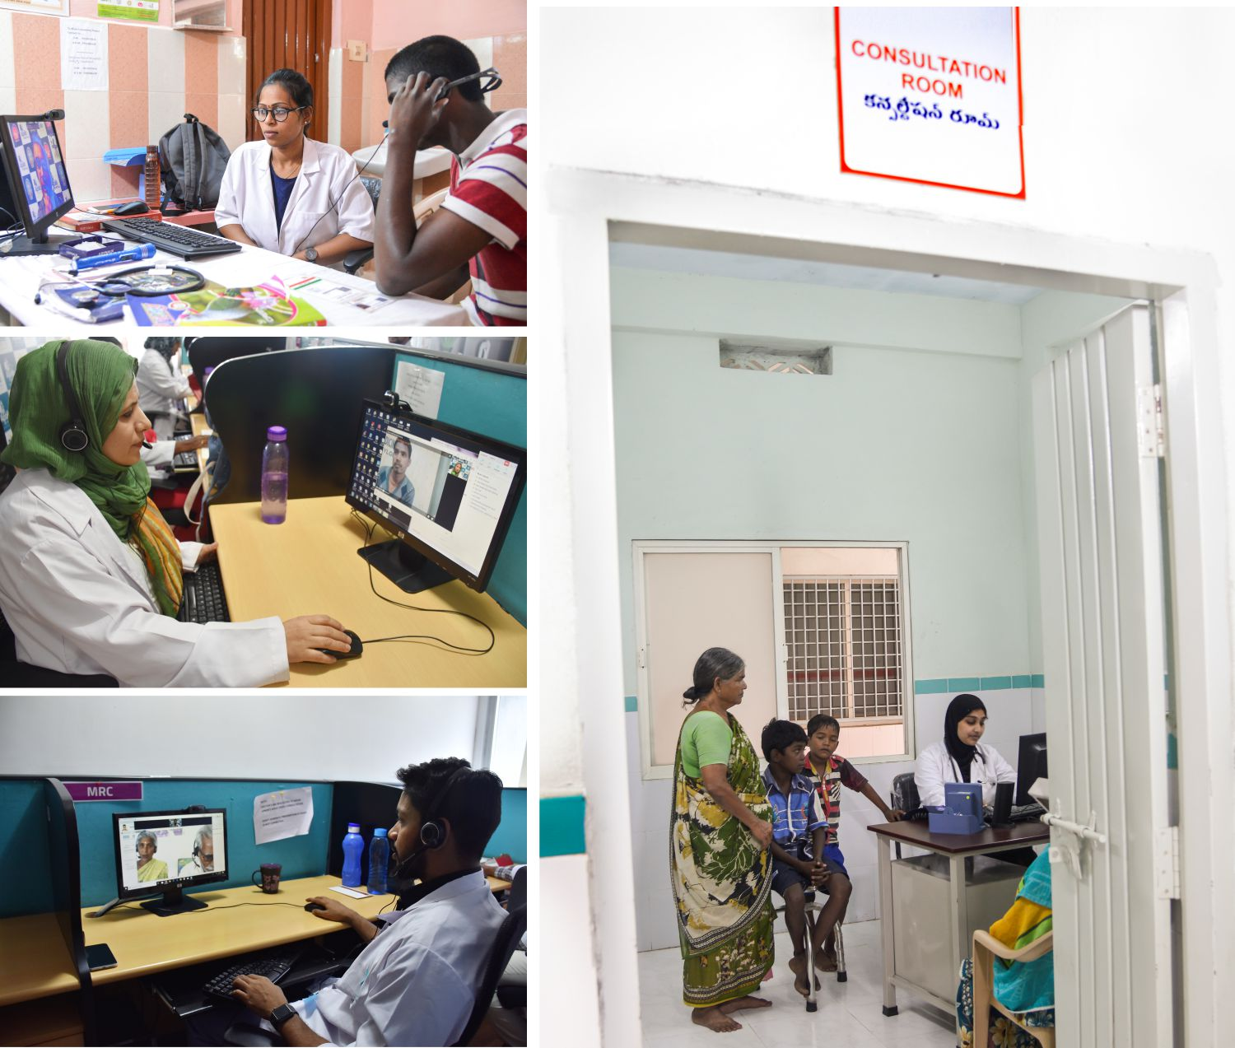
Reference:
- Rimsza, Mary & Hotaling, A.J. & Keown, M.E. & Marcin, James & Moskowitz, William & Sigrest, T.D. & Simon, H.K.. (2015). The Use of Telemedicine to Address Access and Physician Workforce Shortages. Pediatrics. 136. 202-209. 10.1542/peds.2015-1253.
- WHO. (2016). Global Data. Retrieved from Density of physicians (total number per 1000 population): https://www.who.int/hrh/resources/en/
Biography:-
Mr Vikram Thaploo,CEO, Apollo TeleHealth (Apollo Hospital Group, India), has about two decades of industry experience. He has an Advanced Healthcare Management Professional from Indian School of Business with a Post-graduation in Marketing and a graduation in Management
Author details
Full Name -Mr Vikram Thaploo
Contact Number- +91-7893000221, +91-9811901707
Twitter Account- @vikramthaploo
Linkeldn Account- linkedin.com/in/vikramthaploo
Session name/number- Telemedicine
Category- Oral Presentation
Passport Number- R2041316

