The Hospital & The Elephant: A Pre-Commissioning Story
George Schutte
B. Com (University of Pretoria, South Africa)
LLB (University of Pretoria, South Africa)
MBA (cum laude) (University of Stellenbosch, South Africa)

Abstract (300 word limit)
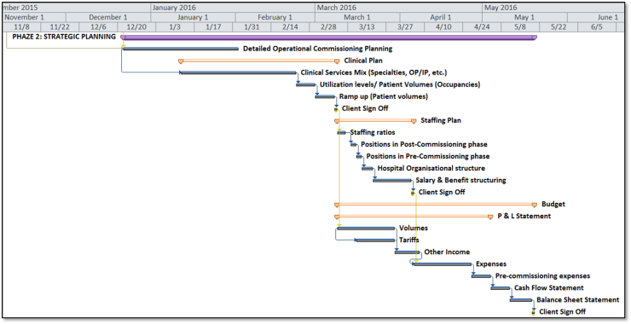
A new Hospital project is always a very challenging journey (to say the least)!
Experience has shown that one such critical element for the success of a new Hospital project is the Pre-Commissioning period; and more specifically PLANNING for this phase. Often the Construction Pre-Commissioning planning is dealt with sufficiently.
However, Planning for the OPERATIONAL Pre-Commissioning activities is often underestimated and therefor neglected.
The result being: always a frustrated team, usually unnecessary delay in the opening, and, most often, over budget.
One criterion for a project to be regarded as successful is the 1,000+ OPERATIONAL actions & activities which need to be sufficiently attended to by the Operational Team. An example of these activities ranges from documentation and staffing to implementing of committees and governance. “Comprehensive” and “organized” are two key characteristics of these activities. The adventure starts from the original vision of the owner and continuous up until the date-of-first-patient. Not only must we attend to these activities but we must also address them in a synchronized manner, with specific time periods allocated to them.
The responsibility to manage this process lies not with the construction project team, but with the OPERATIONAL team. We often feel that this task is boring and tedious. Though, it can be stimulating and fulfilling, íf we: keep it SIMPLE; use suitable TOOLS; COMMUNICATE well; involve the whole TEAM; apply sufficient KNOWLEDGE; (and have FUN).

Image

Recent Publications Hospitals (minimum 5)
- China- Unicare International Hospital (Greenfield project in Haikou)
- China- Specialized Hospital (Greenfield project in Beijing)
- Thailand- Specialized Hospital (Greenfield project in Bangkok)
- UAE- Dar Al Shifa Private Hospital (Greenfield project in Abu Dhabi)
- UAE- Al Reem Private Hospital (Greenfield project in Abu Dhabi)



Biography (150 word limit)
George Schutte, South African by nationality, has 25+ years’ experience in the private hospital space. He started his career in South Africa in the Banking Industry. George then joined Mediclinic Southern Africa as a Hospital Director for 18 years. Thereafter he served as a consultant for greenfield hospital projects in South Africa and Namibia.This experience equipped him to relocate to the UAE, where he served as CEO of various hospitals for a few of years, before joining VAMED as a project leader for the Pre-Commissioning Hospital Operational phase of VAMED’s projects in the Middle East; and more recently also in Thailand, Nepal & China. Currently George resides in Haikou, China.

Qualifications: George obtained a MBA (cum laude) from the University of Stellenbosch Business School in South Africa. He also qualified with a LLB (law) and a B Com (Commercial) degree, both from the University of Pretoria.
Email: gt.schutte@gmail.com george.schutte@vamed.com

Notes/Comments:

