Title: MALE AND FEMALE CONDOM AND OTHER PHYSICAL BARRIERS AMONGST ADOLESCENTS AND YOUNG PEOPLE IN KADUNA STATE, NIGERIA.
ORGANIZATION: African Network of Adolescents and Young Persons Development (ANAYD) and Association of Positive Youth Living with HIV in Nigeria (APYIN).

Keywords: Sexual Active, Condom.
Background: Low use of condoms has create a heavy burden to mitigating the spread of new HIV infection Among Adolescent and Young persons. HIV Prevalence in Kaduna state is seen at 2.2 and at the North Central zone 5.4 in 2016. This study aim at assessing vulnerabilities that lead to low use of condoms and barriers that made it so.

Methods: A study comprising of 115 young person's age 20-24yrs(65 males and 50 females) of different ethnic background, was conducted in November 2016, in Kaduna South LGA of Kaduna state, North West Nigeria. A mixed method approach was employed involving using self-administered questionnaires and in-depth interview to elicit information on the use of condoms. data were analyzed using descriptive statistic.

Results:
- 80% of males and 70% females, age 20-24yrs were sexually active
- High sexual risk was at 75% in the females and 40% in the males.
- Comprehensive knowledge of male and female condoms: only 50 % of males have seen a male condom and 18% of females have ever seen a female condom.
- Condom use among sexually active: only 20% of males have use condom in the last 3 month and only 4% females have use female condom in the last 3 month.

Factors associated with findings were: Poor condom awareness, condom access not youth friendly, female condom not pleasurable and good in sight, size of condom not friendly to some males, religious belief, and fear of been stigmatize by partners.
Conclusion: Male and female condoms are services we most provide to the young ones in other to reduce New spread of HIV infection, Low access and use of condoms will create more burden rather than solution to health of our young ones . Therefore efforts aimed at addressing the above factors will greatly impact on quality of HIV treatment, care and support.
- Image:

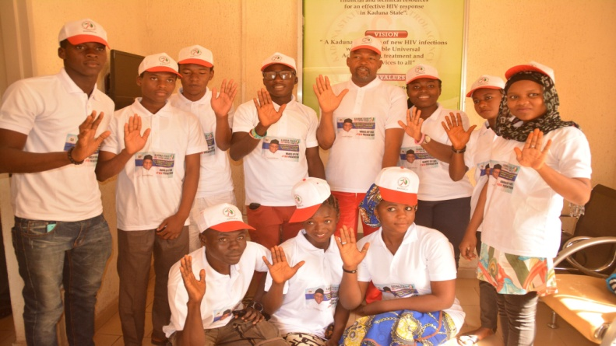

- Reference:
1: National AIDS Reproductive Health Survey (NARHS) Read more: https://www.naija.ng/9576.html#6710
- Biography:
Haruna Aaron Sunday has completed his Biology and Computer Science National Certificate of Education (NCE) at the age 25years from Federal College of Education Zaria, Kaduna State, Nigeria. He is the West Africa Board Representative for Africa Young Positive Network (AY+). Aaron is also the Founder of African Network of Adolescents and Young Persons Development (ANAYD) and Kaduna State Coordinator of Adolescents and Young Persons Living with HIV for Association of Positive Youth Living with HIV in Nigeria(APYIN).
Aaron is a highly sort after panelist, conference speaker, abstract presenter and consultant on adolescents and young persons in Africa. He has served as panelist, abstract presenter and speaker on different forum both at the national and International events including the just concluded YPlus Summit in Kampala Uganda and the forthcoming International HIV Adolescents workshop in Cape Town South Africa and International Family Planning Conference Kigali Rwanda.

- Presenting author details


Full Name: HARUNA AARON SUNDAY
Contact number:+2348164317505
Twitter account: @Real_aaronzy
Linked In account: Aaron Sunday
Session name/ number:
Category: (Poster presentation)
Passport Number:A50389862

