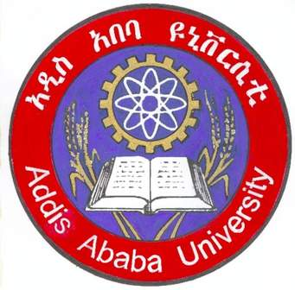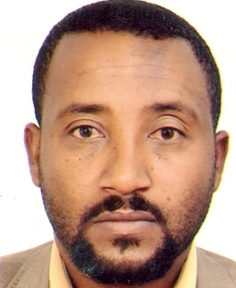

ADDIS ABABA UNIVERSITY, COLLEGE OF EDUCATION AND BEHAVIORAL STUDIES

EXAMINING HIV/AIDS RELATED RISK BEHAVIOR EXPERIENCES OF MEN HAVING SEX WITH MEN (MSM) IN ADDIS ABABA

Dr. Abebaw Minaye (Addis Ababa University, Ethiopia)

And

Mr. Girma Tamiru (MA in Social Psychology, Post graduate fellow
at Yonsei University, South Korea)

May, 2014
Addis Ababa, Ethiopia

Abstract

The aim of this study was to explore risky sexual behaviors from experiences of MSMs in Addis Ababa, to inform the need to include these people to HIV preventive efforts in the country. Using phenomenological method I met 21 MSMs and 4 elite experts working in the area of MSM from Addis Ababa. Fifteen MSMs and the four experts reported their experiences about the topic through in-depth interview. The rest 6 MSMs shared with me their lived sexual lives in group discussion. In addition, I observed this community at four different real life situations, at Khat chewing ceremony, in the night clubs, at engagement and birthday ceremonies (parties) and in cinema halls. Furthermore the profile of gay Ethiopians on Planet-Romeo (only gay social media) and some posts of gays in the city and forwarded comments to the posts on different social media were analyzed.
Participants (MSMs) were aged between 19 and 45 years and came from diverse socio-economic backgrounds. Interviews were tape-recorded, transcribed verbatim, and translated into English. Coding, grouping and categorization was done using open code computer software. Eleven men out of twenty one MSM in the study saw their same-sex attraction as part of their "nature". But ten attracted to the same sex life through peer pressure and sexual abuse by their closest people. Close to 28% of the study participants were found to be HIV positive. Almost all (21) MSMs disclosed that at least once in their life they suffered from different types of STDs and other gay related health problems. Lifetime sexual partner numbers ranged from two to more than 1000.
For several men, relationships were not primarily centered on romantic feelings but instead intimately connected to economic and sexual dependence. Condom use in this community is seen as full of myths as it is parching sex and reducing sexual orgasm. Comprehensive knowledge on HIV in this community is found to be very low as it can be seen in their misconception on unprotected anal sex is not risky type of sex for HIV rather they believe vaginal sex is risky. The sexual network of these people is found very wide and highly interrelated with heterosexuals through bisexuals. Male commercial sex work is expanding and clients for such MCSW are gays, married bisexuals, university students, foreigners, and all types of people from all walks of life irrespective of age, ethnic group, religion, academic background and social status. Several informants felt they are in Psychological stress related living in a highly homophobic society. This study contextualizes risky sexual relationships among MSM in Addis Ababa and highlights the extent to which HIV prevention activities in the city need to consider MSM in the city so as to save the MSM in particular and the sexual majority in general.

Presenting author details
Full name: GIRMA TAMIRU WODAJO
Email- girmayetam@gmail.com
- mashatepi@yahoo.com
Contact number: +82 1034794458/+251911028900/
Twitter account: Girma T. Wodajo @NAOLANDRO
Linked In account: mashatepi@linkedin.com
Session name/ Girma Tamiru Wodajo :
Category: Oral Presentation

