Title: Dendritic cells trafficking into the CNS in response to inflammation and infection

Pooja Jain

¹Department of Microbiology and Immunology; Department of Neurobiology and Anatomy, Drexel University College of medicine, Philadelphia, PA, USA

Keywords: Dendritic cell trafficking, myeloid cells, neuro-immune crosstalk, neuroinflammation, HIV, SIV, Follicular dendritic cells, cervical lymph nodes

- Abstract

I have over 20-year experience in biomedical research with key expertise in host-pathogen interaction between dendritic cells (DCs) and human retroviruses (both HTLV-1 and HIV-1) as well as associated neurological complications. Our seminal contribution lies in bridging two important fields of Neuroscience and Immunology while strengthening DCs’ presence and functions within CNS. This is by means of my original work providing direct evidence for the ability of circulating DCs to migrate across the inflamed blood-brain barrier during an active ongoing neuroinflammatory condition by the live intravital videomicroscopy. This was further substantiated by a variety of non-invasive imaging tools such as NIR, SPECT-CT, MRI and PET imaging. These studies are yielding important pre-clinical data paving ways for potentially new DC-based immunotherapeutic strategies against neuroinflammatory diseases. Fairly recently, we undertook similar approach toward HIV-CNS infection and demonstrated DCs’ interaction with HIV within CNS and cervical lymph nodes. We have also identified myeloid cell-specific targets (i.e. CLEC12A) to inhibit the trafficking of DCs/monocytes into the CNS, which can help resolve HIV reservoir within CNS and associated lymphoid organs.

II. Image

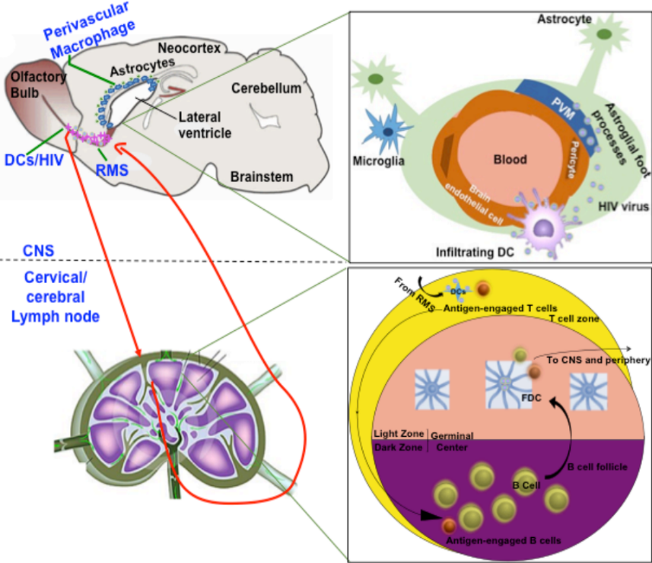

III. Reference
1. Jain, P.*, C. Coisne, G. Enzmann, R. Rottapel, and B. Engelhardt*. α4β1-integrin mediates the recruitment of immature dendritic cells across the blood-brain barrier during experimental autoimmune encephalomyelitis. Journal of Immunology, 184 (12): 7196-7206, 2010 (*corresponding author).

2. Hollenbach, R., Sagar, D., Hegde R., Callen, S., Yao, H., Khan, Z. K., Buch, S., and P. Jain. Effect of morphine and SIV on dendritic cell trafficking into the central nervous system of rhesus macaques. Journal of NeuroVirology, 20: 175-183, 2014.3.

3. Sagar, D., Singh, N., Ginwala, R., Huang, X., Philip, R., Nagarkatti, M., Nagarkatti, P., Neumann, K., Ruland, J., Andrews, A., Remirez, S., Khan, Z. K., and P. Jain. Antibody blockade of CLEC12A delays the course of EAE and attenuates disease severity by impairing myeloid cell CNS infiltration and restoring positive immunity. Scientific Reports, 7(1): 2707-23, 2017.

4. Dave, R., Sharma, R., Muir, R., Haddad, E., Gumber, S., Villinger, F., Nehra, A., Khan, Z. K., Wigdahl, B., Ansari, A., Byrareddy, S., and P. Jain. FDC-TFH Interactions within CNS Draining Cervical Lymph Nodes of SIV-Infected Rhesus Macaques. Journal of Neuroimmune Pharmacology, 2018. Epub ahead of print
IV. Biography
Dr. Pooja Jain is a Professor of the Microbiology and Immunology with a joint appointment in the Department of Neurobiology and Anatomy at the Drexel College of Medicine, USA. Dr. Jain is well respected as a Retrovirologist and Neuroimmunologist. She has authored more than 55 peer-reviewed publications, 300 abstracts, and numerous invited talks across United States and overseas. Her leadership skills are reflected in mentoring dozens of researchers including postdocs, M.D./Ph.D., Ph.D., and master students. She has been serving as the reviewer of various journals, planning committee member of international symposia as well as expert for the NIH study sections.
V. Presenting author details


Full Name: Pooja Jain
Contact number: 215-991-8393
Session name/ number: HIV/AIDS and Retroviral Diseases
Category: (Oral presentation/ Poster presentation)- Oral

