Abstract Template

Title: Development and clinical validation of the Genedrive point-of-care test for qualitative detection of hepatitis C virus

L. Kemp, G. Miele¹, A. Llibre², Y. Shimakawa², E. Mottez², S. Ainsworth¹, R. Firth¹, A. Glass³, S. Pol², D. Duffy²

¹ genedrive plc, Manchester, UK
² Institut Pasteur, Paris, France
³ Lancet laboratories, Johannesburg, South Africa

Keywords: Hepatitis, HCV, IVD, decentralised, rapid, RNA

- Abstract Body (up to 250 words)
We have developed a CE-IVD certified assay for the detection of HCV RNA in decentralised settings on the Genedrive® platform. The platform is an affordable, portable thermocycler that permits testing directly on plasma with results reported in under 90 minutes, using ambient temperature stable assay reagents. To validate the Genedrive HCV ID Kit, we performed a three site retrospective clinical study on plasma and serum samples from Europe and Africa comparing Genedrive results with the Abbott RealTime platform as a benchmark.
The assay is inclusive of all 6 major HCV genotypes, with a LoD of 2362 IU/ml (95% CI 1966 – 2788 IU/ml) in clinical specimens. Using 422 patients chronically infected with HCV and 503 controls negative for anti- HCV and HCV RNA, the Genedrive HCV assay showed 98.6% and 100% specificity to detect HCV. It was equally efficient on freshly collected or frozen plasma samples, and is exclusive of other BBV infections. Initial analysis indicates potential for viral semi-quantification through melting peak ratiometric analysis.
Subsequent independent analysis of samples with HCV genotypes prevalent in Africa compared to Europe demonstrated 100% sensitivity and specificity.
We report the clinical validation of a rapid affordable point of need HCV molecular test that meets the criteria decentralised HCV assays for use in low to middle income countries. The Genedrive HCV ID Kit is positioned to enable real-time treatment management of chronic HCV patients in decentralised settings.

- Image:
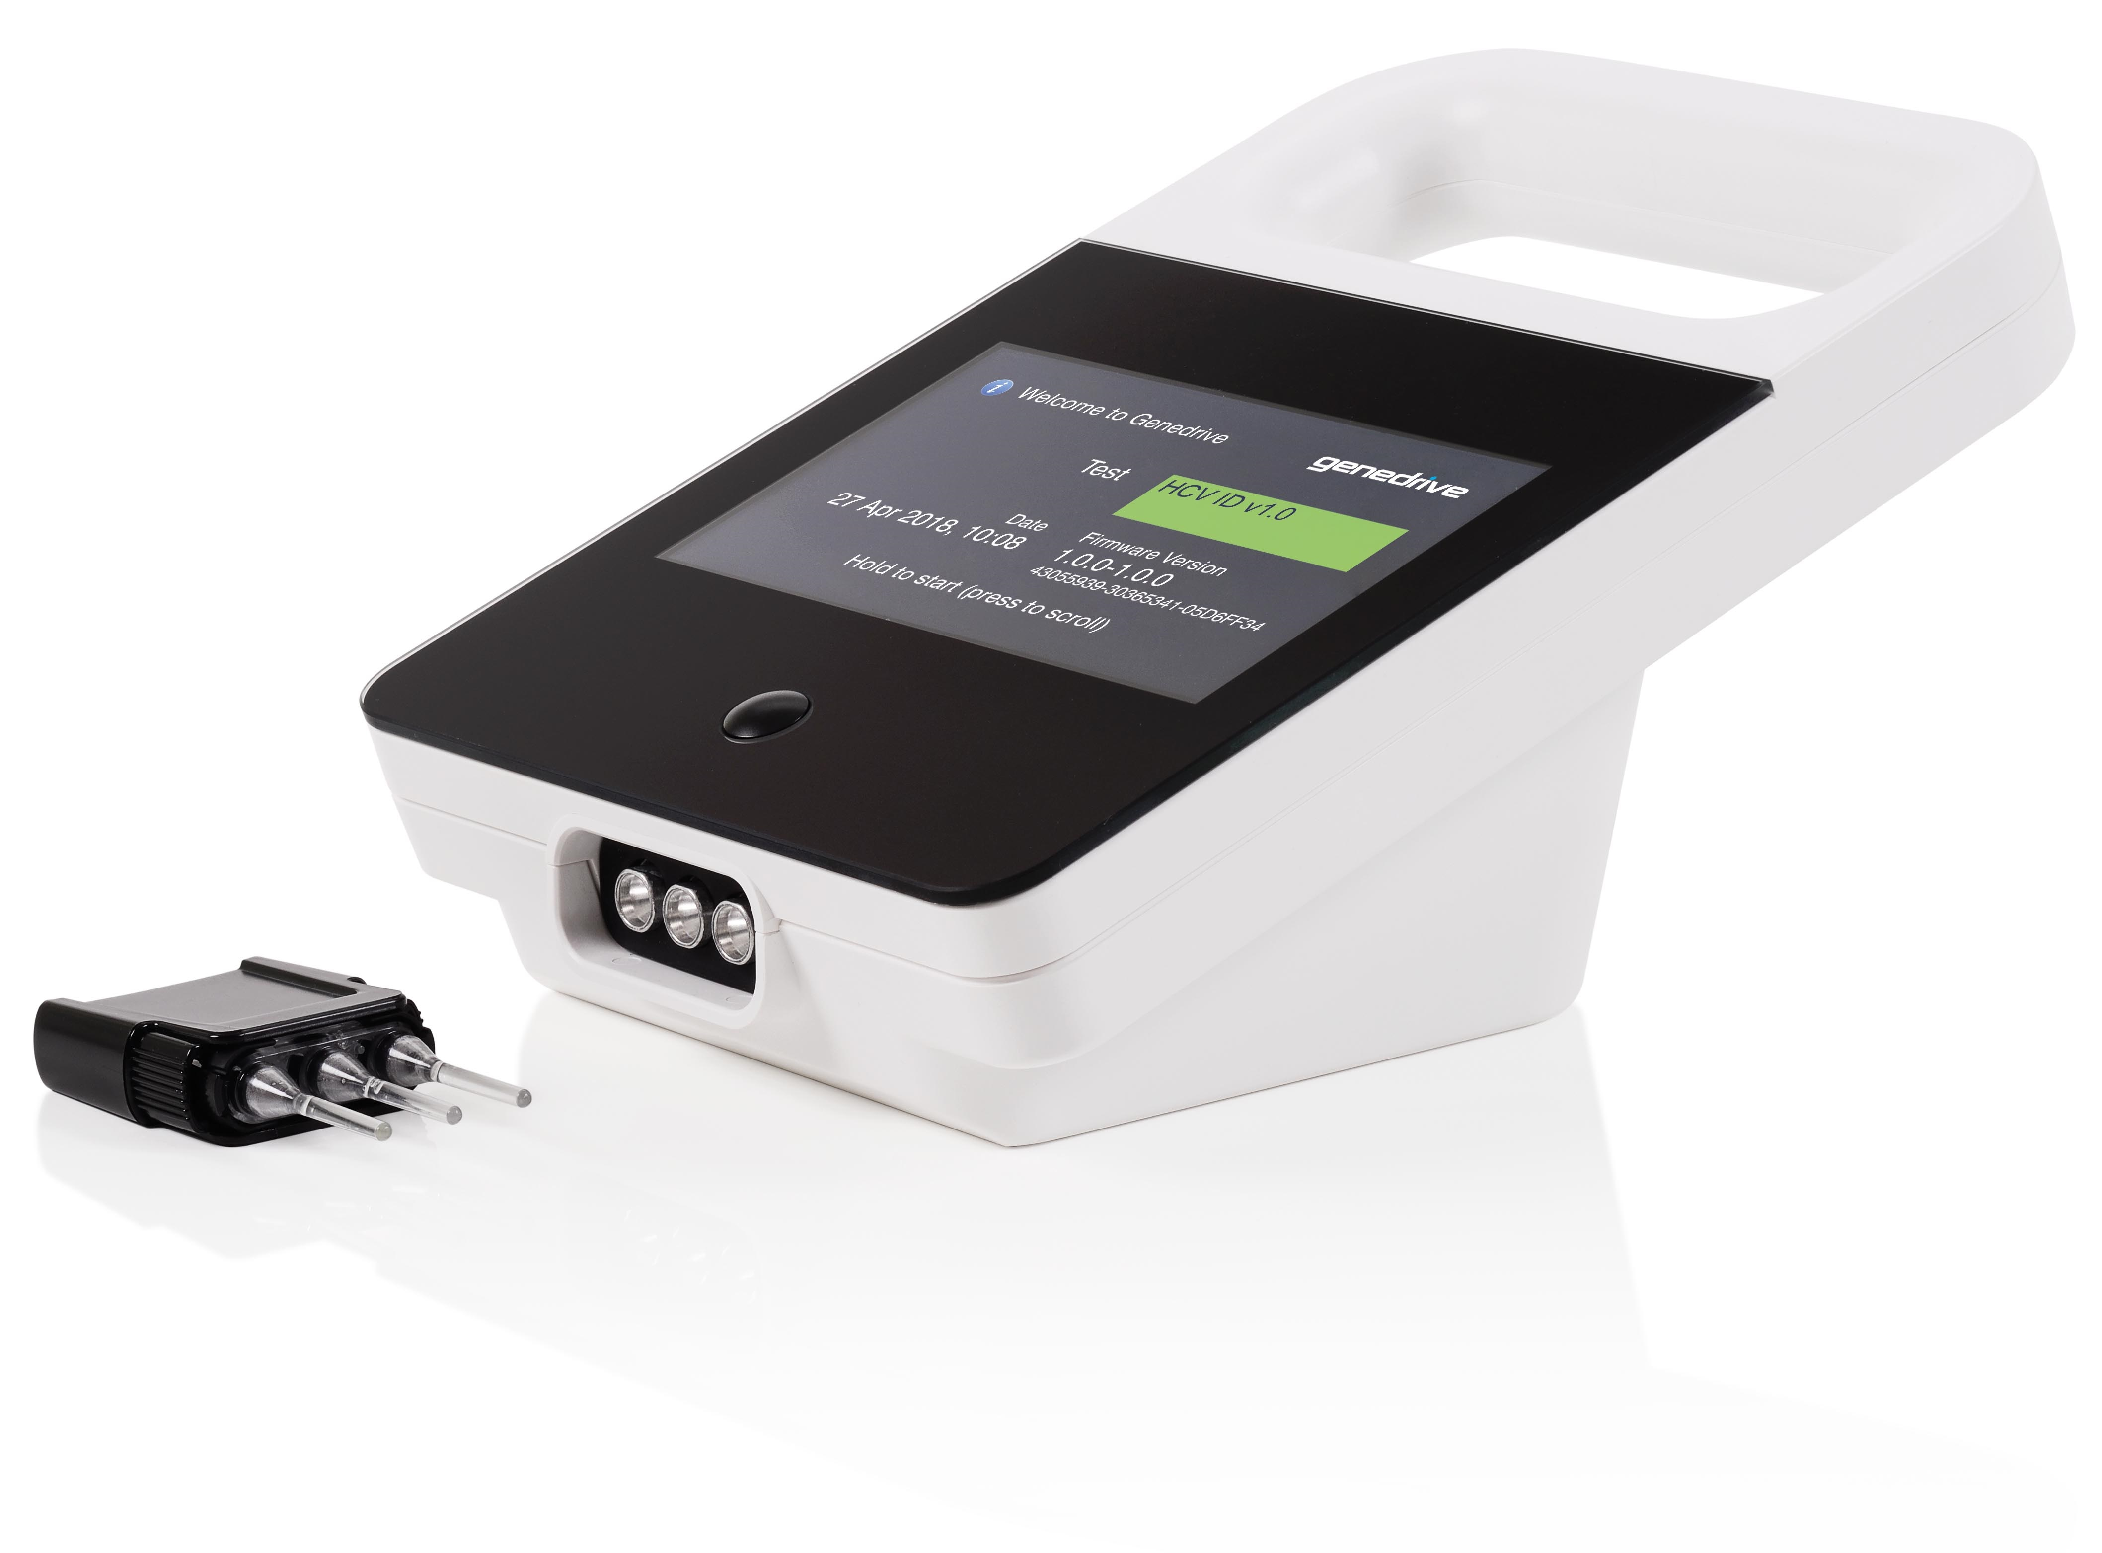
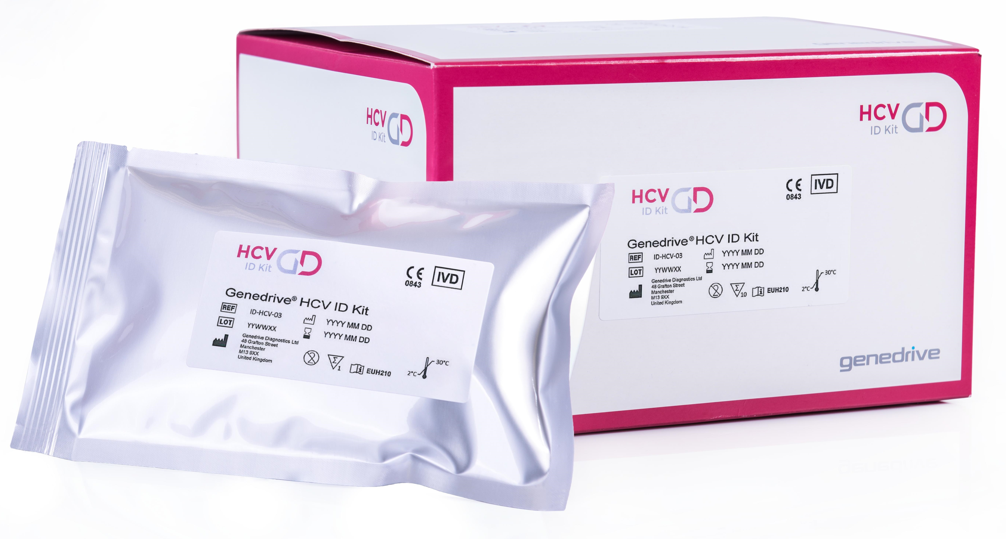

- Reference:
- A. Llibre, Y. Shimakawa, E. Mottez, S. Ainsworth, T. P. Buivan, R. Firth, E. Harrison, A. R. Rosenberg, J. F. Meritet, A. Fontanet, P. Castan, A. Madejon, M. Laverick, A. Glass, R. Viana, S. Pol, C. P. McClure, W. L. Irving, G. Miele, M. L. Albert, and D. Duffy, Development and clinical validation of the Genedrive point-of-care test for qualitative detection of hepatitis C virus. Gut, 2018.
- Biography:
Laura Kemp completed her PhD in Biochemistry in 2014 from The University of Manchester. She is the IVD Trials Manager at Genedrive Plc. and has five year’s diagnostics experience.
- Presenting author details

Full Name: Laura Rosalind Kemp
Contact number: +44(0)7584165243
Linked In account: https://www.linkedin.com/in/laura-r-kemp-16539148/
Session name/ number:
Category: (Oral presentation/ Poster presentation)
Passport Number: 524445869

