ECG diagnostic of myocardial bridges
Olena Gogayeva, Liudmyla Dzakhoieva
National Amosov’s Institute of cardiovascular surgery NAMS of Ukraine, Kyiv
Key words: ECG, myocardial bridges.
Location anomaly of coronary arteries, so called myocardial bridge (MB) first was described by Reyman in 1737. According to the literature, anomaly frequency on autopsy varies from 7% to 85%, while on angiography just 0.5%-12%. We have diagnosed and treated 355 symptomatic patients with MB. ECG data, angiograms and intraoperative findings were compared. We have identified an informative ECG signs that allow us to suspect the presence of MB. 330 (92.9%) patients had sinus rhythm, 15 (4.2%) had atrial fibrillation, atrial fluttering appeared in 6 (1.6%) and 4 (1.1%) patients had rhythm migration. The heart rate range was 43 to 169 beats per minute with average of 68. For 281 of patients (79.1%) we noticed left ventricular (LV) hypertrophy, 329 patients (92.6%) had different signs of chronic coronary insufficiency. In 27 cases (7.6%) left bundle branch block (LBBB) was founded. In 71 patients (20%) we found focal changes in the anterior wall of LV. 18 patient (5.07%) had acute ischemia, 3 (0.84%) patients had acute Q-MI, 61 patients (17.1%) had ruptures. Ruptures localization were as following: 29 (47.5%) on anterior-septal wall of LV, 21 (34.4%) on the posterior wall of LV and 11 (18.03%) on apical-lateral area of LV. The transient change in the depth of inverted T wave in left precordial leads was noticed due to the dynamic nature of compression of the coronary artery.
II. Image: Transient ischemia as ECG sign of MB.
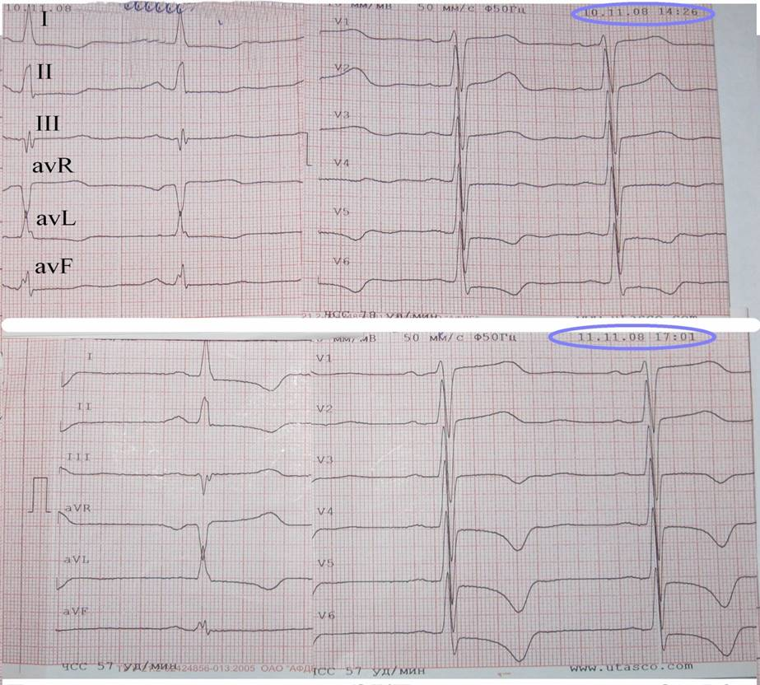
III. References:
- Lee MS, Chen CH. Myocardial Bridging: An Up-to-Date Review. J Invasive Cardiol. 2015;27(11):521-8.
- O.Gogayeva Myocardial bridges: experience of diagnosis and treatment. International Journal of Cardiology 2012; 155(1):S48-S49

IV. Biography:
Cardiologist Olena Gogayeva, MD PhD is a senior Researcher in the Department of surgical treatment of ischemic heart disease in the National Amosov’s Institute of cardiovascular surgery NAMS of Ukraine. She has 112 published papers and 29 patent of inventions of Ukraine.
V. Presenting author details
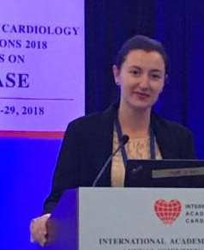
Full Name: Olena Gogayeva
Contact number: +380672843413
Twitter account: -
Linked In account: Olena Gogayeva
Session name/ number:
Category: (E-Poster presentation)
Passport Number: 119094

