Title: Predictors Of ‘Super-Responders’ To Cardiac Resynchronization Therapy For Congestive Heart Failure In Bangladeshi Population.
Umme Habiba Ferdaushi1, M. Atahar Ali1, M.Nazrul islam1, ShailaNabi1, Mainul Islam1.
1Dept. of cardiology, National Institute of cardiovascular diseases, Dhaka, Bangladesh.

Super-responders (n=6) Other patients (n =29) P-value

Keywords: Cardiac resynchronization therapy, Heart failure, Super-Responders, electrical dyssynchrony.
- Abstract Body (up to 250 words)
Cardiac resynchronization therapy (CRT) is the established management for HF patients with LV systolic dysfunction and signs of electrical dyssynchrony. Some patients after CRT implantation become ‘super-responders’. Our proposed definition of super-responders is patients with an increase LVEF of ≥15% and an improvement of (NYHA) functional class (at least 1 class).
The aim of our study was to identify predictors of being a super-responder to CRT in our population.
Thirty five consecutive patients underwent CRT for a period of one year were studied prospectively. Before and 3months after implantation clinical, electrocardiographic and echocardiographic evaluations were performed. At the 3 months follow-up, patients were classified as ‘super-responders’.
Of the 35patients, there were17.1%super-responders. At baseline, there were some signiﬁcant differences between super-responders and the other patients that they had signiﬁcantly smaller LV end-diastolic diameter (65.4±6.4vs.73.4±9.3mm,P=0.001), smaller degree of MR(mean 1.9±0.9vs.2.6+0.8,P=<0.001), smaller left atrium (42.8±4.6vs.50.0±6.5 mm, P < 0.001), a shorter duration of HF symptoms (months; 15.1±17.8vs.33.9±35.7,P=0.01) and they all had non-ischemic cardiomyopathy. After 3 months, we observed a significant improvement of NYHA functional class, LVEF, LV diameters, MR grade in both groups. Regarding the magnitude of response LV diameters, LVEF showed a significantly greater improvement in super-responders. In the multivariate logistic regression analysis, MR grade, LVEDD and the duration of symptoms for <12 months were independent predictors of super-response to CRT.
Patients in earlier phases of the cardiomyopathy, with a less advanced left-sided structural involvement of heart seem to have a greater probability of becoming super-responders and independent predictors of reverse remodelling.
- Table:
Comparison of baseline characteristics of super-responders and the other patients.

Super-responders (n=6) Other patients (n =29) P-value

Female (%) 67 10 0.001
DCM (%) 100 57.1 0.001
Age (years) 60±8 62±11 0.41
NYHA class 3.0±0.7 3.1±0.6 0.66
Duration of symptom 15.1+17.8 33.9+35.7 0.001
QRS duration(ms) 153.5±30.8 143.5±31.6 0.30
LA (mm) 42.8±4.6 50.0±6.5 0.04
MR grade 1.9±.9 2.6±.8 0.001
LVEDD (mm) 65.4±6.4 73.4±9.3 0.001
LVESD (mm) 57.3±7.5 63.6±10.2 0.06
LVEF (%) 25±5 22±4 0.43

ICM, ischaemic cardiomyopathy; MR, mitral regurgitation; LVEDD, left ventricular end-diastolic diameter; LVESD, left ventricular end-systolic diameter; LVEDV, left ventricular end-diastolic volume; LVESV, left ventricular end-systolic volume; LVEF, left ventricular ejection fraction.
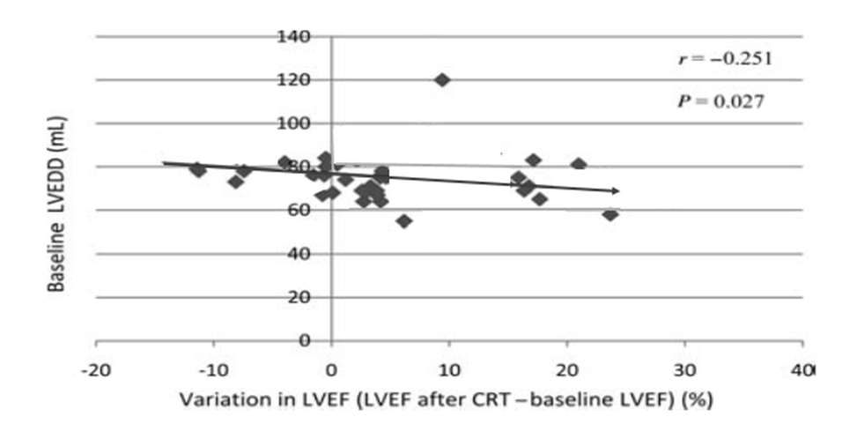
Figure: Correlation between baseline left ventricular diastolic diameter and variation in left ventricular ejection fraction after cardiac resynchronization therapy.
- Reference:
1. Vardas PE, Auricchio A, Blanc J-J, Daubert J-C, Drexler H, Ector H et al. Guidelines for cardiac pacing and cardiac resynchronization therapy: The Task Force for Cardiac Pacing and Cardiac Resynchronization Therapy of the European Society of Cardiology. Developed in Collaboration with the European Heart Rhythm Association. Eur Heart J 2007;28:2256–95.
2. Swedberg K, Cleland J, Dargie H, Drexler H, Follath F, Komajda M et al. Guidelines for the diagnosis and treatment of chronic heart failure: executive summary (update 2005):The Task Force for the Diagnosis and Treatment of Chronic Heart Failure of the European Society of Cardiology. Eur Heart J 2005;26:1115–540.
3. Yu C-M, Bleeker GB, Fung JW-H, Schalij MJ, Zhang Q, van der Wall EE et al.Left ventricular reverse remodeling but not clinical improvement predicts long-term survival after cardiac resynchronization therapy. Circulation 2005;112:15806
4. Castellant P, Fatemi M, Bertault-Valls V, Etienne Y, Blanc J-J. Cardiac resynchronizatioherapy: ‘nonresponders’ and ‘hyperresponders’. Heart Rhythm 2008;5: 193–7.
- Biography:
Dr. Umme Habiba Ferdaushi has completed her MBBS at the age of 25 years from Sher-e-Bangla Medical College, Barishal, Bangladesh and postgraduation, FCPS (Cardiology) from Bangladesh College of Physicians and Surgeons, Bangladesh. She has done fellowship in electrophysiology from Escorts Fortis Hospital, New Delhi, India. She is working as assistant registrar at National Institute of Cardiovascular Diseases,hospital, Dhaka, Bangladesh. She has published more than 7 papers in reputed journals and has done oral, e- poster, poster presentation in several international conferences.
- Presenting author details


Full Name: Dr. Umme Habiba Ferdaushi

Contact number: +8801716534362
Twitter account: drhabiba30@yahoo.com
Linked In account:
Session name/ number: 3rd International Heart Conference
Category: (Oral presentation/ Poster presentation)
Passport Number: OC2189684

