THE STUDY OF HETEROTOPIC OSSIFICATION OF HIP BONES AND PELVES MUSCLES AND LIGAMENTS
Dr Sumita Agarwal, B.D.S, M.Sc & PhD Medical Anatomy, People’s University Bhopal, Madhya Pradesh, India
Abstract
Statement of the Problem: The bony pelvis stabilizes and transmits weight from axial skeleton to the lower limbs and the hip bone connects lower limbs to the pelvic girdle for stability compromising range of movement. These joints show variety of degenerative diseases and ankylosis. Heterotrophic ossification is an abnormal growth of bone in healing soft tissues. The present study is aimed to observe the ossifications of Transverse acetabular ligaments, Obturator membrane and gluteus maximus muscle in hip bones and fibrous capsule of hip joints and ossifications in pelves of sacrotuberous, sacrospinous ligaments, Erector spinae aponeurosis muscles and bilateral ankylosis of sacroiliac joint. Material & Methods: The study was performed on 128 dried human hip bones and 6 pelves of unidentified sex and age, in the Dept. of Anatomy. Various ossifications and their measurements were recorded using Vernier calipers. Results: The present study showed the incidence of completely ossified Transverse Acetabular ligament in 4 hip bones i.e., 3.12% with completely ossified fibrous capsule of hip joint on left side. The incidence of bony spurs along the margin of Obturator Foramen in 4 left hip bones is 6.25% along with the ossification of the gluteus maximus muscle on dorsal aspect of ilium. Out of 6 pelves, 1 pelvis presented complete ossification of Erector spinae aponeurosis bilaterally on the dorsal surface of the sacrum along with complete ossification of sacrotuberous ligament of right side and sacrospinous ligament of left side along with bilateral ankylosed sacroiliac joint of pelvis. Conclusions: The knowledge of these abnormal ossifications of hip bones and pelves may be of immense help to Orthopaedicians, Surgeons, Neurosurgeons and radiologists to come to differential diagnosis and plan treatment accordingly.
Image:

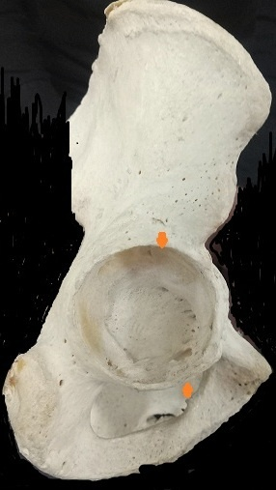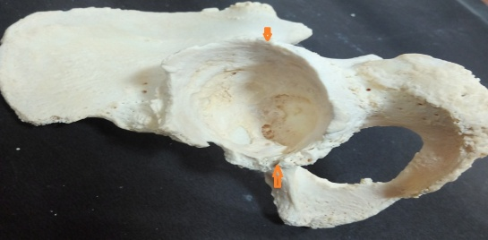
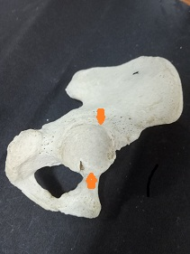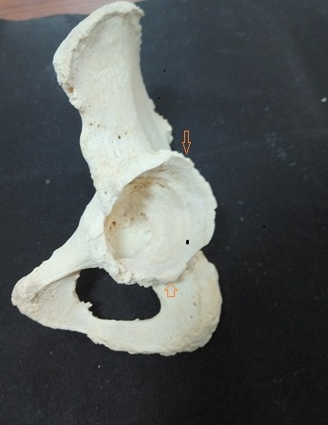
Fig. No.1 Upward pointing arrow showing Ossified Transverse Acetabular ligament and downward pointing arrow showing ossified Acetabulare Labrum in hip bone

Fig. No.2 Hip bone showing bony projections of ossified Obturator membrane muscle

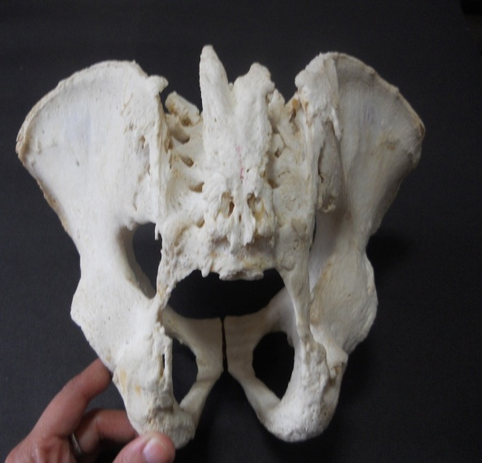
Fig. No. 3 Pelvis (ventral & dorsal views) showing ossified Erector Spinae aponurosis and both left sacrospinous and right sacrotuberous ligaments as well as bilaterally ankylosis of sacroiliac joints
Recent Publications (minimum 5)

1. Firoozabadi R, Alton T, Sagi HC (2017) Heterotopic Ossification in acetabular fracture surgery. Journal of the American Academy of Orthopaedic Surgeons 25(2):117–24.
2. Bossche LV, Vanderstraeten G (2005) Heterotopic ossification: a review. J Rehabil Med 37: 129-136.
3. Hsu JE, Keenan MA (2010) Current review of Heterotopic ossification. UPOJ 20: 126-130.
4. Chakravarthi KK, Siddaraju SS, Venumadhav N, Bali, SA(2017) Abnormal ossified structures around the hip joint and its clinical implications. International Journal of Research in Medical Sciences 5 (12):5391-5395.
5. Perumal A, Sathiya S(2014) Ossified transverse acetabular ligament-an osteological study. Int J Curr Res Rev 6(8):37.

Biography
Dr Sumita Agarwal a creative and competent individual with over 06 years of diverse experience in Academics & research in Anatomy. Her area of research is Anthropometry. With proper planning, organizing & managing educational activities teaches Anatomy to UGs & PGs students. Recognized, respected & nurtured the creative potential of each student; fostered a healthy learning atmosphere in class & responding to all classroom queries in a spontaneous, empathic manner.
Email id:
docsumita29@gmail.com

