

Abstract Template

Title: Great Expectations – Building resilience with simulation

Morick, NJ
1Central Australia Health Service, Clinical Nurse Educator Intensive Care, Alice Springs Hospital

Keywords: Resilience, health-outcomes, expectations, reality, leadership

- Abstract Body
Improving the resilience of our workforce in healthcare will assist to reduce turnover rates and improve individual and team performance¹. Multiple tools and programs have been developed worldwide to increase individual’s resilience, but perhaps we should use a more simplistic approach.
As people, we invest in our expectations and as leaders we cultivate expectations. In simulation that is particularly evident, are we cultivating the correct expectations? Do our simulation practices create perpetuate a Grey’s Anatomy effect?
We know an abundance of clinical knowledge regarding the patients we care for, the pathophysiology, the pharmacology and how to reduce patient risk. Despite the abundance of knowledge, clinicians often hold unrealistic expectations concerning the health outcomes for patients in their care with regards to the success rates of therapy, the progression of chronic disease and the system limitations of care. As leaders of simulation in healthcare we must ensure that we are leading clinicians to realistic expectations and an improved resilience.

Image:

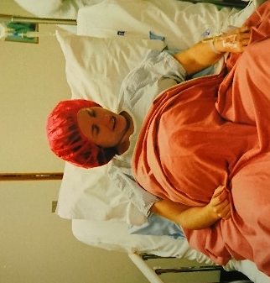
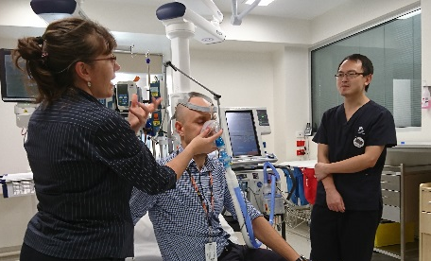
- Reference:

1 Welp, A., Meier, L.L., Manser, T., (2015) Emotional exhaustion and workload predict clinician-rated and objective patient safety Workload and Patient Safety Frontiers in Psychology Psychology for clinical Settings 5 Pg 1-14

2. Serrone RO, Weinberg JA, Goslar PW, et al Grey’s Anatomy effect: television portrayal of patients with trauma may cultivate unrealistic patient and family expectations after injury Trauma Surgery & Acute Care Open 2018;3

Biography:
Naomi currently works as a Clinical Nurse Educator in Intensive Care. She has a passion for education, facilitating learning and understanding why people do what they do. She holds a Masters in Advance Nursing Practice with a focus on Adult Learning. Naomi teaches using a variety of methods including bedside teaching, lecture style presentations, simulation and elearning, believing that we learn best when there is an element of discomfort. Naomi facilitates / co-ordinates on several programs including the Flinders Graduate Cert, ANZBA Emergency Management of Severe Burns, NHET Sim, Adult and Paediatric BASIC courses, Adult and Paediatric ACCCN Advanced Life Support and Teaching on the Run as well as programs she has developed and delivers.

Presenting author details
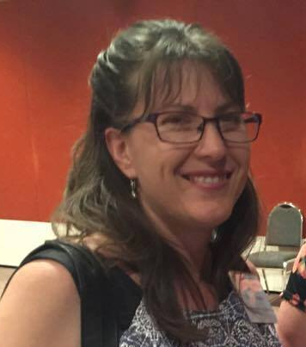
Full Name: Naomi Morick
Contact number: +61 0437388331
Linked In account:
Session name/ number:
Category: Oral Presentation
Passport Number:



