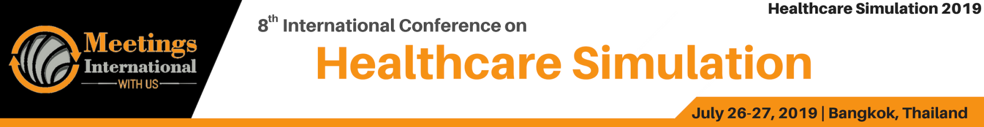

Abstract Template

Title: Radial artery catheterization on arterial puncture training arm manikin by novice anesthesia trainees. Does body posture matters?

A randomized, crossover, pilot study.

Ummed Singh, Ajay Kumar, Ajit Kumar, Praveen Talawar

1Department of Skill Development and Medical Education, All India Institute of Medical Sciences, Rishikesh, India
2Department of Anesthesiology and criticsl csre, All India Institute of Medical Sciences, Rishikesh, India

Keywords: Arterial puncture, training arm manikin, needle manipulation time, body posture.

- Abstract Body (up to 250 words)

Background: Radial artery catheterization is commonly used for invasive pressure monitoring in perioperative and intensive care unit settings. This procedure, however, does not come without risk and complications including radial artery occlusion, pseudoaneurysm, infection and hematoma.¹ Further, radial artery catheterization failure rates increase with the number of catheterization attempts, which should be kept to a minimum.² While performing fine manipulation tasks use of dominant hand, arm in flexed position and sitting body posture are associated with significant decrease in hand error.³
Aim: We aimed to compare the traditional standing body posture and sitting with supported forearm body posture for radial artery catheterization in regards to clinically relevant end points.
Methods: Novice trainees trained in radial artery catheterization by palpation technique, on arterial puncture training arm manikin in sitting and standing body posture during practice session. During post-test the sequence of body posture was decided by randomization and video recording of all participants was done while performing the skill. The primary end point of the study was needle manipulation time. Additional end points were (1) The number of skin perforations (2) The number of attempts targeting the vessel (3) The number of catheters place in first attempt.
Results: Twenty-two participants were analyzed. Needle manipulation time was significantly higher in traditional standing body posture [44 s (range 21–73 s) vs.29 s (range 10 –66 s), P = 0.0002]. In the traditional standing posture, a higher number of the attempt targeting the vessel (37 vs 28, p = 0.025) were required. First attempt success rate was signiﬁcantly higher in sitting with supported forearm posture group (17/22 vs. 10/22, P = 0.015). There was no significant difference in number of skin perforations in both body postures (25 vs 23, p = 0.081).
Conclusion: Sitting with supported forearm body posture for radial artery catheterization significantly improves clinically relevant aspects of the procedure.

Image:

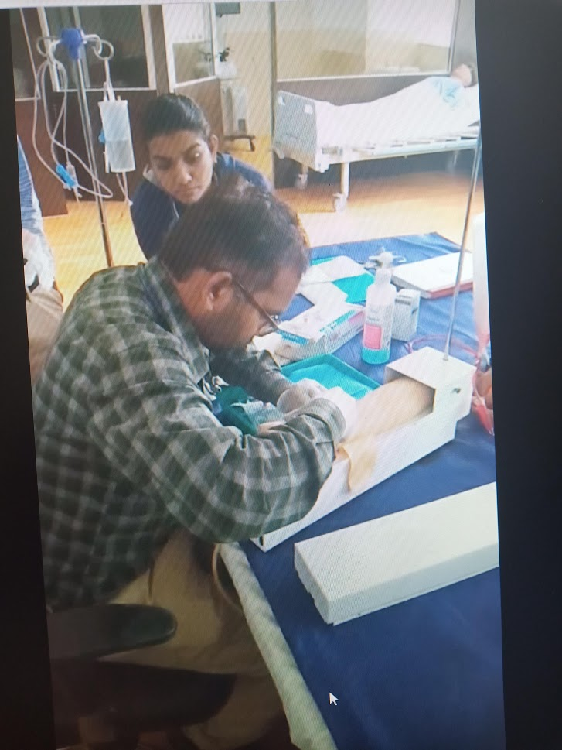
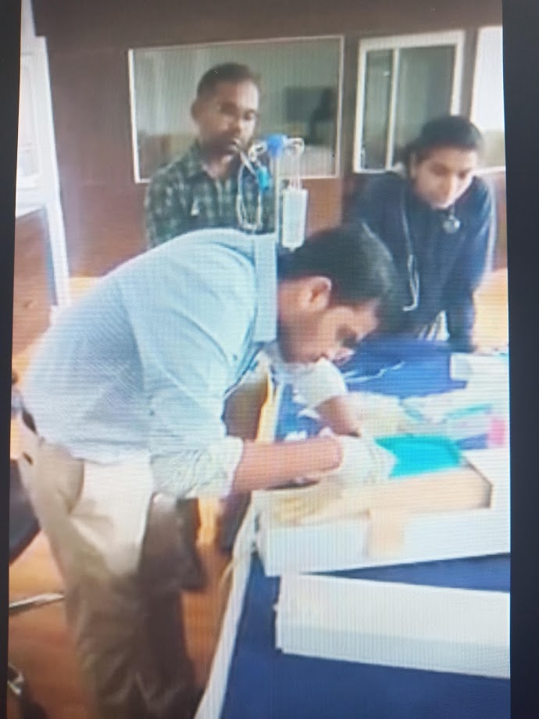
III. Reference:

1.Scheer B, Perel A, Pfeiffer UJ. Clinical review: complications and risk factors of peripheral arterial catheters used for haemodynamic monitoring in anaesthesia and intensive care medicine. Crit Care 2002; 6: 199–204.
2.Sakai H, Ikeda S, Harada T, Yonashiro S, Ozumi K, Ohe H, Ochiai M, Miyahara Y, Kohno S. Limitations of successive transradial approach in the same arm: The Japanese experience. Catheter Cardiovasc Interv 2001; 54: 204–8.
3.Tzu-Hsien Lee, Te-Shiang Cheng. Effects of Hand Posture, Breathing Type, Arm Posture and Body Posture on Hand Errors. International Journal of Occupational Safety and Ergonomics (JOSE) 2012; 18: 393–398.

Ⅳ. Biography:
Dr Ummed Singh has completed his MD anaesthesiology in 2013 from Gujarat university and DM cardiac anaesthesiology from All India Institute of Medical Sciences New Delhi, india. He is assistant professor in department of anaesthesiology and critical care at All India Institute if Medical Sciences Rishikesh, a premier tertiary care hospital and research organization. He has special interest in simulation for healthcare and research and presently working on training module development for undergraduate and postgraduate teaching on simulation.

Ⅴ. Presenting author details

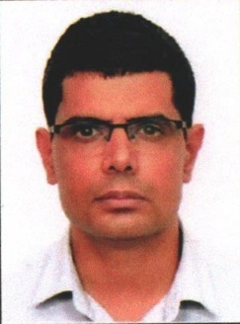
Full Name: Ummed Singh Contact number: +91 8800685648
Twitter account: Ummed Singh @UDhatterwal
Linked In account:
Session name/ number:
Category: (Oral presentation/ Poster presentation) Passport Number:



