Title: Sim mobile unit in primary healthcare
- Simulation centre, CHC Ljubljana, Development of Health Services, Ljubljana, Slovenia
- Authors : dr. Antonija Poplas Susič, Uroš Zafošnik, Davorin Marković

Keywords: Simulation, SIM centre, education, primary health care, SIM mobile unit

- Abstract Body
The team in family practice often meets life-risk patients. Simulation is an excellent way for health care workers to train their skills in a safe environment. It is an effective, ethical and safe way to practice theoretical knowledge. Trainees acquire experience in simulation in life threatening situation, how to approach acute situation and situations where decisions have consequences. This way we approach the clinical environment as close as we can.

But sadly, learning with simulations in healthcare is usually not available to professionals. Contributing factors to this problem are the lack of knowledge and poor equipment combined with high education costs and time shortage in medical teams. We have developed a mobile simulation unit ( SIM mobile) that will enable all medical teams in primary healthcare access to modern simulation equipment. We have used SIM mobile to conduct simulations in over 20 diferent locations in Slovenia ( Comunity health centres, prehospital units). Participants were doctors of family medicine, nurses and EMT workers. The study was caried out from june 2018 to august 2018. SIM mobile was avaliable for 120 hours in 10 days. Total training time was 120 hours and was used 100% of the time by the participants of the study.

SIM mobile provides opportunities for outstanding educational experiences that translate into better patient care and improved provider safety. A mobile simulation experience that can be brought to healthcare professionals in rural and frontier communities, thus reducing the need for providers to travel for training.

- Image:
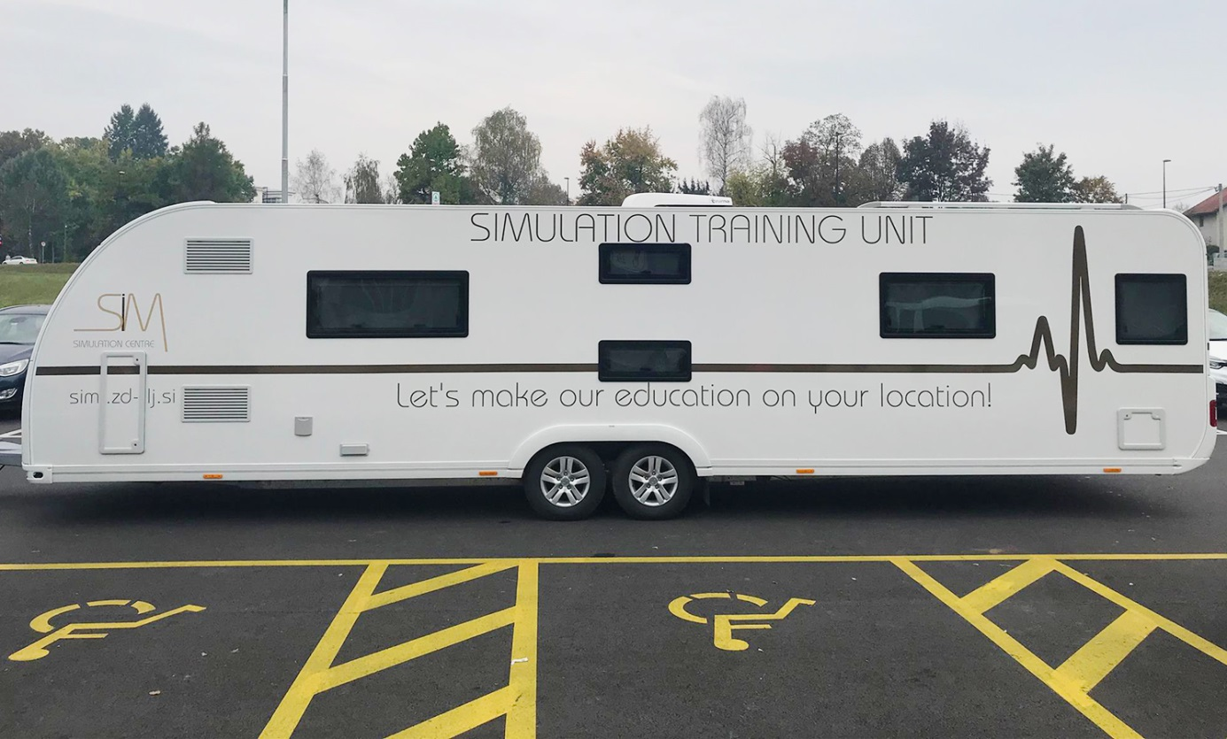
- Reference:
- Ballangrud, R. Hall‐Lord, M. L. Hedelin, B. in Persenius, M. (2014). Intensive care unit nurses' evaluation of simulation used for team training. Nursing in critical care, 19(4), 175-184.
- Dowson, A. Russ, S. Sevdalis, N. Cooper, M. in De Munter, C. (2013). How in situ simulation affects paediatric nurses' clinical confidence. British journal of nursing, 22(11), 610-617.
- Georg, C. in Zary, N. (2014). Web-based virtual patients in nursing education: development and validation of theory-anchored design and activity models. Journal of medical Internet research, 16(4), 105.
- Kalisch, B. J. Aebersold, M. McLaughlin, M. Tschannen, D. in Lane, S. (2015). An intervention to improve nursing teamwork using virtual simulation. Western journal of nursing research, 37(2), 164-179.
- Kren, A., Benkovič, R., Zafošnik, U. (2017). Treatment of emergency medical conditions - Simulation-based learning in healthcare. Fakulteta za zdravstvene cede Novo mesto.
- Mileder, L. P. Urlesberger, B. Szyld, E. G. Roehr, C. C. in Schmölzer, G. M. (2014). Simulation-based neonatal and infant resuscitation teaching: a systematic review of randomized controlled trials. Klinische Pädiatrie, 226(05), 259-267.
- Pena, G. Altree, M. Babidge, W. Field, J. Hewett, P. Meddern, G. (2014). Mobile Simulation Unit: taking simulation to the surgical trainee. General surgery, 85, 339-243.
- Perkins, G. D. (2007). Simulation in resuscitation training. Resuscitation, 73(2), 202-211.
- Roh, Y. S. in Lim, E. J. (2014). Pre-course simulation as a predictor of satisfaction with an emergency nursing clinical course. International journal of nursing education scholarship, 11(1), 83-90.
- Saaranen, T. Vaajoki, A. Kellomäki, M. in Hyvärinen, M. L. (2015). The simulation method in learning interpersonal communication competence—Experiences of masters' degree students of health sciences. Nurse education today, 35(2), 8-13.
- Shannon, R.E. (1975). Systems Simulation: The Art and Science, Prentice-Hall Englewood Cliffs (New Jersey), (p.34).
- Stockwell, D. C. in Slonim, A. D. (2006). Quality and safety in the intensive care unit. Journal of Intensive Care Medicine, 21(4), 199-210.
- Vadnais, M. A. Dodge, L. E. Awtrey, C. S. Ricciotti, H. A. Golen, T. H. in Hacker, M. R. (2012). Assessment of long-term knowledge retention following single-day simulation training for uncommon but critical obstetrical events. The Journal of Maternal-Fetal and Neonatal Medicine, 25(9), 1640-1645.
- Qayumi, K. Pachev, G. Zheng, B. Ziv, A. Koval, V. Badiei, S. in Cheng, A. (2014). Status of simulation in health care education: an international survey. Advances in medical education and practice, 5, 457-467.

- Biography:

Lecturer Uroš Zafošnik, Registered Nurse, MSc of social works, was working as head nurse of emergency services in CHC Maribor for four years before starting work in emergency services of CHC Ljubljana, where he worked for three years. Curently he is Head and Coordinator of SIM Centre now for five years. He is also international ITLS and MTS instructor and besides that he was involved in a working group designing standards for triage at Ministry of Health Slovenia. He is also a lecturer at Faculty of health sciences Novo Mesto.
- Presenting author details

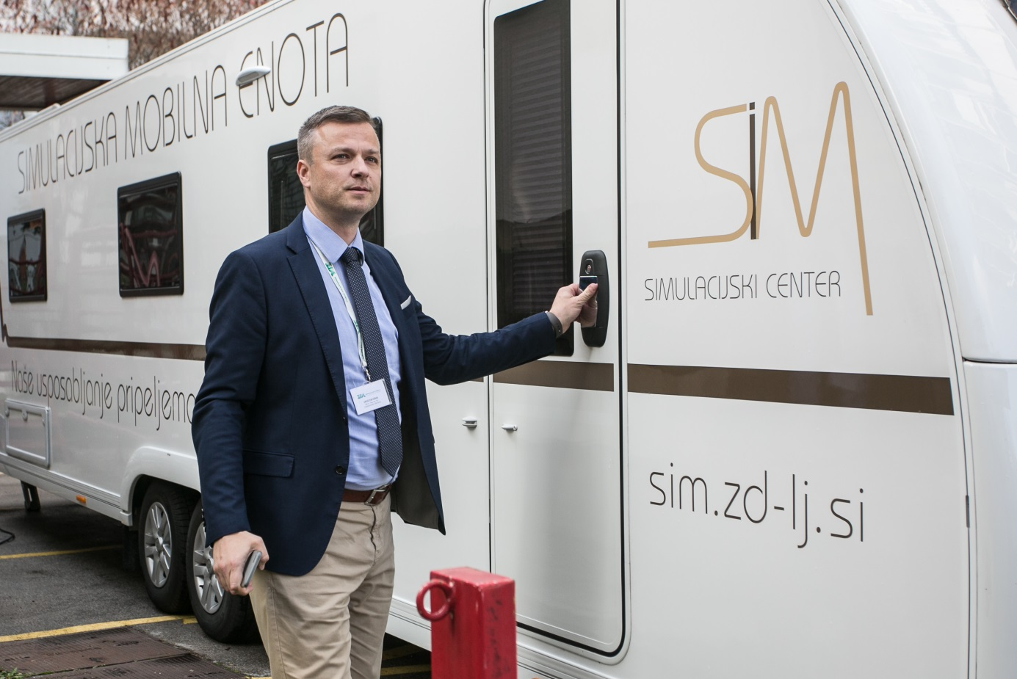

Full Name: Uroš Zafošnik
Category: (Oral presentation/ Poster presentation) - both

