
Micro hyperthermia by laser as non-invasive treatment for SUI - two year follow up

Andrzej Kuszka
Head of gynecological department, Krankenhaus Preetz, Preetz, Germany

Regarding the etiology of female stress urine incontinence (SUI) one important parameter is a lack of support function for bladder and urethra by pelvic floor, caused by the structure of connective tissue in endopelvic fascia.(1) Despite the benefit of mesh or sling, some patients will not accept (fear of surgery, lighter cases f SUI). The non-invasive micro hyperthermia by laser is a promising new therapeutic option. (2,3)

Being conducted between 2016 and 2019 , our prospective study (4) aimed the mid-term results (24 month) of laser treatment according to the severity of SUI. Fifty-nine women, 32 mild (SUI I), 16 moderate (SUI II) and 11 severe (SUI III) cases were included. Laser therapy was performed with Erbium:YAG laser (Fotona) following the IncontiLase® protocol (5). Patients received 5 laser treatments, one at baseline, and one at 1, 2, 3 and 4 months. Objective (pad test) and subjective data (ICIQ-UI SF and PISQ-12 questionnaires) were assessed at baseline, 1 month after the 2nd session, 6 months and 2 years after the 5th session.

For SUI I patients, objective cured rates were 69% still after the 2 years (range 14-32 months). Sustainable cure rate was achieved 6 month after last session. Limited success was seen for SUI II, laser failed for SUI III. Sexual function, determined by the PISQ-12 score, also improved, the best results were achieved for SUI I.

Objective and subjective measures indicated that mild SUI can be cured/improved by intravaginal laser therapy. Follow-up data 6 months and 2 years after the laser intervention showed sustainability of the treatment. Therefore, laser therapy may be offered for women with mild SUI between pregnancies, or for women wishing a mesh-free, minimally invasive intervention

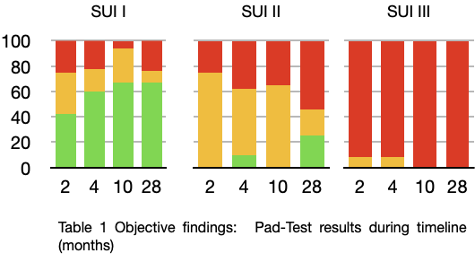

- Sender Herschorn, Female Pelvic Floor Anatomy. The Pelvic Floor, SupportingStructures, and Pelvic Organs, TREATMENT OFSUI S2VOL. 6 SUPPL. 5 2004 REVIEWS IN UROLOGY p. S5-S6
- Pablo González Isaza & Kinga Jaguszewska & Jose Luis Cardona & Mariusz Lukaszuk; Long-term effect of thermoablative fractional CO2 laser treatment as a novel approach to urinary incontinence management in women with genitourinary syndrome of menopause; Int Urogynecol J (2018) 29:211–215, DOI 10.1007/s00192-017-3352-1
- G. A. Lapii, A. Yu. Yakovleva, and A. I. Neimark ; Structural Reorganization of the Vaginal Mucosa in Stress Urinary Incontinence under Conditions of Er:YAG Laser Treatment; Bulletin of Experimental Biology and Medicine, Vol. 162, No. 10, February, 2017 MORPHOLOGY AND PATHOMORPHOLOGY - DOI 10.1007/s10517-017-3650-
- Andrzej Kuszka, Marianne Gamper, Claudia Walser, Jacek Kociszewski, Volker Viereck. Erbium:YAG laser treatment of female stress urinary incontinence: midterm data; Int Urogynecol J 2020 Sep; 31(9):1859-1866
- Fistonic N, Fistonic I, Gustek SF, Turina IS, Marton I, Vizintin Z, et al. Minimally invasive, non-ablative Er:YAG laser treatment of stress urinary incontinence in women – a pilot study. Lasers Med Sci. 2016;31:635-43. 10.1007/ s10103-016-1884-0 5

Andrzej Kuszka M.D, certified obstetrician and gynecological surgeon has got his clinical experience in more than 13 years in women clinics in Germany. With his strong focus on urogynecology he is dedicated to advanced pelvic floor ultrasound diagnostics (pregnancy & prenatal, breast care), pelvic organ surgery (laparoscopic, vaginal, laser), incontinence surgery (slings, pararurethral injections) and pelvic floor organs complication management. As Head of Obstetrical-Gynecological Dept. AGUB III Clinic in Preetz he put more and more emphasis on the possibilities of minimal-invasive pelvic floor organ therapy (lasers , radio-frequency). His research concerned midterm effects of laser incontinence (SUI grade I) therapy with Er:YAG and CO2-lasers, including comparing these two. And a new approach on intraurethral laser therapy for more severe cases of SUI.

