Capacity-building assets for integrated care: how to use existing evidence to accelerate the adoption of integrated care?
Jon Txarramendieta, Kronikgune, Basque Country, Spain

Abstract
Statement of the Problem: The transformation of healthcare systems is highly complex and, as such, the health and social care authorities in charge of this system redesign are seeking support to improve their capacity for integrated care. There is a real opportunity to maximise the use of existing evidence on integrated care and ensure it is readily available to meet the needs and context of a particular health and care system. However, it is also important to recognise that the healthcare systems will have very different starting points, or levels of maturity. As such, they will all require different levels/types of assets and support to strengthen their capacity for successful implementation of integrated care. Methodology & Theoretical Orientation: The SCIROCCO Exchange project aims to address this need by facilitating the access of authorities to tailored, evidence-based assets and personalised capacity-building support for the adoption of integrated care. The project builds upon the preliminary achievements of the EU Health Programme funded project SCIROCCO, which has developed a validated online self-assessment tool to assess readiness for integrate care. The ambition of the SCIROCCO Exchange project is to maximise the value and impact of the Model and the Tool by developing a Knowledge Management Hub to act as an integrator of existing integrated care evidence in order to facilitate easier access to personalised support and knowledge transfer that matches the needs of authorities. Conclusion & Significance: Integrated care is considered as fundamental element driving transformation of healthcare systems. The challenge remains how to address different levels of capacities to implement integrated care. SCIROCCO Exchange Hub can facilitate the access to capacity-building support that is needed for transition and improvement of existing systems for the adoption and scaling-up of integrated care.

Image
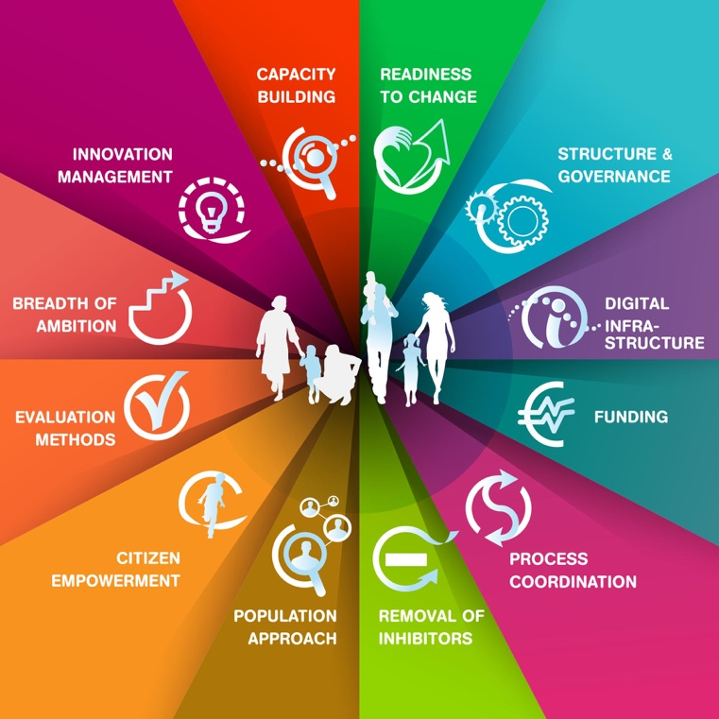

SCIROCCO Exchange Maturity Model for Integrated Care
Recent Publications (minimum 5)
- Grooten L (2020) The transfer of knowledge on integrated care among five European regions: a qualitative multi-method study 20:11.
2. Grooten, L (2019) Assessing the maturity of the healthcare system for integrated care: testing measurement properties of the SCIROCCO tool 19:63.
3. Grooten et al. (2019) A scaling-up strategy supporting the expansion of integrated care: a study protocol 6.
4. Grooten et al (2018) An Instrument to measure maturity of integrated care: A first validation study 18 (1):10.
5. Pavlickova, A (2017) SCIROCCO tool to support delivery of integrated care in Europe 17(5): A504


Jon Txarramendieta holds an Engineering in Industrial Organisation (University of Deusto, 2010) and Master’s degree in Health Management (Deusto Business School, 2015). In 2017, he obtained the Expert Course in Health Services and Chronic Diseases Research (University of Alcalá, Madrid). He has experience in the implementation of health services in national and European projects’ context. Since 2016 he has been involved in different EU-funded projects as a Project Manager at KRONIKGUNE.

Email: jtxarramendieta@kronikgune.org

