Evolution of Building Resilience in a Timeline of 11 Years: a Holistic Practice of Oman Healthcare Sector during Catastrophic Cyclones
Juhina S AlShamsi , BSc, Yahya Construction LLC, Sultanate of Oman

Abstract (300 word limit)
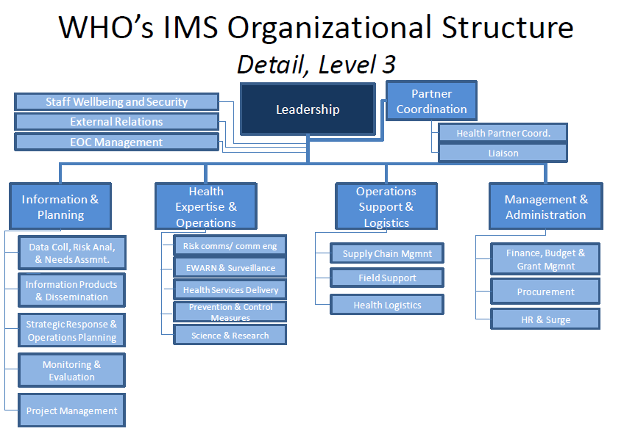
Statement of the Problem: Situated in the southeastern coast of Arabian Peninsula, Sultanate of Oman is to encounter a cyclone every five years. This has demanded additional efforts of emergency management. What are the characteristics associated with health institutions in Oman that have manifested resilience practices, despite the steady increase in tropical storms? Oman’s role in safeguarding through healthcare institutions has elucidated, from cases of maintaining bed capacity during a category five cyclone in 2007 to a full evacuation of hospitals within 48 hours in 2018. This study introduces a holistic approach to building disaster resilience through preparedness and response actions in a timeline of 11 years. Methodology & Theoretical Orientation: Oman’s practices of emergency management are assessed with Safe Hospital Framework provided by the World Health Organization (WHO). The qualitative results are measured with respect to WHO Response and Recovery checklists. Key components being analyzed include but not limited to, sustainable infrastructure, livelihood affairs, and crosscutting matters. Along with deductive interviews, Communications Center, from Oman Ministry of Health (MoH), has been utilized to acquire quantitative research materials. Conclusion & Significance: It has become evident that Oman Incident Management System (IMS), operating under the National Committee for Civil Defense (NCCD), is evolving through a short period. Over the past ten years, the government has expanded the number of medical centers to meet the demand of healthcare capacity. To ensure competence, hospitals in Oman are gradually becoming decentralized since decentralization policy first took an effect in the 1990s. Additionally, over 80% of the public hospitals started to operate electronically (e.g. adopting a cashless transaction system). These efforts have preserved common goals on protecting patients and healthcare workers through investing in medical care infrastructure.

Image

Recent Publications (minimum 5)
- Juhina Said Al Shamsi (2016), “Emergency Operations Centers: May 2015 Texas Flooding and Flooding in Oman Case Study”
*The paper was accepted for a poster presentation at the Annual Collin College Undergraduate Interdisciplinary Student Research Conference in Texas, USA.



Biography (150 word limit)
Juhina Al Shamsi is a capable and passionate emergency management practitioner. She obtained her Bachelor’s degree in Emergency Administration along with studies in Entrepreneurship from University of North Texas. When working for Grand Prairie Fire Department, She established information materials to educate the public on the public alerting system as well as participating in reviewing the city preparedness plan. Above all, she has demonstrated strong research skills as evidenced by a poster presentation, addressing EOC activations, in which she received an intellectual property for in 2018. Findings highlighted the importance of EOCs on analyzing risks and on drawing very effective emergency conclusions. The approach collates with an adequate action heavily depends on an office-oriented coordination, number of activation hours, and advanced technology systems. As she intends to develop public safety procedures in the healthcare sector, her current paper reflects the healthcare’s evolution during emergencies based on case studies.
Email: juhina.alshamsi@hotmail.com

Notes/Comments:

Thanks & regards!

