DENGUE CONTROL AND PREVENTION STRATEGIES LEARNT FROM VARIOUS DENGUE OUTBREAKS IN TAMIL NADU, INDIA.
PARASURAMAN BASKER.Ph.D
Abstract
Statement of the Problem: Dengue Fever (DF) and its severity, Dengue Hemorrhagic Fever (DHF) and Dengue Shock Syndrome (DSS) are prevalent almost in entire globe since a decade seasonally as well as perennial in some parts of tropical countries. Strategies on the control and prevention of dengue have been dealt with reference to outbreaks occurred in Tamil Nadu, India.
In the present discussion, strategies employed in different dengue outbreaks have been taken. Epidemiological factors associated with agent, hosts and environments have been analyzed to implement appropriate interventional strategies. The observations made from each outbreak and their control measures are highlighted hereunder
- Among Dengue serovars DEN-1, 2, 3 and 4, either single serovar or its combinations of 1 and 3 are prevalent in all outbreaks. Mortality due to dengue was observed among individuals those had infected the new serovar from the first exposure of virus.
- Diagnostic tool NS-1ELISA is as effective as the sample to be tested is eligible even on second day of onset of fever whereas the sample for Ig-M MAC ELISA would be employed after fifth day of onset of fever. This observation was lead to implement all containment measures as early as possible.
- Since there is no specific treatment for DF, the supportive therapy herbal based Nila vembu Kudineer (alkaloid in the herb Nila vembu) was witnessed as effective to enhance platelets.
- Entomological surveillance in which permissible level of indices House Index (< 1%) and Breteau Index (< 5) were required to control dengue. The same indices should be kept minimum 200 meters in human dwellings as the flight range of dengue vectors is 100-200 meters.
- It was known that man power engaged for entomological surveillance in different tiers should be statistically significant with that of observation made by supervisors.
- It was observed that the place where the positive cases are being reported even after permissible level of entomological surveillance is due to either the existence of hidden breeding sites or due to the establishment of Trans ovarian transmission.
- The incubation period of viruses is 10-15 days in infected human. It is the time bound for halting the outbreak. If it is extended, evaluation on control measures with the interrelationship between agent, host and environment is absolutely required.
The above strategies would be discussed in the forum.
Biography:
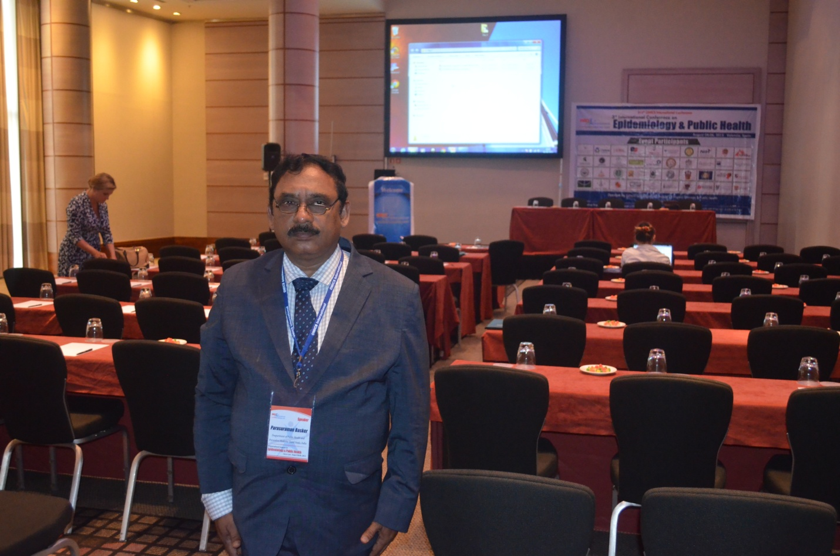

Biography: Dr.Parasuraman Basker had been awarded Doctoral degree in zoology at the age of 29 years old from Annamalai University, Tamil Nadu, India. Following it he was Research Associate in ICAR and UGC research projects on the fauna of Carabids (Coleopteran Insect) in South India and mosquito cytogenetic in the University of Agricultural Sciences, Bangalore and Bangalore University respectively. Subsequently, he entered into Tamil Nadu public Health service through Tamil Nadu Public Service Commission (TNPSC) for the post of SENIOR ENTOMOLOGIST in 1995. Since then, he had been working as Senior Entomologist in the Department of public Health and Preventive Medicine which assigns for the prevention and control of vector borne and Zoonotic diseases. He taught Medical Entomology to MBBS students in the Government Stanely Medical College since 2006 to 2008.
Experiences gained from his field activities have been shared in national and international conferences and published research papers in the leading both national and international scientific journals. To show his consistency in research, 34 Research Abstracts presented in 9 International and 25 National Conferences since 1983. In his credit, 22 research papers have published in reputed national and international journals. He visited Canada, Malaysia, Morocco, Singapore, Spain and Birmingham (UK) as presenters with the Government of India Travel Grants (CSIR, INSA, ICMR and NHM).
He is the recipient of Professor Kameswara Rao award for his best presentation in the National conference sponsored by Applied Zoological Research foundation, IRRI, Cuttack, Orissa which was held at Valvada, Gujarat in 1998. He was the recipient of the Appreciation award from the District Collector, and from the Honorable Minister for Health & Family welfare to the Government of Tamil Nadu for outstanding contribution in prevention and control of vector borne diseases during 2017. He was retired from the service on 30.06.2018.
Email: drbasker60@gmail.com P.Basker

