A framework for law-making in the age of digital health
Bianca Phillips, LLB. BComm. GradDipLP. LLM (telemedicine). Completing a doctoral thesis in law (law-making).

Abstract (300 word limit)
Statement of the Problem: Digital health is an area of interest for research institutions and governments around the world due to its potential to limit the global burden of disease through better disease prediction and prevention. In the digital age, law-makers have immense power over the pervasiveness of digital health technologies in our society. Indeed, oftentimes, it is the law which provides the foundations for what is permissible or not; how technologies can be created, developed and used clinically or commercially. The law may also establish rules that impact on civil rights, privacy, security and data ownership which are fundamental societal issues. This research considers a case study to examine how laws are made within a specific field of digital health to determine the extent by which substantive legal issues were considered by law-makers, and how accountable law-makers were for the reasons of their decisions. The case study was the Australian My Health Record System (national e-health record system). Methodology & Theoretical Orientation: A historical documentary review of public record information was undertaken to ascertain information on law-making processes utilised. The theoretical basis for the review was the legal process school, established by former Harvard Law Professors, Henry Hart and Albert Sacks. Preliminary Findings: The law-making process for Australian e-health record system did not encourage the production of high-quality references in support of statements of clinical efficacy. Further, at times, no references were provided to support statements of clinical efficacy. Additionally, it was found that substantive legal issues were not appropriately assessed, including those of data ownership and human rights, despite the fact that human rights concerns were brought to the attention of the federal government by the Parliamentary Joint Committee on Human Rights, and the Human Rights Commission. Recommendations: The paper proposes a framework for law-making. It comprises of a series of broad considerations for law-makers in the field of digital health. The framework could have applications from the level of private decision-making through to legislative decision-making, and with further assessment, it could potentially be applied across jurisdictions. The proposed framework consists of 8 pillars of law-making founded on the belief that principles of human rights, clinical and societal benefit, as well as harm and risk reduction are essential considerations of law-making in the field of digital health.

Image

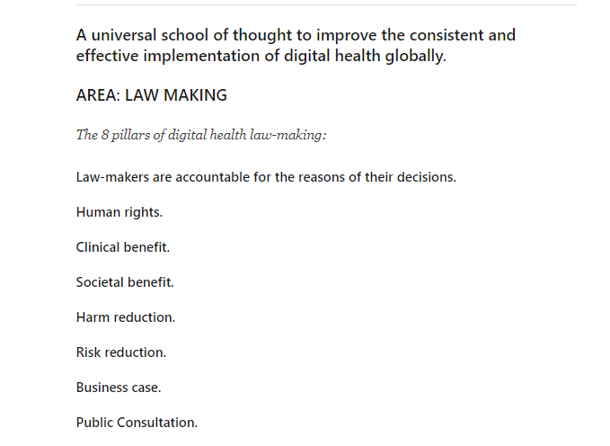
Recent Publications (minimum 5)

- Comparison of e-Health Records: Australia versus the US, Mar 2019, Medical Journal of Australia, InSight.
- Telemedicine for diabetes and heart failure: an evidence review, Feb 2019, Medical Journal of Australia, InSight.
- Digital health success hinges on four principles, Jan 2019, Medical Journal of Australia, InSight.
- My Health Record: Legal Challenges, Dec 2018, Medical Journal of Australia, InSight.
- Making the Digital Health Revolution, Oct 2018, Medical Journal of Australia, InSight.
- My Health is shifting the control paradigm, Aug 2018, The Australian Hospital and Healthcare Bulletin.
- Submission to the My Health Record Senate Inquiry, 2018.
- A series on the digitisation of medical information Part 2: the laws of digitised medicine​, Aug 2016, Lexis Nexis AU.
- Ownership challenges for MyHealth, 21 Jun 2016, Medical Journal of Australia, Insight.
- Series on the Digitisation of Medical Information: Electronic Health Records in Australia, Recent Changes, 19 May 2016, Lexis Nexis AU.
- Series on digitised medicine: assessing the benefits and limitations of electronic health, Mar 2016, LexisNexis AU.
- The digitisation of medical information and the implications for privacy, Nov 2015, LexisNexis AU.
- Patent Challenges, Oct 2015, Medical Journal of Australia, Insight.
- Comment on the ALRC Report into Serious Invasions of Privacy in the Digital Era, Jun 2015, LexisNexis AU.
- New Victorian Privacy and Security Laws, Apr 2015, LexisNexis AU.
- Preventive IVF, 16 Feb 2015, Medical Journal of Australia, Insight.
- Submission to Expert Review of Medicines and Medical Devices, Jan 2015.
- The e-health records cloud, Dec 2014, Law & Society Conference, The University of Queensland.
- Telemedicine: Jurisdiction in the Cloud (Volume 11, No 8), Sep 2014, LexisNexis AU.
- Telemedicine Risks, Aug 2014, Medical Journal of Australia, Insight.
- Law in the age of telemedicine, Jul 2014, Speaker at the Swinburne University eResearch Symposium.
- Telemedicine Security Governance: Lessons from a recent OAIC Audit Report (Volume 11, No 6), Jul 2014, LexisNexis AU.
- Telemedicine: The legal duties of the health practitioner (Volume 11, No 7), Jul 2014, LexisNexis AU.
- Who owns health data? (Volume 11, No 5), Jun 2014, LexisNexis AU.
- Telemedicine Governance: Individual Physicians and Hobby App Developers (Volume 11, No 4), May 2014, LexisNexis AU.
- Why privacy is the key to gaining consumer trust of e-health (Volume 11, No 3), Apr 2014, LexisNexis AU.
- The e-health records cloud, Mar 2014, Presented at the 23rd Annual Medico Legal Congress 2014 in Sydney.
- ehealth: in the press (Volume 11, No 2), Mar 2014, LexisNexis AU.
- Telemedicine: why the law must change to promote a better healthcare system (Volume 11, No 1), Feb 2014, LexisNexis AU.
- The e-health records cloud – how and why the law must change to promote better privacy in healthcare (Volume 11, No 1), Feb 2014, LexisNexis AU.


Biography (150 word limit)
Bianca is advocating for a future where telemedicine allows for access to healthcare no matter where you live, where the mainstream use of wearables allows us to predict the onset of disease before it happens, and where clinical outcomes are improved because of uses of precision and personalised medicine. She believes that the digital health future should balance the needs of both patients and healthcare providers by placing human rights, evidence-based clinical benefits, risk and harm reduction at the center of digital health law-making, prior to matters of a business case being established. She aims to be a prominent voice for a Digital Health School of Thought founded on these principles. She has established a network for digital health thought leaders, and all are welcome to join for updates, to express an interest in joining the team, or to list your initiatives on the website - www.e-healthconsultants.com
Email: brphillips@swin.edu.au

