Using latent class analysis to identify the association between latent class inpatient length of stay: a case study
Christina Scolieri, MSL, USMC-R
Winston W.H. Eng, BSE, MS
Joshua Foley, PharmD
Benjamin Cassidy, PharmD
Daniel Edmonds

Abstract (300 word limit)
The primary objective of this case study was to identify differences in length of stay (LOS) in patients undergoing total hip arthroplasty (THA) that are associated with medications administered within a latent class assignment (LCA). The patient population included all patients who underwent total hip arthroplasty (THA) from August 2017 through June 2018 (n=248) in a 430-bed acute care hospital located in northeastern Ohio. Utilizing Latent Class Analysis to identify medication groupings by patient, and a subsequent zero-truncated negative binomial regression model (ZTNB) analysis, we were able to assess the differences in mean length of stay between latent class assignments. With LC1 as an initial reference point, patients assigned to LC2 had an increase in length of stay of 4.5 days (P <0.001). Setting the reference point at LC2, a decrease of 0.68 days (P < 0.001) length of stay was associated with patients assigned to latent class 3 (LC3) instead of LC2. A second iteration of the ZTNB model including eight additional covariates also yielded statistically significant values between latent class assignment and length of stay. The results of each analysis iteration, whether including or excluding covariates, yielded consistent results in statistically significant value differences in the LC1 vs. LC2 length of stay values and LC2 vs LC3 length of stay.

Image
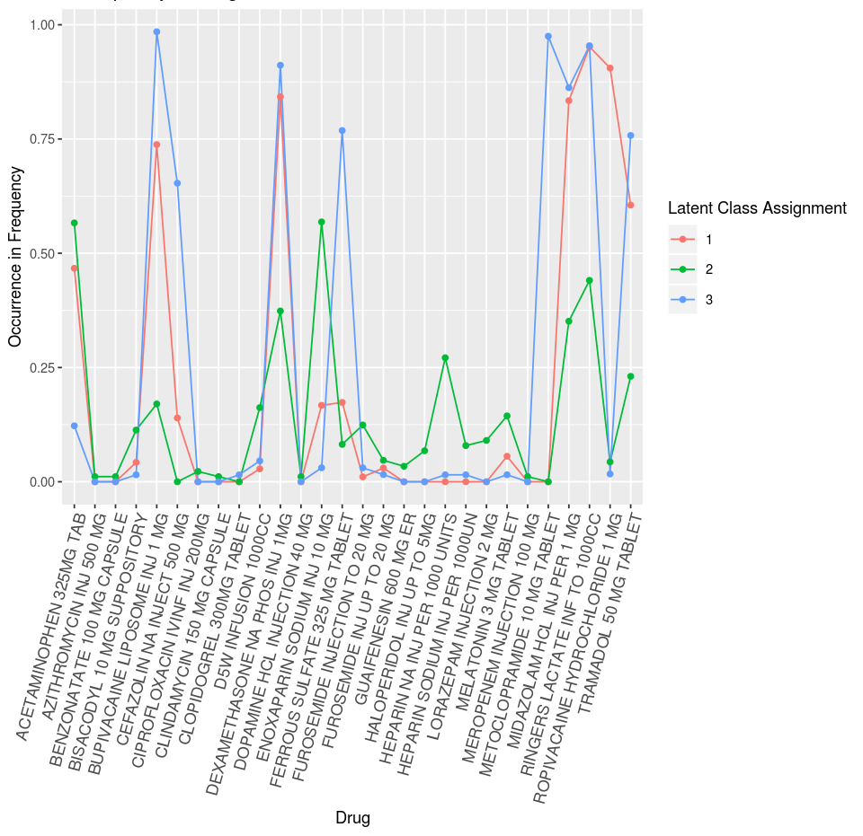
Recent Publications
- Scolieri, C., Eng, W., Foley, J., Cassidy, B., Edmonds, D. Using latent class analysis to identify the association between latent class and inpatient length of stay: a case study. Manuscript submitted for publication. 2018. 1-13.
- Chatter, R., Scolieri, C. Opioid Abuse and Misuse: Pharmacy’s Role in Prevention, Monitoring, and Management. White Paper. 2018. 1-12.
3. Scolieri, C. (2014, March 28). ACA Obstacles [Letter to the Editor]. Pittsburgh Post-Gazette, n.p. Retrieved from https://www.post-gazette.com/opinion/letters/2014/03/29/ACA-obstacles/stories/201403290042

Biography (150 word limit)
Christina Scolieri, a United States Marine Corps veteran and expert in Health Law has devoted her career to improving patient care and outcomes. Having worked in both academia and the medical device and pharmaceutical industry, she has built a model utilizing evidence-based criteria measurements paired with industry initiatives in order to facilitate true change within an organization to improve patient outcomes. The foundational idea behind many of Christina’s patient initiatives is behavioral change. Data allows us to create brilliant algorithms and subsequent outputs, but in her opinion, the real challenge comes from the implementation of the output, and that is the behavioral component. This unique perspective has allowed for significant findings and improvement for partner facilities whom have partnered with Christina and Omnicell’s Performance Center.

Email: christina.scolieri@omnicell.com

Notes/Comments:
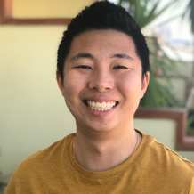 Winston Eng, a Bioengineer and Biostatistician would also be presenting this research topic in tandem with Christina Scolieri. Winston has spent much of his career in genomics and more recently has made the transition to the pharmaceutics and medical device industry. During his time with Omnicell, Winston has been integral in creating algorithms and AI models that allow us to improve patient care models and outcomes.
Email:
winston.heng@omnicell.com

