Abstract

Integration of Geo-spatial technology and Hydraulic Models to map flood Prone Areas in Woybo River Catchment, South Western Ethiopia, Aschalew Fekadu1,*, Daniel Teka2, Kassa Teka2,
1Department of Natural Resource Management, Institute of Geo-information and Earth Observation Sciences (I-GEOS), Mekelle University
2Department of Land Resources Management and Environmental Protection, Mekelle University

Keywords: Remote Sensing, Design rainfall; Design runoff; HEC-RAS

- Abstract

Flooding is one of the major challenges globally threatening human life. In Ethiopia there are limited research efforts that address challenges related to flooding through integrated approach of satellite imageries and hydraulic models. In this study, integration of Geo-spatial technology and one-dimensional (1-D) HEC-RAS model was used in Woybo River catchment. The Required data set, a remotely sensed land sat 7 image of march 2013 with a spatial resolution of 30m, were downloaded from united states geological survey. These images were classified into different land cover types so as to use them for estimating the roughness coefficient of the various cover types. Daily peak rainfall data were collected from two metrological stations (1990 – 2013) to estimate design rainfall and runoff corresponding to5, 10, 25, 50, 100 and 200 return period. Steady flow analysis was carried out in HEC-RAS to evaluate the flooding risk zones along the river. The result showed that the estimated design rainfall corresponding to these return periods is 63.2, 70.87, 80.57, 87.77, 94.91 and 102.02 mm and estimated runoff corresponding to these return periods is378, 461, 568, 650.5, 733, and 817m3/sec. Up to 1987 ha of land can be inundated through a runoff having a 200 yr. return period and that flood prone areas were at the lower reach along the River extending to 50m from the river banks. The results were verified using ground-based assessment corresponding to the various return periods.

Image:

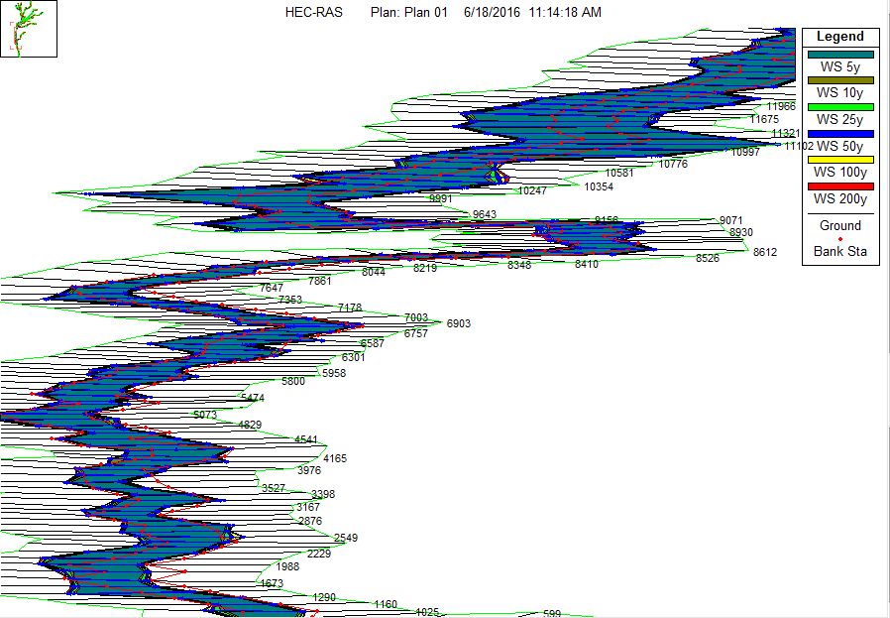
- Reference:

- Agarwal, M.C. Katiyar, V. S. & Babu, R. (1988). Probability analysis of annual maximum daily rainfall of U. P., Himalaya. Indian Journal of Soil Conservation 16(1, 35-42).

- Abhas, k. Robin, B. & Jessica, L. (2012). Cities and flooding. Integrated urban flooding risk management for the 21st centry. p 21/638

- Asgar, S. H. Alireza, P. & Majid, R. (2013). Flood Zoning in Rural Watersheds by GIS and HECGEO-RAS in North western Iran. Greener Journal of Science, ISSN: 2276-7835 Vol. 3.

Biography:
I graduated my MSc at the age of 25 years from Mekelle University I-GEOS. I am the Director of Datum Geo-spatial consultancy PLC, Transport infrastructure asset management expert in AACTPMO. I have published 2 papers in OMICS journals and I have been serving as an editorial board member of national journals.

Presenting author details

Aschalew Fekadu +2519 13 20 56 02
Twitter account:@aschalew_f
Linked in account: mmbalm11@gmail.com
Session name/ number:
Category: (Oral presentation/ Poster presentation)
Passport Number: EP4541020

