Growing teratoma syndrome following recurrence of ovarian immature teratoma: a case report
Neringa Musteikaite, MD, Lithuanian University of Health Sciences
Jurgita Makstiene, MD, PhD, Lithuanian University of Health Sciences

Abstract

Immature teratoma is a malignant germ cell neoplasm that comprises from 20% to 50% of malignant ovarian germ cell neoplasms. Growing Teratoma Syndrome (GTS) is a clinical pathological condition defined as the occurrence of a neoplastic mass consisting exclusively of mature teratoma in combination with normal levels of neoplastic markers during or after chemotherapy in patients with Germ Cell Tumors (GCT). The incidence of GTS is 12% of overall ovarian GCT and is most likely to occur if mature teratoma elements are found in the primary neoplasm. Being unfamiliar with the disease entity, many oncologists may misinterpret this syndrome as a disease progression.

A 17-years-old girl as a result of suspected lower abdominal neoplasm, was hospitalized to the Hospital where surgically resected left ovarian neoplasm was identified as a pure immature teratoma. After 6-months follow-up elevated neoplastic markers in addition to a neoplasm under the right ovary were detected. A pure immature teratoma was diagnosed after surgical procedure, and 2 courses of chemotherapy were conducted. Nevertheless, the second episode of

recurring neoplasm at the paraaortic site and rectal serosa diagnosed as a mature teratoma was detected after 2 months post-chemotherapy periods. 4 months later, a polycystic right ovarian lesion was identified during control tests. Moreover, no elevation of neoplastic markers was detected, and a strategy of close follow-up was established.
Our clinical case reflects a position that GTS neoplasms are resistant to chemotherapy and should be surgically resected to have a positive long-term prognosis. Furthermore, a potential of malignant
degeneration demands a thorough histological investigation and constant post-surgical follow-up is required in order to prevent the event of neoplastic disease recurrence. It remains unclear, whether this teratoma maturation pattern is a result of neoplasm’s exposure to chemotherapy, or it can be a natural, rarely occurring behaviour of this neoplasm.

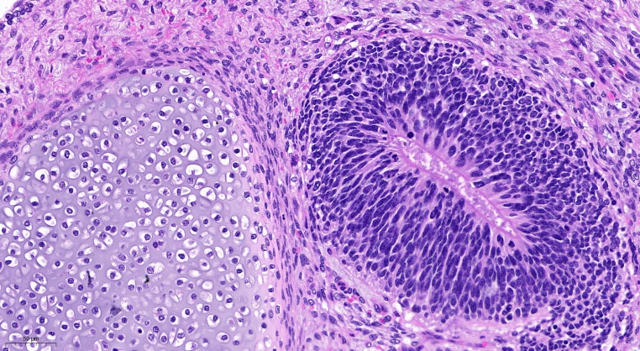
Figute 1: Immature teratoma: immature neuroectodermal tissue(right) consists of a rosette composed of primitive, mitotically active cells with increased N:C ratios and hyperchromatic nuclei is seen adjacent to cartilage, H&E 25X.

Recent Publications

1.Imran H, Siddiqui A, Wilson F, Pashankar F. Growing Teratoma Syndrome After Chemotherapy For Ovarian Immature Teratoma. Journal of Pediatric Hematology/Oncology. 2019;42(7):e630-e633.

2. Pashankar F, Hale J, Dang H, Krailo M, Brady W, Rodriguez-Galindo C et al. Is adjuvant chemotherapy indicated in ovarian immature teratomas? A combined data analysis from the Malignant Germ Cell Tumor International Collaborative. Cancer. 2015;122(2):230-237.

3. LI X, ZHU D, LV L, YU J. An uncommon recurrence of an immature teratoma: A case report. Oncology Letters. 2016;11(4):2453-2456.

4. How Common Is the Growing Teratoma Syndrome in Patients With Ovarian Immature Teratoma?. International Journal of Gynecologic Cancer. 2017;27(2):409.1-409.

5. Xue-Lian Li, Xian-Rong Zhou, Hua Jiang. Growing teratoma syndrome following primary ovarian immature teratoma: two cases and review of literature. Int J Clin Exp Med 2016;9(2):4858-4865



Biography
Neringa Musteikaite has completed her medical studies at the age of 24 years from Lithuanian university of Health Sciences and she is the fourth-year pathologist resident doctor from Lithuanian university of Health Sciences. She is the member of Lithuanian Society of Pathology. She has presented an oral reports at the 11th international congress on clinical and medical case reports and at the conference organised by Lithuanian Society of Pathology.
Email:neringa.musteikaite@gmail.com

Notes/Comments:

