Fetal Alobar Holoprocencephaly
Maherunnessa¹, Shahana Shermin², Hemonta Poddar³

Abstract:
Alobar Holoprocencephaly is a very rare fetal congenital malformation. It is a disorder caused by the failure of procencephalon(forebrain) to sufficiently divide into the double lobed cerebral hemisphere. The result is a single lobed brain with skull and facial defects. Here we report a case of alobar holoprocencephaly detected by USG at 29 week of gestation though the routine 22 week anomaly scan was normal. She was counseled regarding the poor outcome of fetus with such disorder but she decided to continue the pregnancy up to term. She was admitted at her 38 weeks of pregnancy and delivered a male baby with congenital birth defects- alobar holoprocencephaly with cleft palate with cleft lip and absence of nasal bone.

Authors:
- Associate Professor, Ibrahim Medical College & BIRDEM General Hospital, Dhaka, Bangladesh.
- Senior Medical Officer, BIRDEM General Hospital, Dhaka, Bangladesh.
- Intern Doctor, BIRDEM General Hospital, Dhaka, Bangladesh.

Figures:
Fig 1: USG showing undivided cerebral hemisphere 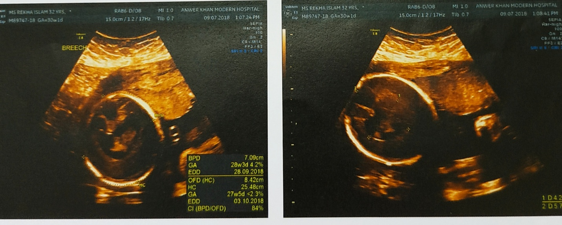

Fig 2: Newborn with cleft lip, cleft palate and absent nasal bone
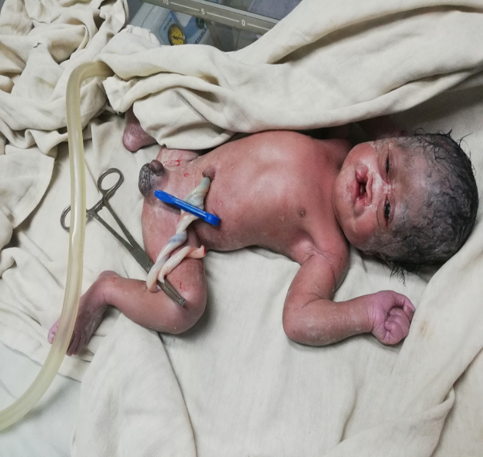

Reference:
1. National Institute of Neurological Disorders and Stroke. Holoprosencephaly information page [Internet]. 2007. Available from: http://www.ninds.nih.gov/disorders/ holoprosencephaly/holoprosencephaly.htm
2. National Human Genome Research Institute. Learning about holoprosencephaly [Internet]. 2012. Available from: https://www.genome.gov/12512735.
3. Poenaru MO, Vilcea LD, Marin A. Holoprosencephaly: two case reports. Maedica 2012; 7(1):58-62.
4. Raam MS, Solomon BD, Muenke M. Holoprosencephaly: a guide to diagnosis and clinical management. Indian Pediatr 2011; 48(6):457–66.
5. Solomon BD, Gropman A, Muenke M. Holoprosencephaly overview [Internet]. 2000 Dec 27 [Updated 2013 Aug 29].Seattle (WA): University of Washington 2013; 13(4):87-91.
6. Desai J, Rohena OL. Holoprosencephaly clinical presentation. E med 2014; 40(5):679-80.
7. Amold WH, Meiselbach V. 3-d reconstruction of a human fetus with combined holoprosencephaly and cyclopia. HeadFace Med 2009; 5:14.
8. Tonni G, Ventura A, Centini G, De Felice C. First trimester three-dimensional transvaginal imaging of a lobar holoprosencephaly associated with proboscis and hypotelorism (ethmocephaly) in a 46,XX fetus. CongenitAnom (Kyoto) 2008; 48(1):51-5.
9. Swatek J, Szumiło J, Burdan F. Alobar holoprosencephaly with cyclopia - autopsy-based observations from one medical centre. Reprod Toxicol 2013; 41:80-5.
10. Niknejadi M, Ahmadi F, Irani Sh. Holoprosencephaly: A case report and review of prenatal sonographic findings. IntJ Fertil Steril 2008; 2(1):39-42.

Biography:
Dr Maherunnessa has completed FCPS from Bangladesh College of Physicians & Surgeons (BCPS) in 2003. She is currently employed as an Associate Professor of Gynaecology & Obstetrics at BIRDEM, Dhaka. She has published 14 papers in different journals.

Presenting author details:
Full Name: Dr Maherunnessa Mukta
Contact Number: 01817049296
Email: mmaherun@gmail.com
Category: Poster presentation

