Fetal Hydrops from Cardiac Arrhythmia with Postnatal Resolution
Nina Nonette P. Diansuy, MD, Department of Obstetrics and Gynecology, Philippine General Hospital, Philippines
Ireene S. Cacas-David, MD, Department of Obstetrics and Gynecology, Philippine General Hospital, Philippines

Abstract
Sustained fetal cardiac arrhythmias can cause cardiovascular failure subsequently leading to nonimmune fetal hdyrops. This is a case of a 29-year old primigravid, who delivered via primary low segment cesarean section a live baby girl with fetal hydrops, 33 weeks by pediatric aging, 2100 grams, with an Apgar score of 5 becoming 7. The initial antenatal surveillance was unremarkable at 22 weeks age of gestation until she presented with an incidental finding of fetal hydrops (ascites, scalp edema) and fetal bradyarrhythmia (78-82 bpm) with occasional premature atrial contractions at 24 weeks age of gestation. Work-up for the cause of hydrops was negative for immunologic, structural, infectious and hematologic causes. Management of fetal sinus bradycardia with premature atrial contractions is only supportive and warrants close antenatal fetal surveillance because it is usually well-tolerated by the fetus and spontaneously resolves before or after delivery. However, the presence of hydrops may be a marker of worsening cardiovascular function from the sustained bradycardia. Timing of delivery is important to balance the risks and benefits to both mother and fetus. The sinus bradycardia persisted postnatally with no structural defects or heart blocks on electrocardiogram and echocardiogram. Inotropic medications, such as dopamine, epinephrine and caffeine, were given to the newborn to increase the heart rate and was subsequently tapered down and discontinued. Serial abdominal examination showed decreasing abdominal girth from 32 cm at birth to 29 cm upon discharge. The baby was discharged after 30 days, with good activity and complete resolution of the ascites and edema. Fetal heart rate improved from 80-98 beats per minute to 90-122 beats per minute, off any medications. Follow-up after 1 year showed an infant at par with developmental milestones expected for her age.
Image
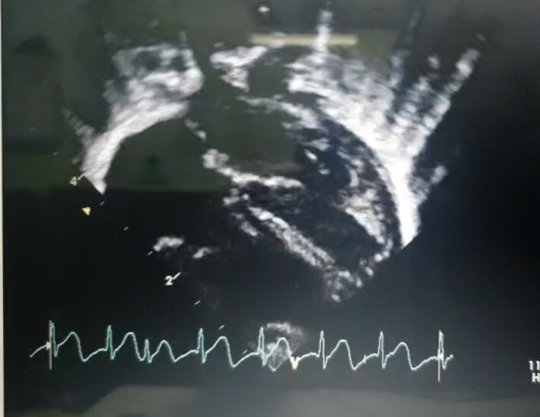

Figure 1. 2D echocardiogram showed good biventricular activity, sinus bradycardia with a structurally normal heart and a 1:1 atrioventricular ratio with occasional premature atrial contraction.
Recent Publications
- Creasy RK, Resink R, Iams J, Lockwood C, Moore T, Greene M. Creasy and Resnik’s Maternal-Fetal Medicine Prinicples and Practice. Elsevier Saunders. 7th edition. 2014.
- Montreal V, Montreal F, Wilson R, Montreal F, Halifax J. Investigation and Management of Non-immune Fetal Hydrops . SOGC Clinical Practice Guideline. J Obstet Gynaecol Can 2013;35(10):e1–e14.
- Bravo-Valenzuela N, Rocha L, Nardozza LM, Junior E. Fetal Cardiac Arrhythmias: Current Evidence. Ann Pediatr Card 2018;11:148-63.
- Parilla B, Starsburger J. Fetal Arrhythmias. The Global Library of Women’s Medicine. ISSN: 1756-2228) 2008.
- Miyoshi T, Maeno Y, Sago H, Inamura N, Yasukouchi S. Fetal Bradyarrhythmia Associated With Congenital Heart Defects. Circulation Journal. 2015; 79: 854–861.
- Abdel-Hady H, Nasef N, Shabaan A, Nour I. Caffeine Therapy in Preterm Infants. World J Clin Pediatr. 2015 Nov 8; 4(4): 81–93.
- Strasburger J, Wakai R. Fetal Cardiac Arrhythmia Detection and In Utero Therapy. Nat Rev Cardio. 2010 May; 7(5): 277-290.
Photograph



Biography

Dr. Diansuy is a senior Perinatology fellow at the Philippine General Hospital, specializing in high-risk pregnancies. Her passion to improve perinatal outcomes of complicated pregnancies in a third world country, lead her to specialize in Maternal and Fetal Medicine. She already had published a research study on evening primrose oil capsule as an alternative and cheaper cervical ripening agent to Dinoprostone. Her goal is to contribute more research studies that would benefit the underprivileged for better pregnancy outcomes.
Email: nonette.diansuy@gmail.com

