CASE REPORT in Oman: Successful Pregnancy after Combined B lynch and Bakri Balloon
Zaplan, R., Al-Fana, A., Desierto, M.
- Abstract
The combined use of B-lynch suture and Bakri balloons known as “uterine sandwich” has not been extensively reported in literature. Although there are case reports that described its successful use for intractable postpartum haemorrhage and effective future fertility preservation with some reported cases of endomyometritis.⁷ Its limited case report of pregnancy inspired to share about the outcome of this successful pregnancy after catastrophic PPH complication from previous caesarean section managed with “uterine sandwich” technique. This also impart solution to manage pyometra or endomyometritis as part of the complication in this procedure. A 39-year-old woman, gravida 6, para 4, abortus 1, at 32-week gestation was admitted from emergency with vaginal bleeding and labour pain. She has previous two low segments caesarean section (LSCS) where the last LSCS was complicated with massive PPH controlled with B-lynch suture and Bakri balloon. She received 4 PRBC and admitted in ICU with abdominal drain. This complicated with pyometra and abdominal collections. She underwent suction curettage and insertion of pigtail for intrauterine drainage. Patient responded well with proper antibiotics, anticoagulation, and multidisciplinary co-management with the surgeon, microbiologist and internist. She recovered and discharged in her day 21 post-operative and advised completion of antibiotics for 7 days more. After 3 years of this LSCS, she got pregnant and had her booking visit in Armed Forces Hospital (AFH) at 23 weeks gestation. She was booked for elective repeat LSCS at 36-37 weeks gestation. When she presented in emergency, she was taken for emergency LSCS and delivered to a live baby boy with weight 1905 grams and apgar score of 6,8. Intraoperative findings showed abdominal wall adhesions up to the peritoneum obliterating the lower anterior wall and bladder cannot fully visualized. Uterine contour was still intact with minimal filmy to band adhesions to omentum and upper anterior abdominal wall and patient went home after 4 days.

Figure 1.

Abdominopelvic CT showed uterus bulky with large fluid collection within the endometrial cavity 85 mm x 65 mm x 95 mm with stippled air densities within. Multiple lower abdominal intraperitoneal and abdominal wall collections with air pockets within. Enlarged endometrial cavity with significant amount of fluid and air pockets with. Endometritis was highly suspicious caused by gas producing organism.

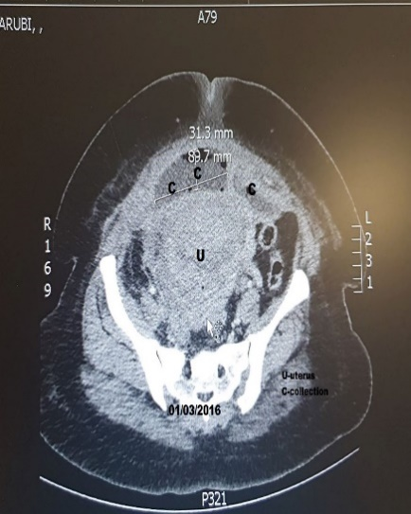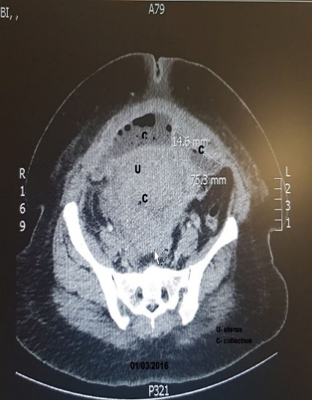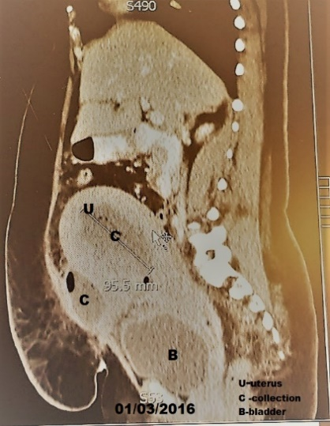

Figure 2
Repeated abdominal CT scan done on day 17 post-operative day which showed uterus bulky with large fluid within the endometrial cavity with multiple air density within it.

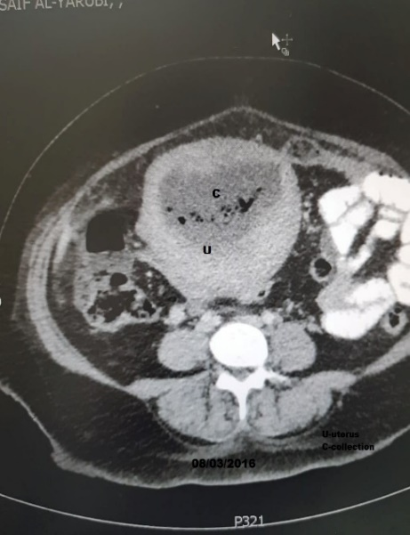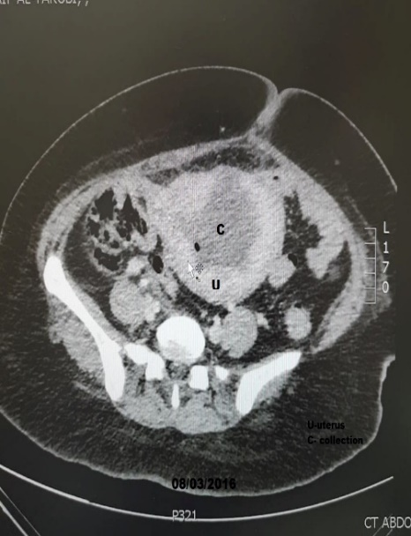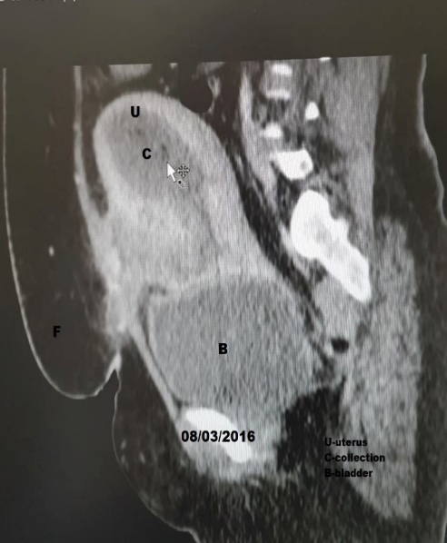

- References:

- H. A. Mousa and Z. Alfirevic, “Treatment for primary postpartum haemorrhage,” Cochrane Database of Systematic Reviews, no. 1, Article ID CD003249, 2003.
- World Health Organisation, The Prevention and Management of Postpartum Hemorrhage. Report of a Technical Working Group, WHO, Geneva, Switzerland, 1990.
- D. Danso and P. Reginald, “Combined B-lynch suture with intrauterine balloon catheter triumphs over massive postpartum haemorrhage,” International Journal of Obstetrics and Gynaecology, vol. 109, no. 8, p. 963, 2002.
- M. Harma, N. Gungen, and A. Ozturk, “B-Lynch uterine compression suture for postpartum haemorrhage due to placenta praevia accreta,” Australian and New Zealand Journal of Obstetrics and Gynaecology, vol. 45, no. 1,
- Application of the B-Lynch brace suture with associated intrauterine balloon catheter for massive haemorrhage due to placenta accreta following a second-trimester miscarriage Journal of Obstetrics and Gynaecology 26(3):267-8 · May 2006
- The difficult pph- experience of combined use of B-lynch brace suture and intrauterine Bakri Balloon York hospital K Merrick, O Jibodu,U Rajesh
- Successful term delivery after Khairy’s modified B-lynch suture technique: First case report
Middle East Fertility Society Journal 22(1):87-90 · March 2017
- The uterine sandwich for persistent uterine atony: Combining the B-Lynch compression suture and an intrauterine Bakri balloon. American journal of obstetrics and gynecology 196(5):e9-10 · June 2007
- Use of combination method (uterine sandwich technique) to control postpartum hemorrhage Atmajit Singh Dhillon, Karminder Dhillon* l. Int J Reprod Contracept Obstet Gynecol. 2018 Jul;7(7):2753-2758

- Biography
Dr. Rowena A. Zaplan is a consultant in Obstetrics and Gynaecology in Armed Forces Hospital (AFH), Oman and joins the prestigious hospital since 2013. She works as a clinician and an associate professor for 15 years. She is a medical graduate from Philippines and a certified Fellow of Philippine Obstetrics and Gynecology Society (POGs).
Dr. Amal Al Fana is a consultant in Obstetrics and Gynaecology (Minimal Invasive Gynecology Surgery) in AFH, Oman.
Dr. Michelle Desierto is a specialist in Obstetrics and Gynaecology in AFH, Oman. She is a medical graduate from Philippines and a certified Fellow of Philippine Obstetrics and Gynecology Society (POGs).

- Presenting Author Details


Full name: Rowena Zaplan
Contact Number: +96898246142
Twitter Account:
Linked in Account:
Session name/number:
Category (Poster presentation)
Passport Number:P8897917A

