Title: A rare shape of placenta ; placenta bipartite, bilobata, dimidiate, duplex: A rare case report
Dr. Pratima Rani Biswas, Dr. Gautom Kumar Paul, Dr. Mina Chowdhury. Dr. Md. Selim.

Keywords: Placenta Bipartite, Bilobata, Dimidiate, Doppler USG.

- Abstract Body (up to 250words)
Placenta bipartite is a rare Variation of placental morphology. 2 The estimated Placenta bipartite is a rare Variation of placental morphology. 2 The estimated incident is up to 2-8 % of pregnancy. There is no distinct racial, ethnic or geographical predilection observed. The diagnosis of an anomalous placenta is important for patient management at time of delivery. Specifically, the bilobed placenta can be associated with first-trimester bleeding, polyhydramnios, abruption, and retained placenta. Careful attention to the cord insertion is also required for optimal fetal management. We report a case of a 24 years multi gravida with previous history of 2 c/s who had regular antenatal checkup and her pregnancy was uneventful till 36 wks. Her early USG at 16 wks showed low lying placenta little away from the OS. She was advised to take complete bed rest, avoid journey and coitus. Couple was warned about pervaginal bleeding which may occur any time and also advised to ready at least four blood donars. Her 2nd USG scan at 26wks showed placenta bipartite and insertion of cord over the OS. Patient was treated conservatively and dose of inj. Oradaxon was completed at 32wks for lung maturation. At 36 wks, patient perceived less foetal movement and then emergency LUCS with BLTL was done. Baby was ok and her postpartum period was uneventful.

Image:

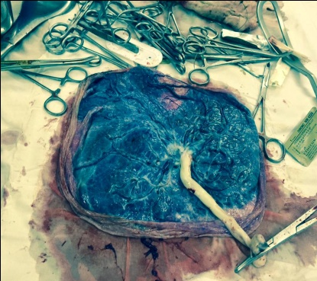
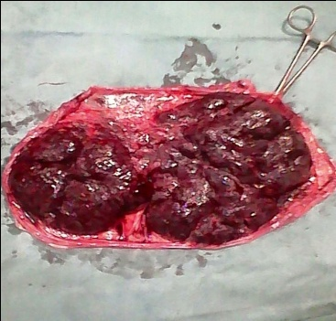

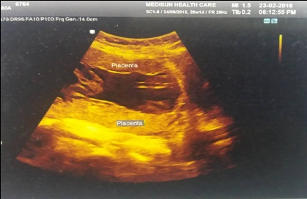
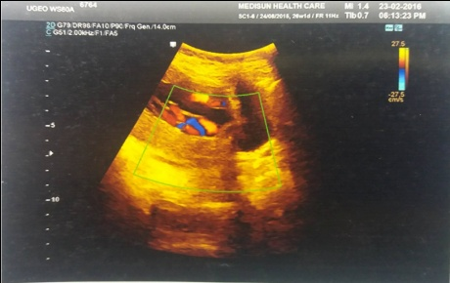

III. Reference
- Das Dentsche Gensundhe, Tswesen.
- Dr Bruno Di Muzio and Dr Yuranga Weerakkody et. All.
- Dyuaric Placentation Theory.
- http;//radiopaedia.org/articles/bilobed/placenta (2015).
- https://embryology.med.unsw.edu.au/embryology/index.php/placenta∵ abnormalities 2015
- Nagi O, et all. Ultrasound obstet Gynecol.2012.
- Valero G, Jeanty P: Sucenturiate and bilobed placenta. Unpublished raw data. Available at www.thefetus.net Accessed August 18,2001.
- Nelson LH, Fishburne JI, Stearns BR : Ultrasonographic description of succenturited placenta. Obstet Gynecol 1977;49(1 suppl):79-80.
- Kleile, H.O, and (1956) [unusual placental form, annular placenta , bilobed placenta] journal of diagnostic medical sonography 18(3). 161-166.

IV. Biography:
Dr. Pratima Rani Biswas has completed his MBBS at the age of 25 years from Sir Salimullah Medical College under Dhaka University and Postgraduate MS (Gynae & Obs ) from Sir Salimullah Medical College under Dhaka University, Bangladesh. She is the Junior Consultant (Gynae & Obs ), Railway General Hospital Dhaka. Bangladesg. She has published more than 03 papers in reputed journals

V. Presenting authordetails



Full Name: Dr Pratima Rani Biswas Contact number: 01712-836021
Category: Oral presentation
Passport Number: OC 6168614

