

Abstract
Title: Medical History and Physical Examinations; Tools for early diagnosis; Means to avoid unnecessary investigations.

Parvin Rahman1,
1Associate Professor, Department of Obstetrics & gynecology, CARe Medical College and Hospital, Dhaka, Bangladesh

Keywords: Medical history, Physical examination, Documentation, Early diagnosis, Cost-effective

- Abstract Body (up to 250 words)

The primary goal of this article is to emphasize on the importance of patient history taking and physical examination during the diagnosis stage. Detailed and adequate history taking and physical examination usually lead to a timely and accurate diagnosis of the disease. Depending on the acquired patient history and examination findings, physician can decide to do further investigations to confirm the initial diagnosis. If done precisely, adequate history taking and proper physical examination can certainly protect patients from the risks of unnecessary testing. Hence, this process is cost-beneficiary which is a great plus for the people of developing countries. Accordingly, it is of paramount importance to keep proper documentation of Patient’s history and physical examination findings as well as tests and investigations done previously. Good documentation is a great resource to learn from past clinical incidents and avoid future adverse ones, hence greatly aiding in ensuring patient safety. Informative and detailed medical history along with inclusive physical examination followed by proper documentation can determine the correct diagnosis at an early stage and pave the way for an effective treatment plan. Present study highlights the importance of patient history taking and physical examination via multiple medical cases apprehended by the author over a period of 2 years. Some systematic approaches are summarized as a means to use efficient history taking and proper physical examination as a strong tool of disease diagnosis. Finally some common hinders and challenges regarding these two powerful tools in context of Bangladesh are discussed and some viable solutions are provided.

Image:

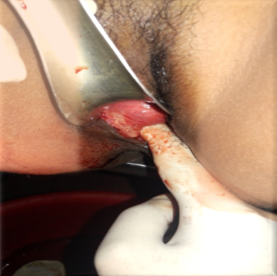

- Reference:

- Muhrer, Jill C. MSN, 2014. The importance of the history and physical in diagnosis. FNP-C Nurse Practitioner, Volume 39 - Issue 4 - p 30–35

- 2015. Marie Stopes International Guidelines for Antenatal care, V1.0 - p 17-28

- History-Taking and Physical Examination; www.med.unc.edu/medclerk/resources/cdim-sgim

- https://en.wikipedia.org/wiki/Physical_examination

Biography:
Parvin Rahman has completed her PhD at the age of 32 years from Russian State Medical University, Moscow, Russia. She has published several papers in reputed journals. She has been serving as a Life member of The Obstetrical and Gynecological Society of Bangladesh and a Life member of World Association of Laparoscopic Surgeons.

Presenting author details



Name: Parvin Rahman
Contact number: 8801817502549
Category: (Oral presentation/ Poster presentation) Passport Number: BL0298604



