

Abstract Template

Title: Predication Of intrauterine Growth Retardation by Second Trimester Umbilical Artery Doppler Abnormalities

Biswas PR¹, Paul GK², Khatun M³, Ullah MS⁴

Keywords: IUGR, Doppler USG.

- Abstract Body (up to 250words)
Objective: To determine the utility of color Doppler sonography of the feto-placental circulation in predicting the outcome in early pregnancies .To examine the diagnostic value of umbilical artery velocity wave forms for the early detection of IUGR
Design: Prospective study.
Method: 114 subjects were included in this study. This study was conducted in the Department of Obs & Gynae ,SSMC & Mitford Hospital in Collaboration with radiology and imaging department of Dhaka Hospital ,Mitford in 2008.
Result: A total 114 subjects of 16 to 22 weeks of gestation were included in this series Mean age of the respondents was 23.74 years with a standard deviation of ± 4.15 years. All patients were within 17 to 35 years age range .19.3% respondents were nullipara ,36.8% were primipara and 43.9% were multipara. Weight of intrauterine growth retarded baby and normal baby was 2.34±0.75 and 3.01 ± 0.42 kg respecitively (p<0.05). Negative correlations were observed between birth weight and S/D ratio (r=-0.336,p<0.001) and birth weight and RI index (r=-0.242,p<0.001).Sensitivity of Doppler USG to diagnose IUGR was 77.8% ,specificity 96.2% ,positive predicictive value 63.6% ,Negative predictive value 98.1% and accuracy 94.7% at S/D cutoff level 5.Sensitivity ,specificity, positive predicictive value, negative predicictive value, accuracy was found 44.4% ,100.0%,100.0%,95.5%,and 95.6% respectively at 5.5 cutoff level. Diagnostic accuracy was determined as receiver operating Characteristic(ROC) curve ,suggesting that the area under the curve (AUC) of Doppler USG at S/D cutoff level 5 and 5.5 was 0.87 and 0.72,respectively ,So S/D cut off level 5 was more appropriate to predict IUGR.
Conclusion : A close linear relationship between birth weight and umbilical artery Doppler velocity waveforms was observed .As umbilical artery Doppler is easy to perform and it is done in between 16 to 22 weeks of gestation can be done along with anomaly scan which is also done at 20-22 week of gestation . so ,UA Doppler does not cause additional USG scan . Along with anomaly scan UA Doppler will help to screen out high risk pregnancy who are going to develop IUGR.

Image:

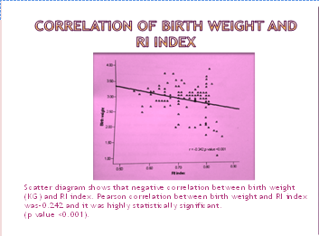
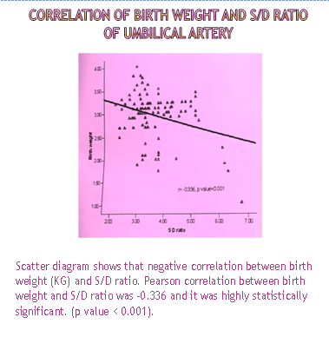

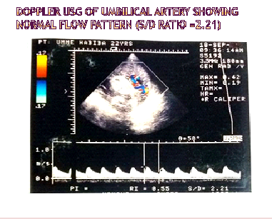

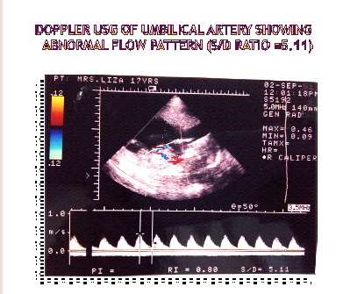

III. Reference
1 - Aardema MW,Oosterhof H,Timmer A,van Rooy I,Aarnoudse JG,2001, ’Uterine artery Doppler flow and uteroplacental vascular pathology in normal pregnancies and pregnancies complicated by pre-eclampsia and small for gestational age fetuses’,Placenta vol.22,pp.405-11.
Acharya G, Wilsgaard T,Berntsen GKR,Maltau JM,Kiserud T,2005, ‘Reference Range for serial measurements of umbilical artery Doppler indices in the second half of pregnancy’, American Journal of Obstetrics and gynecology, vol.192,pp.93744
Al-Gazali W,Chapman MG,Chita SK,Crawford DC,Allan LD,1987,’Doppler assessment of umbilical artery blood flow for the prediction of outcome in fetal cardiac abnormality ‘, BJOG,vol.94,no.8,pp.742-745
Barnett S.Maulik D.International perinatal Doppler Society .Guidelines and recommendations for sale use of Doppler ultrasound in perinatal applications. J Matern Fetal Med 2001:10:75-84.
Beattie RB,Dornan JC ,1989, ‘Antenatal screening for intrauterine growth retardation with umbilical artery Doppler ultrasonography’, BJM vol.298,no.6674,pp.631-35
Bonnin P, Bailliart O,Kedra W,Ciraru-Vigneron N,Niang E,Savin E,etal.1993, ‘Relationship between birth weight and umbilical Doppler blood flow velocity waveforms during the third trimester of pregnancy’, Eur J Med Vol.2,pp.219-22
Dutta DC,2004,Text Book Of obstetrics ,6thedi,Parash publication India,p.462
Huong DLT,Wechsler B,Vauthier-Brouzes D,Duhault P,Costedoat N,Andreu MR,2006,’The Scond Trimester Doppler Ultrasong Examinations is the best predictor of late pregnancy outcome in systemic lupus erythematosus and/or the antiphospholipid syndrome’, Rheumatology vol.45,pp.332-338.
Giles WB,Trudinger BJ,Baird PJ.1985,’Fetal Umbilical artery flow velocity waveforms and placental resistance : pathological correlation’,Br J Obstet Gynaecol vol.92,pp.31-38.
Giles W,Bisits A,O’ Callaghan S,Gill A and The DAMP Study Group,2003,’The Doppler Assessment in multiple pregnancy randomized controlled trial of ultrasound biometry versus umbilical artery Doppler ultrasound and biometry in twin pregnancy’,BJOG,vol.110,pp.593-597
Lakhkar BN,Rajagopal KV ,Gourisankar PT,2006,’Doppler Prediction Of adverse perinatal outcome in PIH and IUGR’,ind J Radiol Imag vol.16,no.1,pp.109-116.
Leung KY,Liu JYS,1998,’Modern management of intrauterine growth retardation’, HKMJ vol.4pp42-6
Lombardi SJ, Rosemond R, Ball R, Entman SS, Boehm FH, 1989, ‘Umbilical artery velocimetry as a predictor of adverse outcome in pregnancies complicated by oligohydramnios’, obster Gynecol. Vol. 74 no.3, Pt 1pp.338-41.
McCowan LM, Mullen JBM, Ritchie JWK. 1987. Umbilical artery flow velocity waveforms and the placental vascular bed. Am J Obster Gynecol vol. 157, pp. 900-902.
McCpwen LM, Harding JE, Stewart A W,2003, Umbilical artery Doppler studies in small for gestational age babies reflect disease severity’, Br.JGynecol vol.107,pp.916-925.
Moeller LK. Intrauterine Growth Restriction ( IUGR).The Obgyn Clincial of Hvidovre ( danish). Available form:
http://www.hosp.dk/hvidovre.nsf/Skalktegorier/velkomst
Ozcan TSbracia M,d’Ancona RL, Copel JA, Mari G. 1998, ‘Arterial and venous Doppler velocimetry in the severely growth –restricted fetus and associations with adverse perinatal outcome’, Ultrasound Obstet Gynecol.vol.12, no.1,pp.39-44.
Pattison RC, Odendaal HJ, Kirsten G.The relationship between absent end-diastolic velocities of the umbilical
artery and perinatal m.

IV. Biography:
Dr. Pratima Rani Biswas has completed his MBBS at the age of 25 years from Sir Salimullah Medical College under Dhaka University and Postgraduate MS (Gynae & Obs ) from Sir Salimullah Medical College under Dhaka University, Bangladesh. She is the Junior Consultant (Gynae & Obs ), Railway General Hospital Dhaka. Bangladesg. She has published more than 03 papers in reputed journals

V. Presenting authordetails



Full Name: Dr Pratima Rani Biswas Contact number: 01712-836021
Category: Oral presentation
Passport Number: OC 6168614



