

Abstract Template

Title: Successful Pregnancy Outcome in a Case of Bi-cornuate Uterus with BOH with Secondary Infertility and GDM – a very rare case report

Dr. Pratima Rani Biswas ¹, Dr. Gautom Kumar Paul ², Dr. Mina Chowdhury ³, DR. Shamim Ahmed ⁴, Dr. Selim ⁵Dr. Raihan ⁶

Keywords: Key Words: Bicornuate uterus, mullerian anomaly.

- Abstract Body (up to 250words)
Uterine malformations very often result in poor pregnancy outcome. The incidence of uterine malformations in general population is estimated to be about 3-5% and 5-10% in women with poor reproductive outcome2. Fertility and evolution of pregnancy depends on the type of uterine anomaly. Many of them are asymptomatic but it is important to consider this diagnosis in recurrent miscarriages - early and late, preterm labors, malpresentations, intrauterine growth restrictions and menstrual disturbances like menorrhagia, dysmenorrhoea. Septate and arcuate uterus represent approximately 75% of malformations while bicornuate, didelphys and unicornuate comprise the remaining 25%. Cases of pregnancy in a bicornuate uterus are still of sufficient interest and rarity to justify being reported. Airoldi et al . reported that high-risk obstetric intervention did not significantly increase the fetal survival rate for uncorrected uterine anomalies5. We are reporting a case of bicornuate uterus with a successful pregnancy outcome diagnosed at 05 weeks gestation in 5th gravida by ultrasound examination

Image:

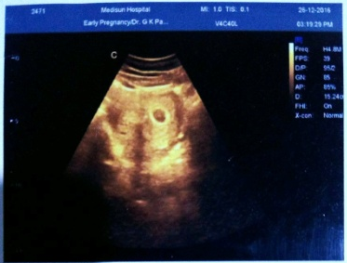
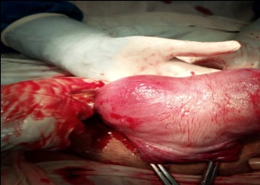

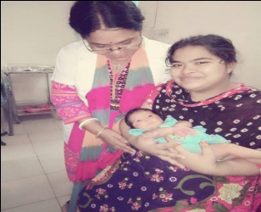
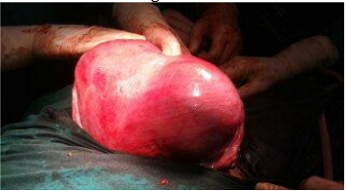

III. Reference
1.Lin PC. Reproductive Outcomes in Women with Uterine Anomalies. J Women Health (Larchmt) 2004; 13(1) : 33-9.

2. Raga F, Bauset C, Remohi J, Bonilla-Musoles F, Simón C, Pellicer A. Reproductive impact of congenital Müllerian
anomalies. Hum Reprod 1997;12:2277-81.

3.Heinonen PK, Saarikoski S, Pystynen P. Reproductive performance of women with uterine anomalies. An evaluation of 182 cases. Acta Obstet Gynecol Scand 1982; 61: 157–162.

4.Golan A, langer R, Wexler S, Seceg E, Niv D, Menachem PD. Cervical Cerclage: its role in the pregnant anomalous uterus. Int J Fertill 1990;35:164-170

5. Airoldi J, Berghella V, Sehdev H, Ludmir J. Transvaginal ultrasonography of the cervix to predict preterm birth in women with uterine
anomalies. Obstet Gynecol 2005;106:553-6.

6. Grimbizis GF, Camus M, Tarlatzis BC, Bontis JN, Devroey P. Clinical implications of uterine malformations
and hysteroscopic treatment results. Human Reproduction Update. 2001;7(2):161-174.

7.Bal R, Bal K, Mallik MP. Mullerian anomalies, reproductive outcomes, rudimentary horn. Different mullerian duct anomalies-Diagnosed
Incidentally or During Emergancy Interventions. 2015; 4(31):5334-5341.

8.Chan YY, Jayaprakasan K, Tan A, Thornton JG, Coomarasamy A, Raine-Fenning NJ. Reproductive outcomes in women with congenital uterine anomalies: a systematic review. Ultrasound in Obstetrics & Gynecology. 2011; 38(4):371-382.

9.Jayaprakash S, Muralidhar L, Sampathkumar G, Sexsena R. Rupture of bicornuate uterus. BMJ Case
Reports. 2011; 2011(10):1-4.

10.Dabiri A, Naghibi T. Pregnancy with IUD in a Bicornuate Uterus. The Scientifc Journal of Zanjan
University of Medical Science. 2012; 20(79):112-115.

11.Hefny AF, Kunhivalappil FT, Nambiar R, Bashir MO. A rare case of first-trimester ruptured bicornuate uterus in a primigravida. International Journal of Surgery Case Reports. 2015; 14:98-100.

12.Jayasinghe Y, Rane A, Stalewski H, Grover S. The presentation and early diagnosis of the rudimentary uterine horn.
Obstetrics and Gynecology. 2005; 105(6):1456-1467.

13.Adeyemi AS, Atanda OO, Adekunle AD. Successful pregnancy in one horn of a bicornuate uterus.
Annals of African Medicine. 2013; 12(4):252-254.

14.Szkodziak P, Wozniak S, Czuczwar P, Paszkowski T, Milart P, Wozniakowska E, et al. Usefulness of three
dimensional transvaginal ultrasonography and hysterosalpingography in diagnosing uterine anomalies. Ginekologia Polska. 2014; 85(5):354
-359.

IV. Biography:
Dr. Pratima Rani Biswas has completed his MBBS at the age of 25 years from Sir Salimullah Medical College under Dhaka University and Postgraduate MS (Gynae & Obs ) from Sir Salimullah Medical College under Dhaka University, Bangladesh. She is the Junior Consultant (Gynae & Obs ), Railway General Hospital Dhaka. Bangladesg. She has published more than 03 papers in reputed journals

V. Presenting authordetails



Full Name: Dr Pratima Rani Biswas Contact number: 01712-836021
Category: Oral presentation
Passport Number: OC 6168614



