

Abstract Template

Title: The Malignant Transformation of a Dermoid Cyst: A Case Report

Maria Rheapaz B. de Guzman, M.D.1, Rommel Z. Dueñas, M.D.1, Lylah Reyes, M.D.1
1Department of Obstetrics and Gynecology, Far Eastern University-Nicanor Reyes Medical Foundation Medical Center, Manila, Philippines

Keywords: Squamous Cell Carcinoma, Mature Cystic Teratoma, Frozen Section

- Abstract Body
The question of whether patients with squamous cell carcinoma in a mature cystic teratoma should undergo conservative surgery or postoperative adjuvant treatment remains unresolved. Ovarian cancer is the second most common malignancy of the lower part of the female genital tract, occurring less frequently than cancers of the endometrium but more frequently than cancers of the cervix. Germ cell tumors are the second most frequent type of ovarian neoplasm and account for approximately 10-20% of all ovarian tumors. The most frequent germ cell tumor is the Mature Cystic Teratoma; overall, only 2% to 3% of germ cell tumors are malignant, and more than 80% of malignant transformations are squamous cell carcinomas arising from the ectoderm. There are currently no reliable procedures for the early detection of ovarian cancer. Available potential screening techniques have included pelvic examination, ultrasound examination, serum CA-125 determination and other tumor markers. There is no established definitive treatment protocol available due to lack of research on this rare case, thus frozen Section of the affected ovary is imperative in dermoid cysts to ensure that it is benign. Frozen sections are utilized mainly to aid in the differentiation of benign from malignant disease. Determining the type of tumor and extent of surgery is very important in Gynecologic Oncology. In this report, we present a rare case of a mature cystic teratoma, which was found to be malignant on frozen section with Intraoperative Stage I-A, and therefore managed by cytoreductive surgery followed by chemotherapy.

Image:
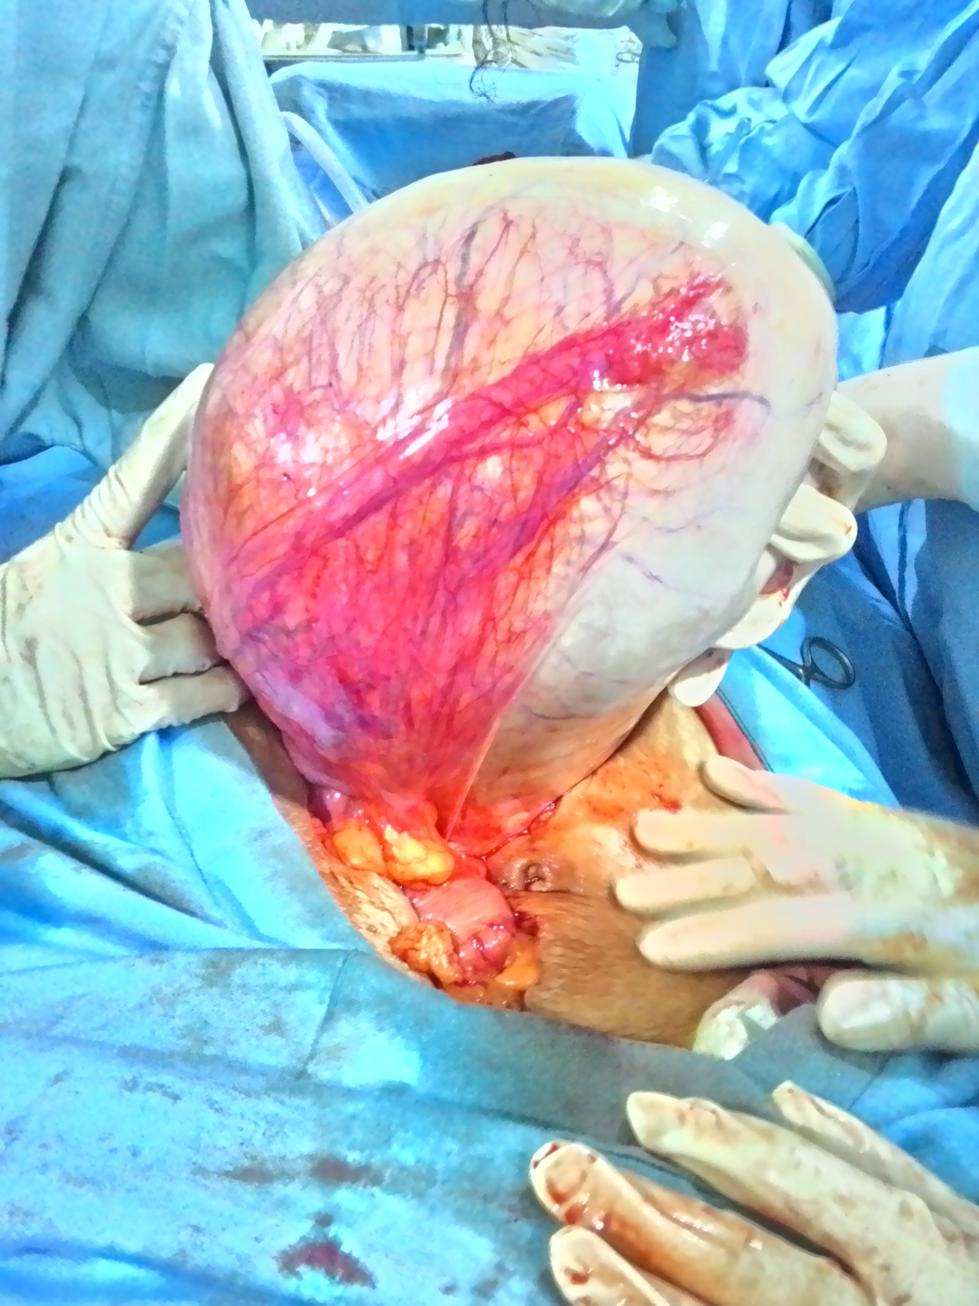

- References:

Park, S. B. (2010). CT findings of mature cystic teratoma with malignant transformation: comparison with mature cystic teratoma. Elsevier , 295.

Hoffman, M. S., & Hochberg, L. (2018). Differential diagnosis of the adnexal mass. UpToDate .

Hackethal, A., Bohlmann, M. K., Franke, F. E., Tinneberg, H.-R., & Munstedt, K. (2008, December). Squamous-cell carcinoma in mature cystic teratoma of the ovary: systematic review and analysis of published data. Lancet Oncology , 1173-1180.

Biography:
Maria Rheapaz B. de Guzman has completed her degree in Doctor of Medicine at the age of 25 years old from Far Eastern University-Nicanor Reyes Medical Foundation, Manila, Philippines. She is currently in her Residency at the Department of Obstetrics and Gynecology in the same institution.

Presenting author details

Full Name: Maria Rheapaz B. de Guzman
Contact number: +639175393255
Category: Poster presentation



