

In-silico approach to FIGLA genes preferentially express in the germline

Shouhartha Choudhury¹ and, Supriyo Chakraborty^{2*}
¹Department of Biotechnology, Assam University, Silchar-788011
²School of Life Sciences, Assam University, Silchar-788011

Keywords: FIGLA, bHLH transcription factor, Gene expression; Spermatogenesis; and Oogenesis

Abstract

The present study investigated factor in the germline (FIGLA) play important roles ovary formation and folliculogenesis, and control oocyte development and somatic cell function. The oocyte-specific transcription factors are essential for oogenesis, pluripotency and embryonic development. The FIGLA transcription factors play germ cell development and regulate reproductive life span and represent candidate genes for reproductive disorders, such as premature ovarian failure and infertility. Those oocyte-specific transcription factors regulate attractive targets to human fertility. In this study, we curated literature-derived information of FIGLA transcription factor in genomic data. We accumulate eukaryotic organism genome i.e. Homo sapiens, Ailuropoda melanoleuca and, Mus musculus for comparative and functional analysis. The bHLH transcription factor data analysis suggested number of FIGLA genes and their domain, motifs, phylogeny, chromosome location and gene expression. In this study, we identified several cell-specific transcription factors using in-silico subtraction. These genes discovered spermatogenesis and oogenesis transcription factor preferentially express in germ cells.

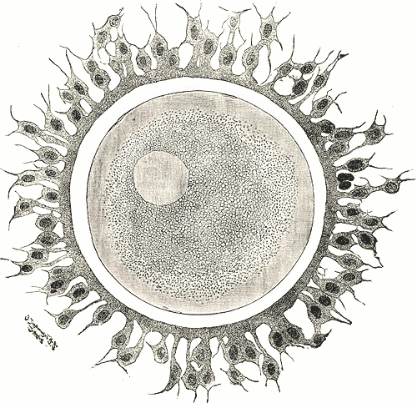
Reference

- Pangas, Stephanie A., and Aleksandar Rajkovic. "Transcriptional regulation of early oogenesis: in search of masters." Human Reproduction Update 12.1 (2005): 65-76.
- Zhao, Han, et al. "Transcription factor FIGLA is mutated in patients with premature ovarian failure." The American Journal of Human Genetics 82.6 (2008): 1342-1348.
- Hu, Wei, et al. "FIGLA, a basic helix-loop-helix transcription factor, balances sexually dimorphic gene expression in postnatal oocytes." Molecular and cellular biology 30.14 (2010): 3661-3671.

Biography

Shouhartha Choudhury has completed his B.Tech and M.Tech in Bioinformatics from India and now pursuing integrated pre-Ph.D. research in School of Life Sciences, Department of Biotechnology, Assam University, Silchar-788011. He submitted four research reports entitled (a) Computational Genomics: AP2/ERF Family in plants, (b) Comparative Genomics: Novel: BCL-2 Family, (c) Genomics of OLIG Family of bHLH transcription factor (d) Genome-wide analysis of NeuroD Family of bHLH transcription factor and (e) In-silco analysis of HAND transcription factor modulated during cardiac hypertrophy in Assam University, for short communication

Author details

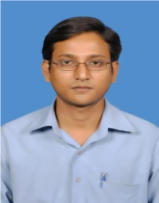

Full name: Shouhartha Choudhury
Contact number: +91-9954411181
Twitter account: Shouhartha Choudhury
Linked In account: Shouhartha Choudhury
Session name/ number:
Category: (Oral and poster presentation)
Passport Number:



