

Abstract Template

Comparison of Various Risk of Malignancy Index (RMI) Scoring Systems for Cancer Risk Assessment among Filipino Women with Ovarian Masses

M.Anwar, MD
Department of Obstetrics and Gynecology, Mariano Marcos Memorial Hospital and Medical Center, Batac City, Ilocos Norte, Philippine

Keywords: Risk of malignancy index (RMI)

- Abstract
Background: To determine the optimal cut-off point of the preoperative risk of malignancy index (RMI) and to characterize the population and determine the association of the following demographic and clinical characteristics with ovarian cancer. Materials and Methods: 172 operated women were assessed retrospectively. RMI of 1, 2, 3 and 4; cut-off values for an effective benign or malignant differentiation together with sensitivity, specificity, negative and positive predictive values were calculated. Results: This cohort study compared the Risk of Malignancy Index (RMI) scoring system (RMI1, RMI2, RMI3 and RMI4). Based on the histological examination of the surgical specimens of 172 patients, 38 (22.09%) had malignant and 134 (77.91%) had benign ovarian masses. Age, body mass index and menopausal status were associated with malignancy. The optimal cut off points of RMI1, RMI2, RMI3 and RMI4 based on ROC curve analysis were as follows: 72.29, 284.49, 254.52 and 284.49 respectively. RMI 2 and RMI 4 have the highest specificity of 85.1% (CI: 77.9% -90.6%), highest positive predictive values of 59.2% (CI: 47.3- 77.7) and highest positive likelihood ratio of 5.11 (CI: 3.28-7.95) while RMI 1 has the highest sensitivity of 86.8% (CI: 0.719-0.956) and highest negative predictive value of 95.3 (CI: 88.7 - 96.9). Conclusions: The RMI scoring systems are recommended to provide an objective assessment of the underlying malignant potential hence can be the test of choice in the preoperative evaluation of the adnexal mass.

Image:
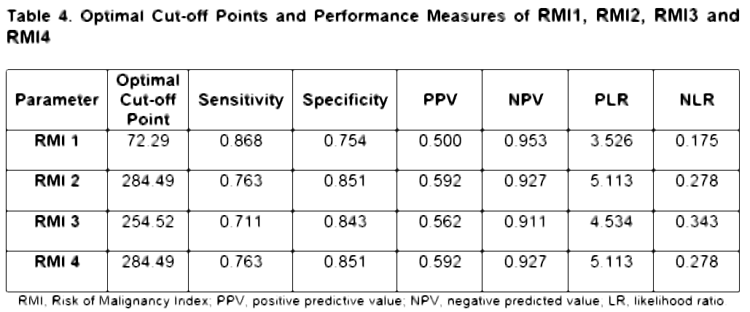
- Reference:

- Doubeni et al. Diagnosis and Management of Ovarian Cancer.Am Fam Physician. 2016 Jun 1;93(11):937-44

- A Chyke, E Anna, and E Allison. Diagnosis and Management of Ovarian Cancer. American Family Physician, 2016. 93, 11.

- Department of Health. Ovarian Cancer. Updated in 2017 (as cited from https://www.doh.gov.ph/Health-Advisory/Ovarian-Cancer)

Biography:
Muhamad Saiful Anwar, MD, is a graduate of YARSI University Medical School in Central Jakarta, Indonesia. He trained in Obstetrics and Gynecology at the Mariano Marcos Memorial Hospital and Medical Center, Batac City, Ilocos Norte, Philippine. and currently doing his residency in Mariano Marcos Memorial Hospital and Medical Center in Batac, Philippines. He is in her fourth year of residency of OBGYNE.

Presenting author details

Full Name:Muhamad Saiful Anwar
Contact number: +639451832535
Facebook account: muhamad saiful anwar

Session name/ number: Comparison of Various Risk of Malignancy Index (RMI) Scoring Systems for Cancer Risk Assessment among Filipino Women with Ovarian Masses
Category: Oral presentation
Passport Number:C0068799

Copyright © 2016-2018 Meetings Int PTE Ltd, All Rights Reserved.
Meetings Int. Pte Ltd

Company Registration No: 201524282R, 28 MAXWELL ROAD, #03-05 RED DOT TRAFFIC, SINGAPORE (069120)
Tel: +6531080483 | Toll Free no. +800-852-6126
Web: https://www.meetingsint.com/conferences/gynecology | E-mail: gynecology@annualmeetings.net

