
International Conference on
Gynecology & Obstetrics
October, 29-30, 2018 |Amsterdam, Netherlands

The Effects of Phaleria macrocarpa (Scheff.) Boerl Extract on Malondialdehyde Level in Preeclampsia-Induced HUVEC Culture

Simanjuntak L^{1,2}, Siregar MFG³, Mose JC⁴ and Lumbanraja SN³
1Doctoral Program, Faculty of Medicine, Universitas Sumatera Utara, Medan, Indonesia
2Department of Obstetrics and Gynecology, Faculty of Medicine, Nommensen HKBP University, Medan, Indonesia
3Department of Obstetrics and Gynecology, Faculty of Medicine, Universitas Sumatera Utara, Medan, Indonesia
⁴Department of Obstetrics and Gynecology, Faculty of Medicine, Universitas Padjadjaran, Bandung, Indonesia

Keywords: Phaleria macrocarpa, preeclampsia, oxidative stress, HUVEC, Malondialdehyde

- Abstract Body
Preeclampsia is a major cause of both maternal and perinatal mortality and morbidity. The pathopysiology of preeclampsia remain unclear but early placental dysfunction followed by oxidative stress, increased lipid peroxidation, and reduced antioxidants play an important role. Malondialdehyde (MDA) is the final product of lipid peroxidation, commonly used as the oxidative stress marker. Prevention and treatment of oxidative stress in preeclampsia using antioxidant including melatonin, beta-caroten, vitamin C or E has been developed but none is yet recommended. Thus the efforts are continuing to find an effective antioxidant in preeeclampsia. Phaleria macrocarpa, a medicinal plant has long been used traditionally and known has high antioxidant capacity by in vitro and in vivo studies. HUVEC culture is an in vitro model widely used to study the preeclampsia pathogenesis. This study aims to determine the effects of Phaleria macrocarpa extract on MDA level in preeclampsia-induced HUVEC culture. Our results showed the Phaleria macrocarpa’s extract reduce MDA level siginifcantly at concentration of 0.977μg/mL in preeclampsia-induced HUVEC culture and at 15.625μg/mL reduce MDA level to control normal level. Thus, Phaleria macrocarpa’s extract might be used as agent to overcome oxidative stress in preeclampsia.

Image:
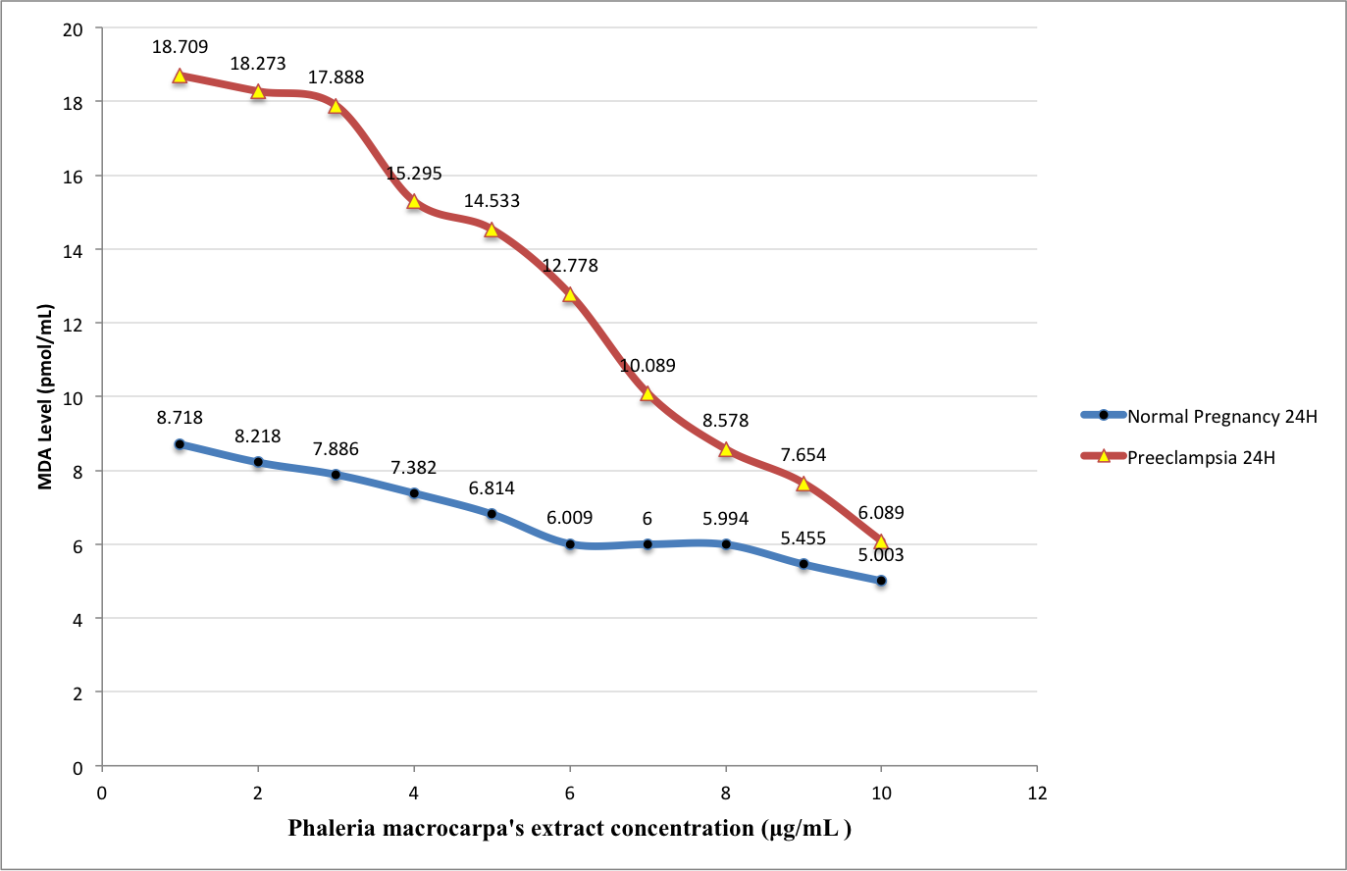
- Reference:

- Cunningham FG, Leveno KJ, Bloom SL, Hauth JC, Rouse DJ & Spong CY 2014: Williams Obstetrics 24th. ed. McGraw Hill Medical pp. 728 – 779
- Hendra R, Ahmad S, Oskoueian E, Sukari A & Shukor MY 2011, Antioxidant, Anti-inflammatory and Cytotoxicity of Phaleria Macrocarpa (Boerl.) Scheff Fruit, BMC Complementary and Alternative Medicine, 11, 110.
- Hubel, CA 1999, Oxidative Stress in the Pathogenesis of Preeclampsia, Proc Soc Exp Biol Med, 222: 222-235
- Maynard S, Epstein FH & Karumanchi SA 2008, Preeclampsia and Angiogenic Imbalance, Annu.Rev. Med, 59, pp. 61-78
- Redman, CWG & Sargent, IL 2000, Placental Debris, Oxidative Stress and Pre-eclampsia, Placenta, 21, 597-602.
- Tiwari P, Kumar B, Kaur M, Kaur G, & Kaur H 2011, Phytochemical screening and extraction: a review, Internationale Pharmaceutica Sciencia, 1, No. 1, pp. 98- 106
- Walsh, SW 1997, The Role of oxidative stress and antioxidants in preeclampsia, Contemporary Obstetrics and Gynecology, 42, pp. 113 – 124

Biography:
Leo Simanjuntak is a senior lecturer at Faculty of Medicine, Nommensen HKBP University, Medan, Indonesia in Department of Obstetrics and Gynecology. Leo Simanjuntak has completed Master degree in Obstetrics and Gynecology at 2003 in Universitas Sumatera Utara. Now preparing dissertation for PhD program at University Faculty of Medicine, Universitas Sumatera Utara, Medan, Indonesia.

Presenting author details


Full Name : Leo Jumadi Simanjuntak
Contact Number : +62811655428
Category: Oral presentation
Passport Number : B7130067
Copyright © 2016-2018 Meetings Int PTE Ltd, All Rights Reserved.
Meetings Int. Pte Ltd

Company Registration No: 201524282R, 28 MAXWELL ROAD, #03-05 RED DOT TRAFFIC, SINGAPORE (069120)
Tel: +6531080483 | Toll Free no. +800-852-6126
Web: https://www.meetingsint.com/conferences/gynecology | E-mail: gynecology@annualmeetings.net

