
International Conference on
Gynecology & Obstetrics
October, 25-26, 2018 |Amsterdam, Netherlands

Abstract

Title: New Tides - Updates in Choosing Hysterectomy Routes for benign uterine disease

Shamsun Nahar
Dept of OB-GYN, Central Medical College,Comilla, Bangladesh

Keywords : Hysterectomy routes, abdominal Hysterectomy, vaginal Hysterectomy, laparoscopic Hysterectomy, benign uterine disease

- Abstract Body
The present study was conducted by searching and reviewing the most recent medical literatures. Abdominal hysterectomy (AH) is the commonest route for surgical management of benign uterine disease that could be performed vaginally which has well-documented benefits . Abdominal hysterectomy (AH) : vaginal hysterectomy (VH) is known to be 3:1. Evidence -Based Practice Guidelines for surgical management are defined by objective criteria - 'OUTCOME ' rather than subjective criteria - "Physician comfort, preference or experience ". But some gynaecologists remain reluctant to change their traditional “practice style” of performing hysterectomy abdominally giving priority to subjective criteria and ignoring objective criteria even without documenting vaginal route is contraindicated. Many publications confirm guidelines enable physicians to perform up to 90% hysterectomy vaginally, dramatically reversing AH :VH to 1:11. ACOG committee on gynecological practice recommended VH is the approach of choice whenever feasible. Laparoscopic hysterectomy (LH) is an alternative to AH when VH is not feasible or contraindicated. Standard guidelines recommended AH is reserved for documented serious disease. A Cochrane review of 34 randomised trials of VH, LH, AH (4495 patients) concluded VH has the best outcome. AAGL recommended surgeons without requisites training and skills for safe VH or LH should take the aid of trained & skilled collegues or refer to such surgeons. Training on different routes of hysterectomy has been emphasised during residency courses
.

Image:
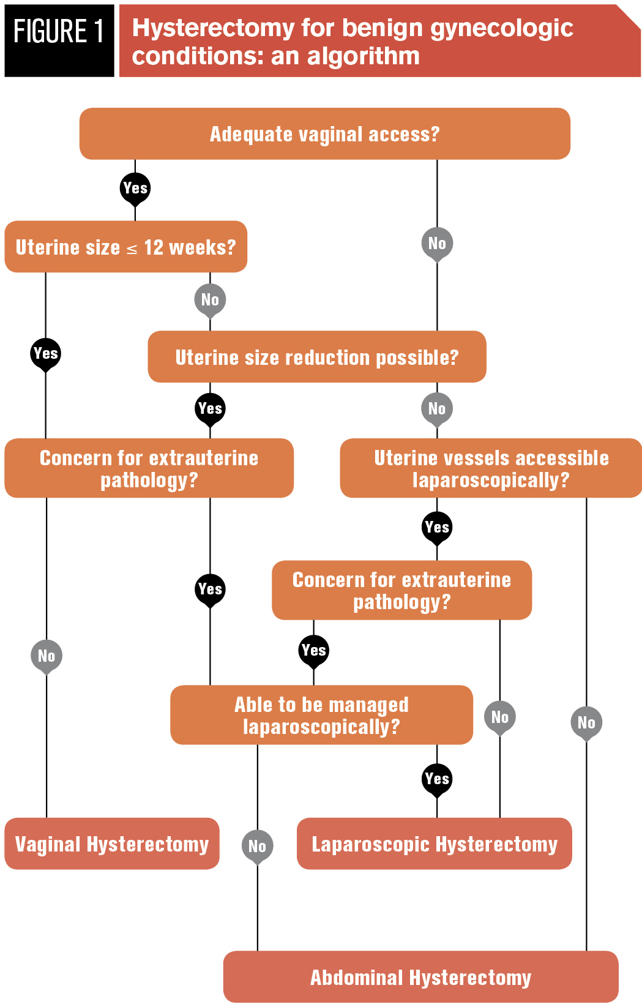
- Reference:

- Kovac SR. Evidence -Based hysterectomy. Gynecol obstet 2013,3:1
- ACOG Committe Opinion No. 444. Choosing the routes of Hysterectomy. Obstet Gynaecol 2009;5:1156-8.
- AAGL Position Statement :Routes of Hysterectomy to treat benign uterine disease J Minim Invasive Gynecol 2011;18 (1):1-3.
- Nieboer TE, Johnson N, Lethaby A, Tavender E, Curr E , Garry R et al.Surgical approach to hysterectomy for benign gynaecological disease. Cochrane Database of Syst Rev 2009 (3) CD003677.
- Kovac SR, Barhan S, Lister M, Tucker L, Bishop M, Das A. Guidelines for the selection of the route of hysterectomy : application in a resident clinic population. Am J Obstet Gynaecol 2002;187:1521 -78099

Biography:
Dr Shamsun Nahar has completed her MS from BSMMU (Bangabondhu Sheikh Mujib Medical University), Bangladesh .She is professor & head of dept of OB-GYN ,Central Medical College, Bangladesh. She has published more than 25 papers in reputed journals & has been serving as executive editor of Central Medical College journal.

Presenting author details



Full Name: Dr Shamsun Nahar
Mobile no. +8801716551941
Session No. Gynecological Surgery
Category: Oral Presentation
Passport no. BH0106157

Copyright © 2016-2018 Meetings Int PTE Ltd, All Rights Reserved.
Meetings Int. Pte Ltd

Company Registration No: 201524282R, 28 MAXWELL ROAD, #03-05 RED DOT TRAFFIC, SINGAPORE (069120)
Tel: +6531080483 | Toll Free no. +800-852-6126
Web: https://www.meetingsint.com/conferences/gynecology | E-mail: gynecology@meetingseries.org

