Title: Sublingual Mifepriston and misoprostol in outpatient regimen for medical abortion, and their further outcome.

Dr Fatema Kamrun Naher¹. Dr Akhtary hossain Choudhury².
- Assistant Professor, Gyn and Obs, Department of Obstetrics and Gynae, Shaheed Ziaur Rahman Medical College, Bogura, Bangladesh.
- Associate Professor, Gyn and Obs, Department of Obstetrics and Gynae, Shaheed Ziaur Rahman Medical College, Bogura, Bangladesh.

Key Words: Medical abortion, Mifepriston and Misoprostol, Previous cesarean section.

- Abstract:
.
WHO dosage guidelines for induced Medical abortion regimen were Mifepriston 200mg followed by Misoprostol 800 microgram sublingually or vaginally 3 hourly maximum 3 dose within 12 hours. It is popular method for termination of pregnancy. According to BBS- 2010, maternal death due to unsafe abortion is 1% . By above guidelines Bangladesh government expects maternal death to be reduced to ‘0’ level. Misoprostol is used to expel the retained product of conception effectively up to the 12 weeks in incomplete abortion. Misoprostol is on the World Health Organization model list of essential medicine. This prospective study was done in SZMCH during June 2017 to April 2018. Total 50 patients were selected, inclusion criteria were, patients taking 200mg of Mifepristone followed by 800 mcg of Misoprostol for medical termination of pregnancy in 1st trimester. Patient having previous vaginal delivery and cesarean section both were included. Patients were followed up to 2 weeks. The aim of this study was to find out, which patient needed surgical evacuation, and find out the complications that can occur during this follow up. The results show that 73.33% patient having previous cesarean section, needed surgical evacuation and 50%of vaginal delivery needed such. For complications, during follow up-60% cases of vaginal bleeding is more than usual. Again, 27% cases cannot pursue normal day to day activities and their cost of treatment increases due to repeated visit to doctor and imaging. So, early decision for surgical evacuation in patient having previous cesarean section is recommended.

- Image:

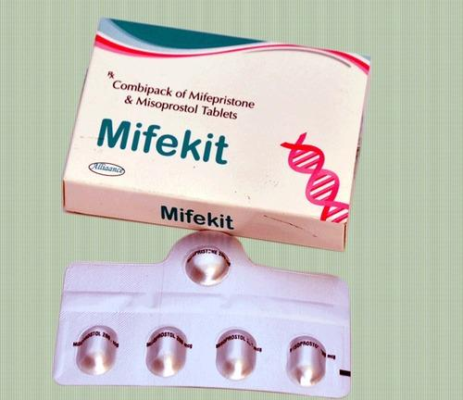

- Reference:

- Rebecca Allen, Barbara M O’ Brien. Uses of misoprostol in obstetrics and gynecology. Rev Obstet Gynecol.2009 Summer, 2(3); 159-168.
- Hillary Bracken et al. A two pill sublingual misoprostol outpatient resigmen following mifepristone for medical abortion through 70 days’ LMP: a prospective comparative open level trial. Contraception 89 (2014) 181-186.
- Bangladesh Bureau of Statistics: 2010, Dhaka, Bangladesh.

- Biography:

Dr Fatema Kamrun Naher has completed MBBS graduation in 1992 from Rajshahi Medical College, Bangladesh. She has achieved Diploma in Gynae and Obs. in 2002 in BSMMU Bangladesh. She obtained her FCPS degree in Obstetrics and Gynae from BCPS, Bangladesh. She worked in a district hospital as Junior Consultant for 8 years. Now she is working in Shaheed Ziaur Rahman Medical College, Bogura, Bangladesh. She has published 3 articles. She has performed several oral presentations in different scientific seminars both national and international platform.
V. Presenting author details:
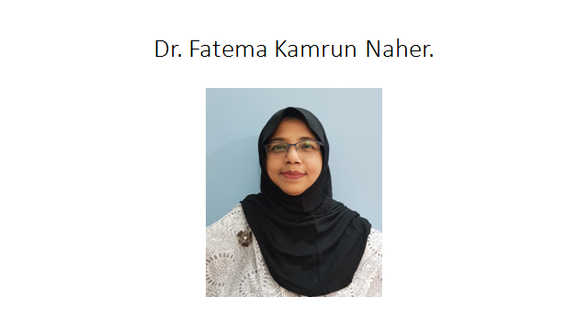
Dr. Fatema Kamrun Naher. Contact number: +8801711235082.
E-mail: fatemahaimonti@gmail.com
Session name/number:
Oral presentation
Passport Number: OC7126332

