Prevalence And Factors associated with Pre-term Delivery at Ad-Din Women’s Medical College and Hospital
J Biswas¹, M Sarkar²
¹Consultant Obstetrician and Gynecologist, Reliance Hospital, Jamalpur, Bangladesh
²Trainee Officer, Department of Biochemistry, Armed Forces Institute of Pathology, Dhaka Cantonment, Bangladesh
Keywords: Pre-term Delivery, Pre-Eclampsia, Antepartum hemorrhage, BMI
Abstract
Background: Pre-term birth is the leading cause of newborn deaths and second leading cause of death in children under five years old. Pre-term birth defines as any birth before 37 completed weeks of gestation or fewer than 259 days since the 1st day of women’s last menstrual period. Of the estimated 130 million babies born each year globally, approximately 15 million are born preterm. WHO estimates the prevalence of pre-term deliveries to be 5-18% across 184 countries of the World. Prematurity is a major hindrance to the attainment of the Millennium Development Goals (MDG)-4 target given its high contribution to neonatal mortality. The survival chances of babies born preterm vary significantly depending on where they are born. The risk of neonatal death due to complications of preterm birth is at least 12 times higher for an African baby than for a European baby. Though most countries especially the low and middle income one’s lack reliable data on preterm birth, nearly all of those with reliable trend data show an increase in preterm birth rates over the past 20 years. Indeed, all but 3 out of 65 countries in the world with reliable trend show an increase in preterm birth rates in the last 20 years. Significant progress has been made in the care of premature infants but not in reducing the prevalence of preterm birth which is generally on the rise. Causes of preterm birth are unknown in over 50% of spontaneous preterm labor while mechanisms of preterm labor remain poorly understood. Identifying and understanding the risk factors for preterm birth has the potential to help address this problem. Bangladesh like other most developing countries lacks reliable data on the burden of preterm delivery. Ad-Din Women’s Medical College and Hospital is the largest regional referral and handles many high risk pregnancies some of which result in preterm birth. Locally, few studies have looked at the prevalence of pre-term deliveries and factors associated with it. This study determined the prevalence of preterm birth and factors associated with preterm deliveries at Ad-Din Women’s Medical College and Hospital, Bangladesh.
Methods: This is cross-sectional descriptive study was conducted at the maternity unit of Ad-Din Women’s Medical College and Hospital in Dhaka in January’2016. A total 200 mothers who met the eligibility criteria and their babies were enrolled in to the study. Mothers were interviewed using a pre-tested questionnaire and additional data extracted from medical records. The maternal nutritional status assessed using BMI. Gestational age was assessed clinically using SFH.
Results: The prevalence of preterm birth was found to be 19%. Common risk factors associated pre-term birth were maternal age, parity, previous pre-term birth (43.3%), PPROM (446.6%), multiple gestation (13.3%), pregnancy induced hypertension (40%), Antepartum hemorrhage (30%). On the other hand, level of education, ANC attendance, anemia, maternal MUAC and inter pregnancy interval were not associated with preterm birth.
Conclusion: Preterm birth among women delivering at Ad-Din Women’s Medical College and Hospital in Dhaka, Bangladesh is a significant problem. Prolonged PROM, PIH and APH are independent determinants of preterm birth. The prevalence of preterm deliveries was 19%. Maternal age < 20 years, parity > 4, twin, maternal UTI, PIH, APH, PPROM, previous history of preterm deliveries were significantly associated with preterm deliveries. So, at risk mothers should receive intensified antenatal care to mitigate preterm deliveries. Better management of these obstetric complications and research to elucidate the mechanisms by which they cause preterm birth, offers a practical approach of reducing the high preterm birth rates.

Background

Preterm birth (PTB) is the leading cause of infant morbidity and mortality in the world. The World Health Organization (WHO) defines preterm birth as any birth before 37 completed weeks of gestation or fewer than 259 days since the first day of woman’s last menstrual period (LMP).
Of the estimated 130 million babies born each year globally, approximately 15 million are born preterm. Prematurity is a major hindrance to the attainment of the Millennium Development Goals (MDG)-4 target given its high contribution to neonatal mortality. The survival chances of babies born preterm vary significantly depending on where they are born.
In developing countries, the main causes of preterm births include infectious diseases and poor availability and accessibility of health care resources. In high-income countries, the increase in the number of preterm births is linked to conception among older women and increased number of multiple pregnancies as a result of usage of fertility drugs. In some developed countries, medically unnecessary inductions and caesarean section deliveries before full term also increase preterm birth rates. In rich and poor countries, many preterm births remain unexplained [1, 2].
Approximately three-fourths of perinatal deaths occur in foetuses that are delivered at <37 weeks, and about 40% of these deaths occur in those delivered at <32 weeks. In addition to its contribution to mortality, preterm birth has lifelong effects on neurodevelopmental functioning such as increased risk of cerebral palsy, impaired learning, and visual disorders and an increased risk of chronic disease in adulthood [3]. The economic cost of preterm birth is high in terms of neonatal intensive care and ongoing health care and educational needs. The social cost is also high, with many families experiencing the sudden loss of a preterm baby or a stressful hospital stay, sometimes for months [2]
The risk of neonatal death due to complications of preterm birth is at least 12 times higher for an African baby than for a European baby. Preterm birth (PTB) is a global problem with prevalence ranging between 5 and 18% across 184 countries. The highest rates of preterm birth are in Sub-Saharan Africa and Asia which account for half the world’s births, more than 60% of the world’s preterm babies and over 80% of the world’s 1.1 million neonatal deaths annually due to complications related to preterm birth. Though most countries especially the low and middle income one’s lack reliable data on preterm birth, nearly all of those with reliable trend data show an increase in preterm birth rates over the past 20 years. Indeed, all but 3 out of 65 countries in the world with reliable trend show an increase in preterm birth rates in the last 20 years. Significant progress has been made in the care of premature infants but not in reducing the prevalence of preterm birth which is generally on the rise. Causes of preterm birth are unknown in over 50% of spontaneous preterm labor while mechanisms of preterm labor remain poorly understood [1–7]. Identifying an understanding the risk factors for preterm birth has the potential to help address this problem. Defining risk factors for prediction of preterm birth is a reasonable goal for several reasons. First, identification of at-risk women allows initiation of risk-specific treatment. Second, the risk factors might define a population useful for studying specific interventions. Finally, identification of risk factors might provide important insights into mechanisms leading to preterm birth. Yet, data regarding preterm births and risk factors are not routinely collected in hospitals
Bangladesh like most developing countries lacks reliable data on the burden of preterm delivery. Ad-Din Women’s Medical College and Hospital is the largest regional referral and handles many high risk pregnancies some of which result in preterm birth. Despite this, few published studies on the burden of preterm birth and the factors associated with it exist locally. This study aimed to determine the prevalence of preterm birth and the factors associated with PTB. The findings of the study are presented in this article.

Methods
Study design:
A hospital based descriptive cross-sectional study was conducted using interviewer administered questionnaire. Additional information was obtained from medical records of the mothers and babies.
Study Area
Ad-din Women’s Medical College and Hospital is the largest referral hospital in Dhaka, Bangladesh. Ad-din Foundation was established in 1980 with the aim of supporting the underprivileged majority of Bangladesh. During its thirty-seven years with development, Ad-din has expanded its existence of diverse projects in several parts of the country. The hospital has a busy maternity unit registering over 10,000 deliveries annually. It also has a busy newborn unit (NBU) which offers specialized neonatal care. Being a teaching and referral hospital, Ad-din handles many high risk pregnancies whose outcomes often include preterm birth.
Participants
The study population comprised of all mothers who had live births at Ad-Din Women’s Medical College and Hospital and their newborns. A total of 200 mothers who met the eligibility criteria were enrolled into the study. These mothers delivered a total of 207 babies 14 of which were twins.
Data collection
All mothers who had live births at Ad-Din in December 2016 were identified using the birth register within 24 h of delivery. Systematic sampling was used to recruit mother-baby pairs. Mothers were traced to the postnatal wards. Informed consent was obtained from the mothers and babies admitted to the newborn unit were also traced. A standard pretested questionnaire was administered to the mothers while additional data was obtained from the mothers’ and babies medical records as required. The records examined for additional data included the mothers’ antenatal and admission records and the babies’ medical records for those admitted in the NBU after delivery. Information collected from the mother included maternal age, level of education, occupation, parity, date of current and preceding delivery (for calculation of interpregnancy interval) and history of previous preterm birth. Information obtained from medical records included antenatal clinic (ANC) attendance and number of visits,hemoglobin level, mode of delivery, onset of labor (spontaneous or medically indicated), pregnancy outcome (singleton or multiple),prelabor rupture of membranes (PROM) for > 18 h, pregnancy induced hypertension (PIH), antepartum hemorrhage (APH), history of burning sensation during pregnancy or treatment for urinary tract infection (UTI). Anemia was defined as hemoglobin level of <10 g/dL. PIH was defined clinically as a blood pressure of > 140/90 mmHg after 20 weeks of gestation with or without proteinuria and/or edema as diagnosed and documented by the attending clinician. APH was defined as any vaginal bleeding in the mother after 24 weeks of gestation as documented in the records by the attending clinician. UTI was defined as a documented clinical/laboratory diagnosis of UTI any time during the pregnancy and/or a positive history of treatment of burning sensation with micturation as reported by the mother. Maternal nutritional status was assessed by measuring the left mid-upper arm circumference (MUAC) using non-stretchable World Food Program MUAC tapes used for screening pregnant mothers. A low MUAC was defined as a measurement of less than 24 cm. Gestational age was calculated using a standard obstetric wheel based on menstrual dates and confirmed within 24 h of birth by clinical assessment using the Symphysio-fundal height and correlate with booking scan EDD. To limit observer bias, gestational assessment of all babies was done by only one research assistant trained by the principal investigator and aided by a printed pictorial scoring chart. Preterm birth was defined as a gestation of less than 37 completed weeks. Prematurity was further categorized as extreme (less than 28 weeks), severe (28–31 weeks), moderate (32– 33 weeks) and late preterm or near term (34–36 weeks).

Data analysis

Data was entered into Microsoft Excel database, cleaned and stored in a password protected external storage device. Data was analyzed using Stata 11.0. Mean, median, frequencies and percentages were reported to describe the variables and inferential statistics were used to establish associations between prematurity and the various risk factors using a chi-square analysis.

Results
Background characteristics of participants
The mean maternal age was 26 ± 5 years with majority (73%) being aged 20 years and above. About 81.5% of the mothers had attained post-primary level of education. About 97% of the enrolled mothers had singleton deliveries while 82% delivered at term. The mean birth weight of term babies was 3059 ± 538 g. The median weight of preterm babies was 2110 g (IQR 1650–2400). The mean gestation was 39 ± 3 weeks and 33 ± 3 weeks for term and preterm babies respectively. Of the preterm births, 62% were late preterm (34–36 weeks), 19% were moderate preterm (32-33 weeks), 16% were severe preterm (28–31 weeks) and 3% were extreme preterm (< 28 weeks).

Prevalence of preterm birth
The prevalence of preterm birth among live births was 21.5% (95% Confidence Interval (CI) of 14.1–22.5%).
Socio-demographic characteristics
About 72.9% of mothers in the term and 73.3% in the preterm group were aged 20–34 years. 17.6% of mothers aged less than 20 years delivered at term compared to 16.6% who had preterm delivery (p = 0.133). The proportions of mothers aged 35 years and above were similar in the two groups. There was more preterm birth in unemployed women (56%) in comparison with term (23%). There was no difference between the preterm and term groups in terms of occupation (p = 0.8356), maternal MUAC (p = 0.22). None of the sociodemographic factors was significantly associated with preterm birth except maternal age less than 20 years which was negatively associated with preterm delivery (OR 0.236) and unemployment positively associated with preterm deliveries.. Table 1 shows the relationship between the socio-demographic characteristics and preterm delivery.
Previous pregnancy characteristics
Most mothers had a parity of less than four. Women with a parity of 4 or more were nearly 5 times more likely to deliver preterm compared to those whose parity was < 4. About 44% of mothers who delivered before term had a history of previous preterm delivery compared to 17.6% of those who delivered at term and this was significant (p = 0.0024). Approximately 10% of mothers in the preterm group and 12% in the term group had an interpregnancy interval of < 24 months but this was not statistically significant (p = 0.8495)). The relationship between previous pregnancy characteristics and preterm birth is summarized in Table 2
Table-1 Socio-Demographic Characteristics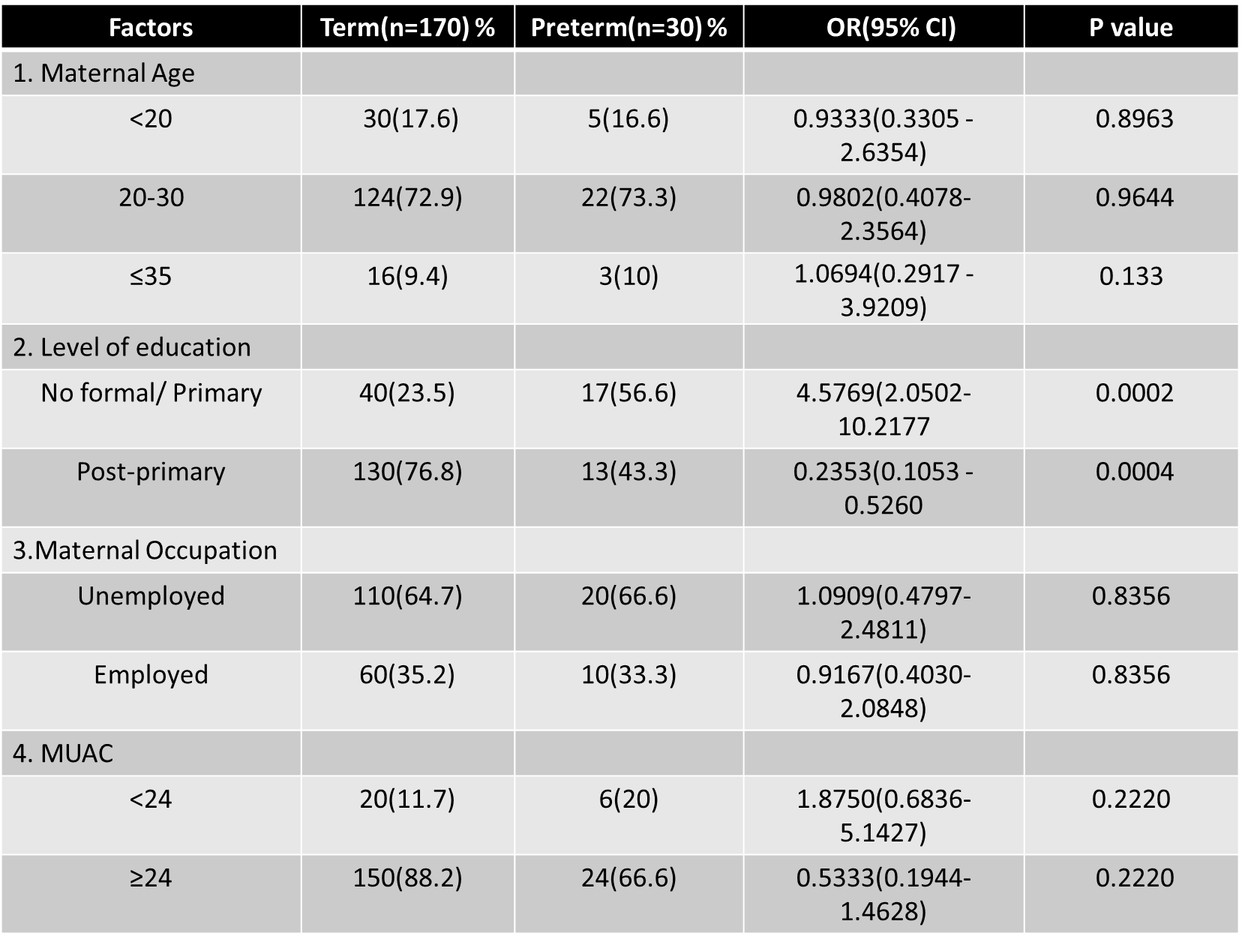

Table-2 Previous Pregnancy Characteristics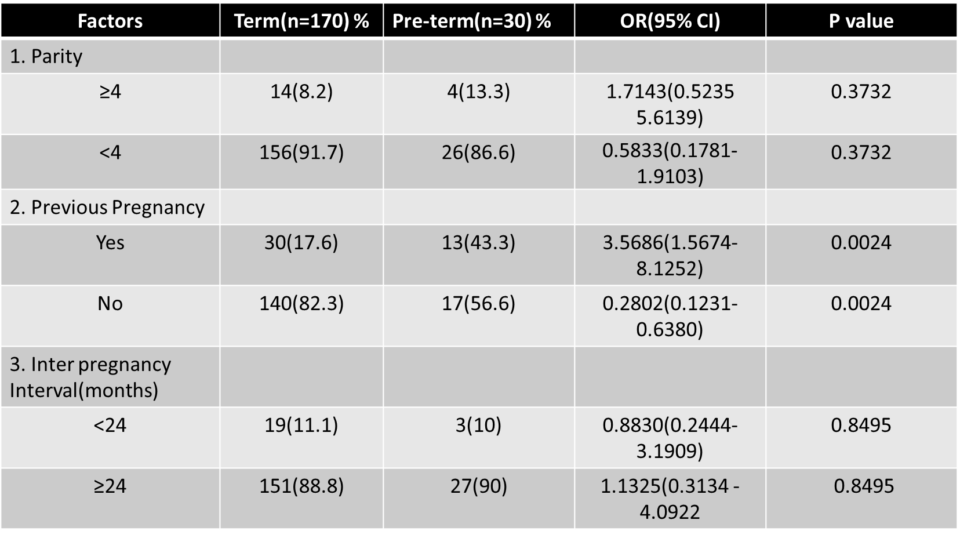
Antenatal factors

The proportion of mothers who did not attend ANC in the term and preterm groups was 2.3 and 3.4% respectively and this was not significant (p = 0.4837). Mothers who had not had any antenatal care were more likely to deliver preterm (OR 1.373). About 44% of mothers in term and 46% in preterm group had less than 3 antenatal visits but this was statistically insignificant (p = 0.7957). The proportion of women who had anemia during pregnancy was the same for the two groups (p =0.6096). Table 3 shows the relationship between the antenatal characteristics and preterm delivery.

Delivery factors
Approximately 60% of preterm deliveries were via Caesarean section (C/S) compared to 40% among those who delivered vaginally. Women who delivered via Caesarean section were nearly 1.5 times (OR 2.7500) more likely to deliver preterm than those who delivered vaginally. Delivery via Caesarean section had significant but marginal
association with preterm birth (p = 0.012). About 26 and 30% of mothers in the term and preterm group respectively had induced labor or medically indicated C/S. However, there was no association between onset of labour and preterm birth (p = 0.6883). The proportion of twin pregnancy among women who delivered at term and preterm was 5.8 and 13.3% respectively (p = 0.1516). Twin pregnancy conferred nearly a 2.2 -fold increase in the risk of preterm birth (OR 2.461). Table 4 shows the relationship between the delivery characteristics and preterm delivery.
Table-3 Antenatal Characteristics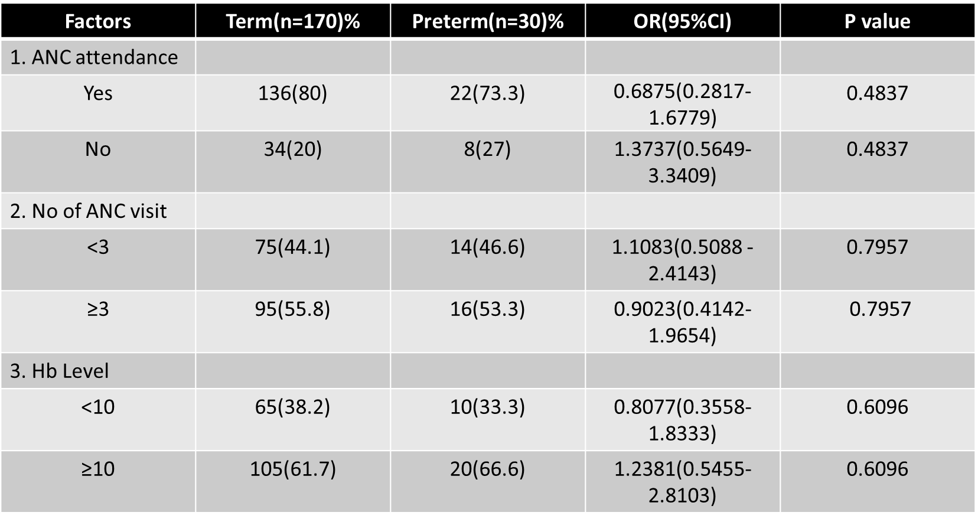

Table 4- Delivery Characteristics
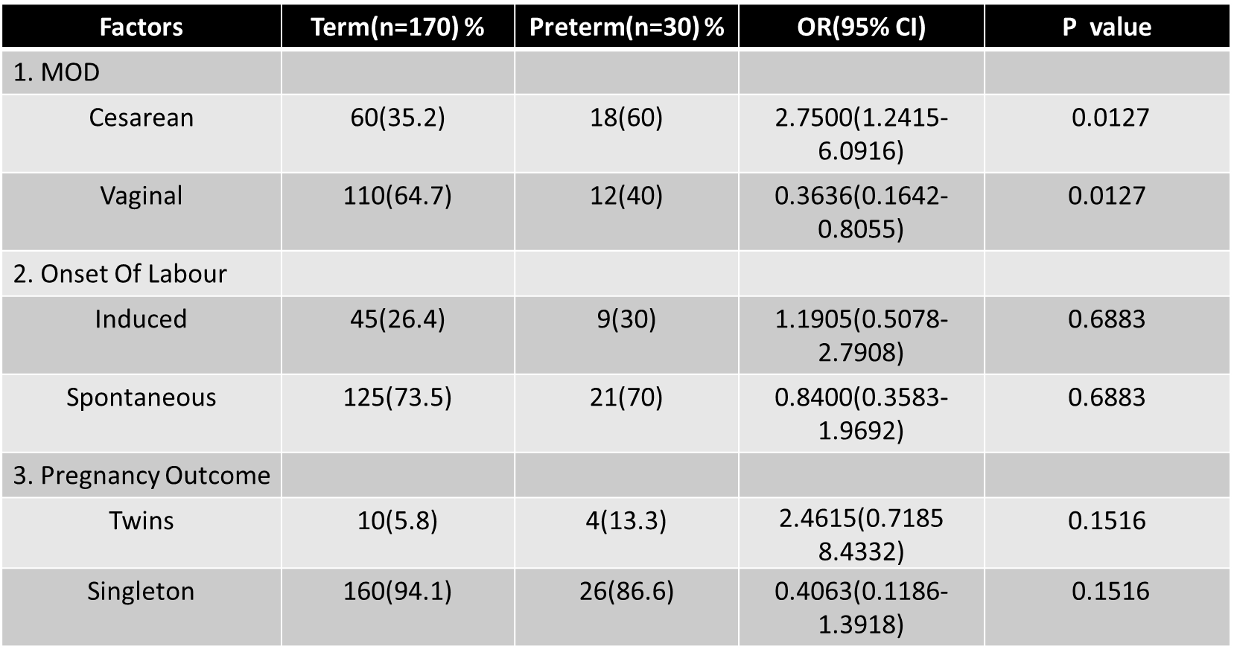
Obstetric factors
About 40 and 13% of mothers in the preterm and term groups had PIH while 30 and 17.5% of mothers in the two groups had APH respectively. Mothers with PIH and those with APH had a 3-fold and 1.5-fold increase in risk of preterm birth (OR 4.48 and 2.00). Approximately 46.6% of mothers who had preterm delivery and 15.2% of those
who delivered at term had a history of PROM for more than 18 h while 53.3% of mothers in preterm group and 48% of those in the term group respectively reported having had UTI or burning sensation with micturation during pregnancy. As shown in Table 5, all these factors were significantly associated with preterm birth (p < 0.05).
Independent determinants of preterm birth
Maternal age, parity, previous preterm birth, twin gestation, UTI, PIH, prolonged PROM and APH were found to be significantly associated with preterm birth. However, on multivariate logistic regression only PIH, APH and prolonged PROM remained significant. The risk of preterm birth increased 3-fold with PIH (OR 4.48), 1.2- fold if the mother had prolonged PROM (OR 4.48) and 1.5-fold with APH (OR 2.00) after controlling for confounders.

Table- 5 Obstetric Characteristics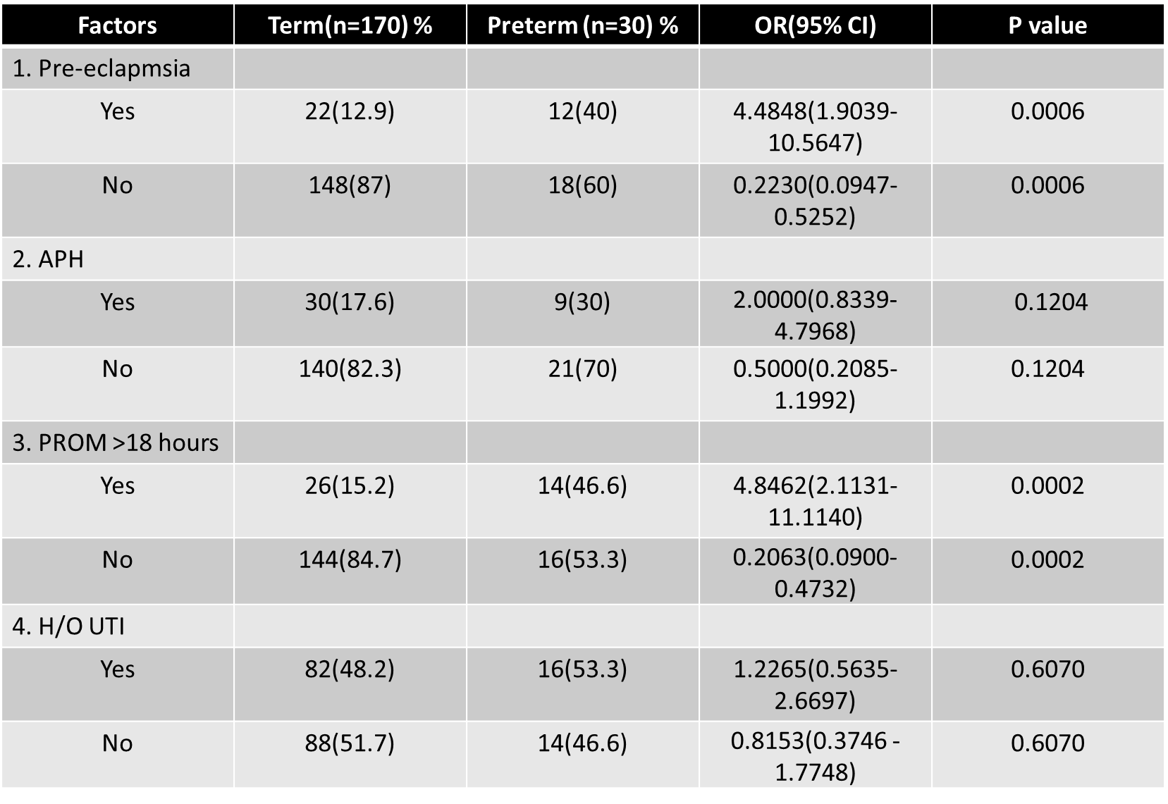
Discussion
Most developing countries lack reliable data on the prevalence of preterm birth [2, 4]. This study aimed to determine the prevalence of preterm birth and associated factors at the largest teaching and referral hospital in Dhaka, Bangladesh. Our findings demonstrate that preterm birth is a significant health problem in this population
with a hospital based prevalence rate of 183 per 1000 live births and that PIH, APH and prolonged PROM are independently associated with PTB. The high rate of preterm birth in this study is in agreement with World Health Organization (WHO) estimates that show that the highest rates are in sub Saharan Africa and South Asia and similar to the finding of other studies in India, Zimbabwe and Malawi [2, 10–12]. However, this PTB rate is higher than would be expected for community based studies. Compared to low and medium level health facilities in which most normal and uncomplicated deliveries are conducted, Ad-Din Women’s Medical College and Hospital being a major referral hospital handles more complicated deliveries, a significant proportion of which are preterm. Consequently, when estimating the PTB rate, the numerator is higher in relation to the denominator for the tertiary hospital resulting in a higher prevalence. The prevalence of preterm birth in the current study is much higher than that reported by Olugbenga and others in a study in a teaching hospital in Nigeria [13]. The difference in PTB rates between our study and the study done by Olugbenga et al. in almost similar setting in the sense of both being teaching hospitals could be explained by the distinct approaches in estimating the gestational age of the babies. While their study excluded mothers who were unsure of dates, those who had a discrepancy of more than 2 weeks between gestation by dates and Ballard’s assessment as well as those who had multiple gestation, our study relied wholly on the clinical gestational age assessment based on SFH. It is likely that our approach overestimated the prevalence of PTB while that of Olugbenga et al. may have underestimated the same.
The current study did not show any association between the maternal socio-demographic factors except maternal age < 20 years that appeared to be marginally protective. Though our findings showed a marginal negative association between maternal age < 20 years and PTB (p value =0.034, OR = 0.236), this is both unexpected and different from other studies [11–14]. Although about 17.5% of all mothers were aged < 20 years, less than 2.5% had preterm birth. The number of women who delivered prematurely in this regard was too small to authoritatively detect significant association with preterm birth and may have inadvertently resulted in the negative association in our study. Previous preterm delivery was associated with preterm birth and this was similar to the findings of other studies [13, 14]. Though the exact mechanism for this is not well established, it may be due to persistence of unidentified factors such as subclinical infections as well as underlying disorders such as hypertension, obesity or diabetes in some women precipitating preterm delivery [1, 15]. The current study demonstrated that mothers with a parity of ≥4 were 4 times more likely to deliver prematurely. This finding is similar to that of previous studies which had shown that multiparaous women were more likely to deliver preterm [13, 14]. High parity is likely to increase the risk of preterm delivery due to uterine changes such as myometrial stretching from previous pregnancies. Some of the mothers with high parity may also have had a bad obstetric history which may be due to unidentified factors that may persist in subsequent pregnancies. Interpregnancy interval had no association with preterm birth. This was different from the findings of Gordon and colleagues and Agustin Conde and others but similar to that of J Etuk and others in Nigeria [14, 16, 17]. It is possible that women in our setting recover faster from the effect of previous pregnancy and this may be due to intensified nutritional care of mothers soon after delivery which is a common practice locally.
Delivery via Caesarean Section was significantly associated with preterm birth but onset of labor was not. This was similar to the finding of Olugbenga et al. [13]. Operative delivery has no causal relationship with preterm birth but rather is as a result of indicated delivery for maternal or fetal reasons occasioned by obstetric complications
such as PIH and APH as observed in this study.
Twin gestation was significantly associated with preterm birth in this study. This is similar to the findings of J Etuk and others [14]. Multiple gestations is associated with uterine over distension and this may result in spontaneous preterm labour. In addition other complications such as pre-eclampsia and polyhydramnios are more likely to occur with multiple gestations and thus contribute to iatrogenic preterm birth [1].
ANC attendance as well as number of antenatal visits was not associated with preterm birth in our study. This is different from what Feresu A et al. had reported in Zimbabwe [11]. This may have been due to the Focused Antenatal Care (FANC) approach in Bangladesh which has emphasized the need to have four targeted antenatal visits which ensures women start ANC attendance much earlier [18]. Anemia in pregnancy had been associated with preterm birth in some studies but not in others [13, 14, 21]. Our study did not show any association between preterm birth and anemia. With the FANC approach, all pregnant mothers receive iron and folate supplements as early as possible and this reduces the risk of complications related to anemia including preterm birth. A low maternal MUAC was not associated with preterm birth. This finding was different from that of Sebayang et al. in Indonesia and Kalanda et al. in Malawi [21, 22]. One possible reason for this difference is that most women in the current study were from an urban setting compared with the rural setting of the other two studies. UTI in pregnancy was associated with premature birth. This was similar to the findings of studies in Iran and Nigeria [9, 15]. Due to morphological and functional changes that occur in pregnancy, stasis of urine favors UTI. Like other infections, UTI stimulate production of cytokines which may induce preterm labor through release of prostaglandins.
Results of the current study demonstrated that after controlling for confounders, prolonged PROM, PIH and APH remained significantly associated with preterm birth. These findings are similar to those reported in other studies. PROM has been associated with chorioamnionitis which may be subclinical and chlamydial vaginitis. Microorganisms that cause bacterial vaginosis can easily ascend in prolonged PROM and cause intra-uterine infections. It is postulated that subclinical chorioamnionitis and other unidentified infections may trigger the release of inflammatory mediators such as interleukin 1 leading to release of prostaglandins from the uterine decidua that ultimately induce preterm labor. PIH which is one of the major obstetric complications was significantly associated with PTB in the current study. Though the pathophysiology of this condition remains poorly understood, uteroplacental ischemia is a plausible explanation for the poor pregnancy outcomes associated with PIH including preterm delivery and low birth weight. Furthermore, PIH is a common reason for indicated preterm deliveries and this may explain its association with PTB even though this may not be causal in nature. Like PIH, APH is also a major contributor to indicated preterm deliveries whether vaginally or operatively without necessarily having a temporal relationship with PTB [1, 9, 15]. This study identifies mothers with prolonged PROM, PIH and APH as a high risk group for PTB. These are largely modifiable factors and should form a good basis for prenatal interventions and better management geared towards reducing the burden of PTB.

Limitations of the study
Only mothers who had live births were interviewed and their babies assessed for gestational age. The study did not address factors associated with preterm stillbirth. UTI in pregnancy was partly based on mothers’ self-report of symptoms and not on laboratory confirmation and therefore over-reporting was likely. Clinical assessment of gestation using the Finnstrom method that solely relied on physical characteristics is also a limitation of this study. Use of secondary data for some variables is another limitation of our study.
Conclusions
Preterm birth among women delivering at Ad-Din Women’s Medical College and Hospital is a significant problem. Prolonged PROM, PIH and APH are independent determinants of preterm birth. Better management of these obstetric complications and research to elucidate the mechanisms by which they cause preterm birth, offers a practical approach of reducing the high preterm birth rates.
Abbreviations
ANC: Antenatal clinic; AOR: Adjusted odds ratio; APH: Antepartum hemorrhage; C/S: Caesarean section; CI: Confidence interval; FANC: Focused antenatal care; Ad-Din: Ad-Din Women’s Medical College and Hospital; MDG: Millennium development goal; MOH: Ministry of Health; MUAC: Mid upper arm circumference; NBU: Newborn unit; OR: Odds ratio; PIH: Pregnancy induced hypertension; PROM: Prelabor rupture of membranes; PTB: Preterm Birth; SVD: Spontaneous vertex delivery; UTI: Urinary tract infection; WHO: World Health Organization
Acknowledgements
The authors would like acknowledge all the mothers who participated in the study as well as their babies. The authors also acknowledge Ad-Din Women’s Medical College and Hospital for funding the study. The results and conclusions are those of the authors and are independent from the funding source.
Funding
The study was funded by authors. The conclusions of the study are solely of the authors.
Availability of data and materials
The dataset supporting the findings of this article can be provided upon request to the corresponding author whose email is
jhummalika25@gmail.com.
Authors’contributions
All authors were involved in the development of the study design and the implementation plan. JB was the principal investigator for the study and wrote the manuscript. MKS is the co-investigators and contributed in the writing of the manuscript. MKS did data analysis and contributed to the writing of the manuscript. All authors critically reviewed the manuscript and approved the final version.
Ethics approval and consent to participate
This study received ethics approval by the Ad-Din Women’s Medical College and Hospital, Dhaka, Bangladesh. Written informed consent was obtained for participation in the study. No inducements or rewards were given to participants to join the study. Confidentiality was maintained at all times. Data collected as part of the study were not linked to individual or personal identifiers.
Competing interests
The authors declare that they have no competing interests.
Biography: Dr. Jhuma Biswas is working as a consultant gynecologists and obstetrician since 2015. She is the youngest fellow in Bangladesh. And completed MCPS and FCPS from Bangladesh College of physician and surgeon (BCPS) and recently completed MRCOG from Royal college of Obstetrics and Gynecology. She is already registered as a Uk Practitioner and will join in one of NHS hospital in UK on November’2020.
Presenting Author Details:

Full Name: Dr Jhuma Biswas
Contact No: +880171323917/ +8801670469718
Email Id: jhummalika25@gmail.com
Category: Oral Presentation
Passport No: BH0517592

References
- Goldenberg RL, Culhane JF, Iams JD, Romero R. Epidemiology and causes of preterm birth. Lancet. 2008;371:75–84.
- March of Dimes/WHO. Born too soon-the global action report on preterm birth 2012.
- Lawn JE, Cousens S, Zupan J. 4 million neonatal deaths: when? Where? Why? Lancet. 2008;365(Suppl 9462):891–900.
- Blencowe H, Cousens S, Oestergaard M, et al. National, regional and worldwide estimates of preterm birth rates in the year 2010 with time trends for selected countries since 1990: a systematic analysis. Lancet. 2012; 379(9832):2162–72.
- United Nations General Assembly. United Nations millennium declaration. New York: United Nations; 2000.
- Martines J, Paul VK, Bhutta ZA, Koblinsky M, Soucat A, Walker N, Bahl R,Fogstad H, Costello A. Neonatal survival: a call for action. Lancet. 2005; 365(Suppl 9465):1189–97.
- Lawn JE, Kerber K, Enweronu-Laryea C, Bateman O. Newborn survival in low resource settings–are we delivering? BJOG. 2009;116(Suppl 1):49–59.
- Finnström O. Studies on maturity in newborn infants. ActaPaediatrScand. 1977;66:601–4.
- Goyal SC, Tak SK, Bhandari B. Determination of gestational age: comparative accuracy of different methods. Indian J Pediatr. 1989;56(1):115–9.
- Shubhada A, Kambale SV, Phalke BD. Determinants of preterm labour in
a rural medical college hospital in western Maharashtra. NJOG. 2013;8(Suppl 1):31–3.
- Feresu SA, Harlow SD, Welch K, Gillespie RW. Incidence of and sociodemographic risk factors for stillbirth, preterm birth and low birthweight among Zimbabwean women. Paediatr Perinat Epidemiol. 2004;18(Suppl 2):154–63.
- van den Broek NR, Jean-Baptiste R, Neilson JP. Factors associated with
preterm, early preterm and late preterm birth in Malawi. PLoS One. 2014;
9(Suppl 3):e90128.
- Olugbenga A, Mokuolu BM, Suleiman OO, Adesiyun A, Adeniyi B. Prevalence
and determinants of pre-term deliveries in the University of Ilorin Teaching
Hospital, Ilorin, Nigeria. Pediatric Report. 2010;2(Suppl 3):11–3.
- Etuk SJ, Etuk IS, Oyo-Ita AE. Factors influencing the incidence of preterm
birth in Calabar, Nigeria. Niger J Physiol Sci. 2005;20(Suppl 1–2):63–8.
- Muglia LJ, Katz M. The enigma of spontaneous preterm birth. N Engl J Med.
2010;362:529–35.
- Smith GCS, Pell JP, Dobbie R. Interpregnancy interval and risk of preterm
birth and neonatal death: retrospective cohort study. BMJ. 2003;327:313–7.
- Conde-Agudelo A, Rosas-Bermãdez A, Kafury-Goeta A. Birth spacing and risk
of adverse perinatal outcomes. JAMA. 2006;295(Suppl 15):1809–23.
- MOH-DRH, DOMC, JHPIEGO. Focused antenatal care and malaria in
pregnancy: orientation package. Nairobi: Ministry of Health; 2002.
- Coley JL, Kapiga S, Hunter D, et al. The association between maternal HIV-1
infection and pregnancy outcomes in Dar es Salaam, Tanzania. BJOG. 2001;
108:1125–33.
- Ndirangu J, Newell M-L, Bland RM, Thorne C. Maternal HIV infection associated with small-for-gestational age infants but not preterm births:
evidence from rural South Africa. Hum Reprod. 2012;27(Suppl 6):1846–56.
- Sebayang S, Dibley M, Kelly P, Shanka A, Anuraj H. Determinants of low
birth weight, and small-for-gestational-age and preterm birth in Lombok,
Indonesia: analyses of the birth weight cohort of the SUMMIT trial. Trop
Med Int Health. 2012;17(Suppl 8):938–50.
- Kalanda BF. Maternal anthropometry and weight gain as risk factors for
poor pregnancy outcomes in a rural area of southern Malawi. Malawi Med
J. 2007;19(Suppl 4):149–53.

