Title: Reduction of Cr(VI) ion by photocatalytic Cu complexes and TiO₂
Name: Takashiro Akitsu
Affiliation: Tokyo University of Science
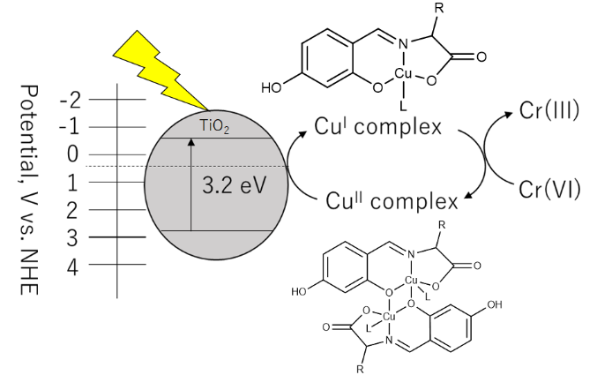
Abstract (200-300 words)

For about a decade, we have studied on L-amino acid derivative Schiff base copper(II) complexes and their photo-reaction with TiO₂ [1], application for reduction of Cr(VI) ion [2], which is harmful to the environment, and some fundamental aspects such as crystal structures [3] for next molecular design and microwave synthesis and so on. Not only brief review of a course of study but also recent results about reaction in aqueous solutions will be mainly mentioned in this talk.
A copper complex having a hydroxy group-bearing amino acid derivative Schiff base as a ligand was synthesized. Similar to the related complex, it showed a reaction of reducing hexavalent chromium ions to trivalent in methanol when irradiated with light. By introducing a hydroxy group this time, water-soluble complexes were obtained, and they showed a reaction of reducing hexavalent chromium Cr(VI) ions to trivalent Cr(III) in water when titanium oxide TiO₂ coexisted. The new point is that such a reaction can be realized in an aqueous solvent.
It is expected to be applied to convert hexavalent chromium ions, which are harmful to the environment, into trivalent ions, which are relatively harmless. In the past, we received an inquiry from a chrome plating factory as a new waste liquid treatment method. However, due to cost constraints and restrictions on the solvent (before it was realized with water at that time), there was experience that it was not practical.
References
1 Y. Takeshita et al., International Journal of Molecular Science, 2015, 16, 3955.
2 Y. Miyagawa et al., New Journal of Chemistry, 2020, 44, 16665.
3 N. Katsumi et al., Acta Crystallographica, 2020, E76, 1539.

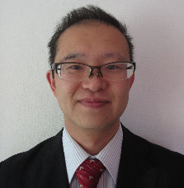
Biography: (100 -200 words)
Takashiro AKITSU has completed his PhD at the age of 28 from Osaka University and postdoctoral studies from Institute for Protein Research, Osaka University. He worked at Keio University, Stanford University, and Tokyo University of Science and now he is full professor of chemistry, Tokyo University of Science. Chiral Schiff base metal complexes and their hybrid systems with functional materials were main theme of his group. He has published more than 220 papers in reputed journals and has been serving as an editorial board member of repute.

• Full Name: Takashiro Akitsu
• Personal Email: akitsu2@rs.tus.ac.jp
• Mobile Number: +81-3-5225-8271
• Category: Role of catalysis in sustainable chemistry
• Date of Birth: October 3, 1971
• Postal Address: 1-3 Kagurazaka, Shinjuku-ku, Tokyo 162-8601, Japan

