Green Extractions in the Food Industry
Mustafa Z Ozel, PhD, UK

Abstract (300 word limit)

Most companies in the food industries use conventional extraction methods such as those using solvents, or steam and hydro-distillation. Recent trends in extraction techniques have largely focused on minimizing the use of petroleum-based solvents. Recently, more efficient extraction methods, such as subcritical water extraction (SWE), supercritical fluid extraction (SFE), and microwave assisted extraction (MAE) have been used for the isolation of organic compounds from various plants. These extraction techniques are not only cheaper and faster, but being considered environmentally-friendly, they would also enable these products to claim a green label. Having a green label is desirable to many customers.

SWE as a method, is non-toxic, non-flammable, fast, cheap, readily available, safe, environmentally friendly and uses a green solvent. The extraction of phenolic compounds, flavonoids, flavor, fragrances and essential oils have been carried out using SWE and both qualitative and quantitative results obtained.

SFE of essential oils with carbon dioxide has certain advantages over steam distillation. Steam distillation can lead to thermal degradation and partial hydrolysis of some essential oil compounds. Supercritical CO2 extraction is relatively fast due to the low viscosity, high diffusivity, and tunable solvent power of the supercritical fluid. SFE is considered a safe and green technology.

MAE is a relatively new extraction technique that combines microwave and traditional solvent extraction. Microwaves are applied to heat the solvents and plant tissues in the extraction process, which increases the kinetics of extraction. MAE has a number of advantages over traditional extraction methods, e.g., shorter extraction time, less solvent, higher extraction rate and lower cost.
Image
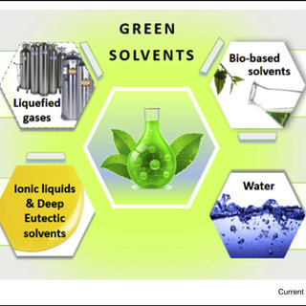
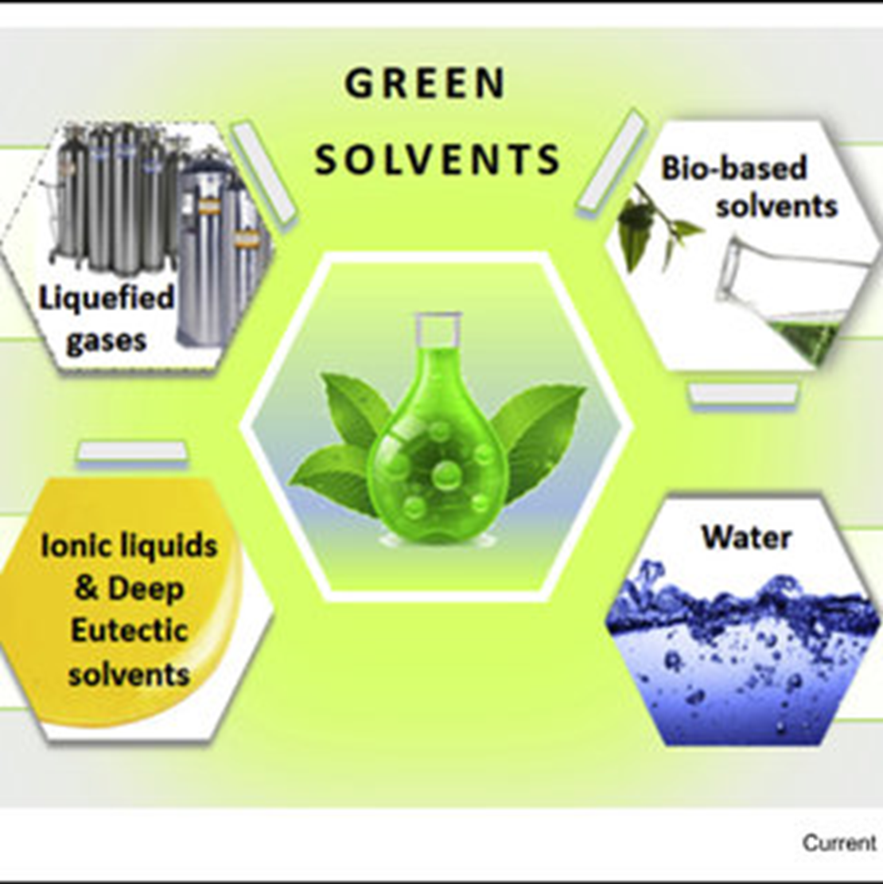
Recent Publications (minimum 5)
- Y. Gao, M.Z. Özel, T. Dugmore, A. Sulaeman, A.S. Matharu. A biorefinery strategy for spent industrial ginger waste. Journal of Hazardous Materials, 401 (2021) 123400 doi.org/10.1016/j.jhazmat.2020.123400.
- N. Balikci, M. Sarimahmut, F. Ari, N. Aztopal, M.Z. Özel, E. Ulukaya, S. Celikler. Toxicity assessment of Hypericum olympicum subsp. olympicum L. on human lymphocytes and breast cancer cell lines. Journal of Applied Biomedicine, 18 (2020) 18-25.
- D. Ozyurt, B. Demirata, R. Apak, J.F. Hamilton, A.C. Lewis, M.Z. Özel. GCxGC-TOF/MS Chromatographic Analysis, Antioxidant Capacity and Phenolic Content of Rosa Canina L. at Different Maturities. Records of Natural Products, 10 (2016) 407-425.
- F. Gogus, M.Z. Özel, H. Keskin, D.K. Yanık, A.C. Lewis. Volatiles of Fresh and Commercial Sweet Red Pepper Pastes: Processing Methods and Microwave Assisted Extraction International Journal of Food Properties, 18 (2015) 1625-1634.
- N. Ramirez, M.Z. Özel, A.C. Lewis, R.M. Marcé, F. Borrull, J.F. Hamilton. Exposure to Nitrosamines in Thirdhand Tobacco Smoke increases Cancer Risk in Non-Smokers. Environment International, 71 (2014) 139-147.

Biography (150 word limit)
Dr. Mustafa Zafer Özel received his BSc and MSc degrees in Chemistry (1993) from Anadolu University, Turkey. He obtained his PhD in Analytical Chemistry (1998) from Leeds University, UK and has 22 years of teaching, research and industrial experience in this area. He worked as an Analytical Chemistry Lecturer / Senior Lecturer in Pamukkale University, Turkey from 1998 - 2008. Following this, he held posts at York University, UK. In 2015, he took up an industrial role in the Global Innovation Team in Sensient Flavors, Milton Keynes, UK. Currently, he has returned to work within the York University Green Chemistry group. Throughout his career, his research interests have been within the fields of environmental analytical, bioanalytical, process analytical, atmospheric chemistry, green chemistry and flavour chemistry.

Email: mustafazozel@hotmail.com

Notes/Comments:

