Effects of Climate Change: Is This Scientific Reality or Mere a Politics?

Meen B. Poudyal Chhetri, NCDM, Nepal

Abstract (300 word limit)

BACKGROUND: Climate change has become a very serious worldwide concern because of its adverse effects in livelihood and environment. Glaciers are melting rapidly in the Himalayan region which has the major portion of glaciers that covers almost 33,000 km². The Himalayan range constitutes a major source of water draining through nine largest rivers in Asia serving more than 1.3 billion people to find their livelihoods. Glaciers are also receding in other parts of the world. Hence, glacial retreat is the most striking evidence of climate change which is a scientific reality. On the other hand, it has been much exaggerated and debated among the developing and developed countries.

PROBLEMS: The scientists have forecasted that the average global temperatures are expected to raise 1.4-5.8ºC by the end of the 21st century. Greenhouse gases from human activities are among the major causes for the global warming. Weather patterns are becoming more unpredictable and extreme – dry seasons become dryer and wet seasons wetter. This situation is causing fear over the long term reduction in total water supply, affecting lives and livelihoods.

CONCLUSIONS: The Earth is warming rapidly due to global warming. Therefore, policy makers must ease the transition to a carbon-free energy industry by passing and adopting legislation that creates favourable market conditions, and ensure that the Kyoto Protocol enters into force. Global warming can be kept within tolerable limits by using various technologies, and carrying out scientific research. It is necessary to negotiate to avoid misunderstanding among the developing and developed nations and develop necessary legal and scientific tools to advance scientific knowledge on the causes and consequences of climate change. Effective implementation of the United Nations Framework Convention on Climate Change (UNFCCC) provisions and Paris accord also help to minimize the effects of climate change.
Image
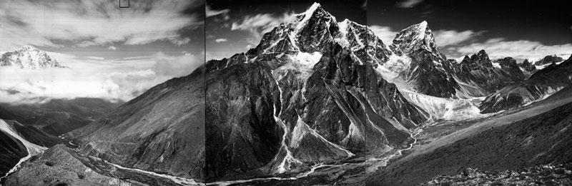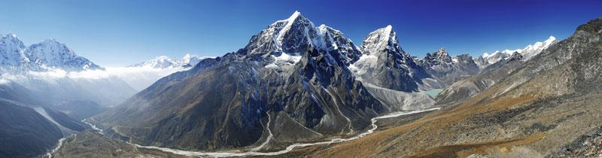
Recent Publications (minimum 5)
- Bajracharya, B., Shrestha, A. B., Rajbhandari, L., (2007). Glacial Lake Outburst Floods in the Sagarmatha Region: Hazard Assessment Using GIS and Hydrodynamic Modeling, Mountain Research and Development, Vol. 27, pp. 336-344, Kathmandu.
- IPCC, (2007b). Climate Change 2007. The Physical Basis, Contribution of Working Group I to the Fourth Assessment Report of the Intergovernmental Panel on Climate Change. Cambridge: Cambridge: University Press, United Kingdom and New York, USA. URL: http://ipcc-wg1.ucar.edu/wg1/wg1-report.html.
- Nepal Disaster Report (2015). Ministry of Home Affairs, Government of Nepal and Disaster Preparedness Network-Nepal.
- Poudyal Chhetri M. B. , Bhattarai D. (2001). Mitigation and Management of Floods in Nepal, Ministry of Home Affairs, Government of Nepal.
- Richardson, S. D. and Reynolds, J. M.(2000a).An overview of glacial hazards in the Himalayas. Quaternary International, 65-66, 31–47.

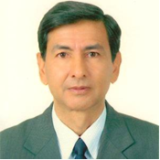Biography (150 word limit)

Dr. Chhetri is Immediate Past President of Nepal Center for Disaster Management (NCDM) and Chairman of The International Emergency Management Society (TIEMS)’s paper Review Committee. He has been appointed as the Adjunct Professor at the Queensland University of Technology, Brisbane, Australia. He is the Council Member of the International Society for Digital Earth (ISDE). In the past, he served as the Director of the Department of Disaster Management of the Government of Nepal from 2001 to 2003. In 2004 He worked as the Deputy Regional Administrator in Hetauda, Nepal. From 1995 to 1996, he was the Chief District Officer and Chairman of District Disaster Relief Committee in Dhading district of Nepal. Dr. Chhetri also held different senior positions in various government agencies of Nepal including the Commission for the Investigation of Abuse of Authority, Ministry of Home Affairs, Ministry of Finance, Ministry of Agriculture and Ministry of Education.

Email: meen.chhetri@yahoo.com

Notes/Comments:
I would like to present my paper as a Keynote speaker.

